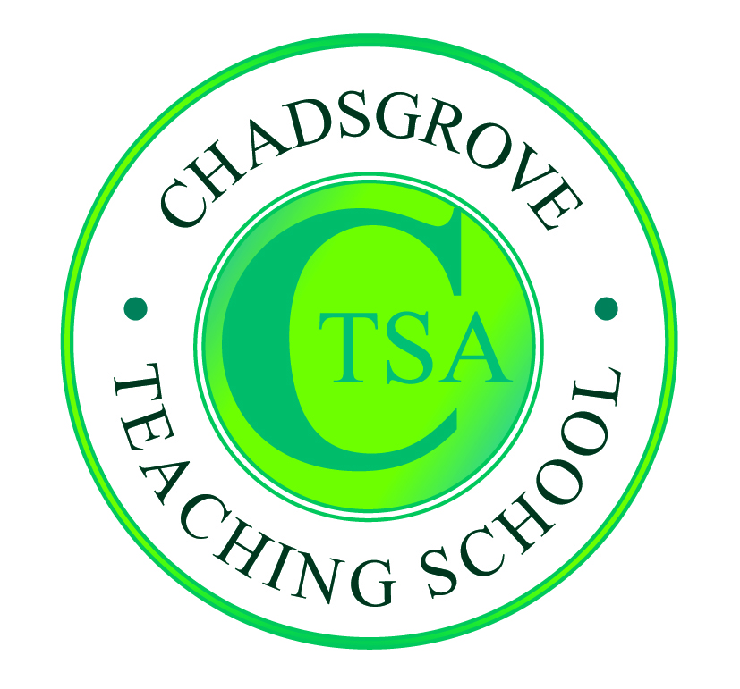Chadsgrove Teaching School

School Support Services ‘Pay-as-you-go’ Order Form

|  |  |  |  |  |
| --- | --- | --- | --- | --- |
| Service required |  | | | |
| Total cost |  | | | |
|  | | | | | |
| School Name | |  | |  |
| Headteacher | |  | | |
| Multi-Academy Trust  *(if applicable)* | |  | | |
| Lead contact: Name | |  | | |
| email | |  | | |
| Telephone | |  | | |
| Address for correspondence | |  | | |
| Invoicing Address  (*if different to correspondence address*) | |  | | |
| Cost Centre for Internal Transfer for **Worcestershire Schools** please complete **both** sections below  Internal Order: Cost Centre: | | | | |
| Authorised Signature: | | | Name in Capitals: | |

*Please return to:*

Chadsgrove Teaching School, Meadow Road, Catshill, Bromsgrove, Worcestershire, B61 0JL

Tel: 01527 871511 Fax: 01527 579341 email: tsa@chadsgrove.worcs.sch.uk