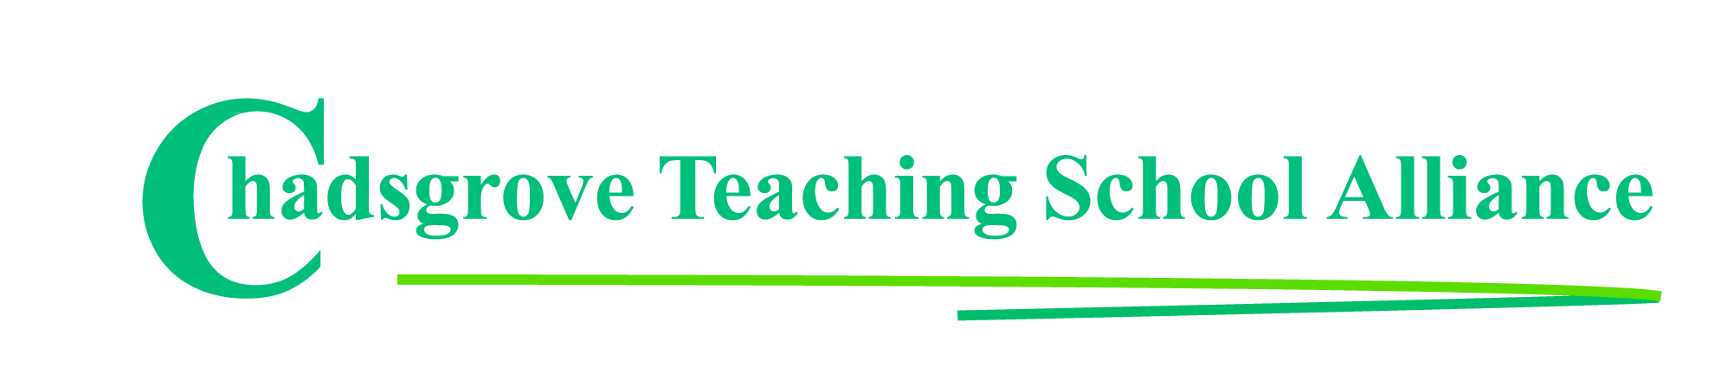

Summer Courses 2018

Date | Course Leader | Course Title
18th April  10.00 – 4.00 | Nathan Atkinson  Inclusion Consultant | Pupil Premium: Strategies to Narrow the  Attainment Gap  Mainstream  SEND Schools | £110
20th April  10.00 – 4.00 | Richard Aird OBE  Education Consultant & Trainer | Personalising Assessment & Learning  for Pupils with PMLD  SEND Schools | £110
25th April  1.30 – 4.00 | Iain Chatwin  SEND Consultant & Trainer | Lego-based Therapy  SEND Schools  Mainstream | £65
27th April  10.00 – 4.00 | Jane Thistlethwaite  VI Consultant & Trainer | Making Sense of Our Vision Sensory World  Mainstream  SEND Schools | £110
15th May  9.15 – 3.30 | Suneeta King &  Emma Jordan  Speech & Language Therapists | Autistic Spectrum Disorder and Communication  SEND Schools  Mainstream | £80
22nd May  1.30 – 4.00 | Iain Chatwin  SEND Consultant & Trainer | Supporting Pupils with ADHD in Secondary  Settings  Mainstream | £65
23rd May  9.15 – 12.00 | Hannah McCone  & Keely Jenner  Speech & Language Therapists | Challenges and Opportunities:  Applying strategies and approaches across the  curriculum to develop communication skills  Mainstream  SEND Schools | £60
5th June  10.00 – 4.00 | Merie Eglesfield &  Ashley Newman  Approved Trainers | Leading a Mentally Healthy School  SEND Schools  Mainstream | £110
13th June  9.30 – 3.30 | SENCO Conference *1 Free place for CTSA SENCO Network members  SEND Schools  Mainstream  at Bromsgrove School, B61 7HP * Second delegate rate £75 |  | *£155
11th July  1.30 – 4.00 | Iain Chatwin  SEND Consultant & Trainer | Lego-based Therapy  SEND Schools  Mainstream | £65

Course details available at: http://www.chadsgroveschool.org.uk/web/cpd_courses
For further information, please contact: courses@chadsgrove.worcs.sch.uk
Chadsgrove Teaching School Alliance
Meadow Road, Catshill, Bromsgrove, Worcestershire. B61 0JL
Tel: 01527 871511 Fax: 01527 579341
Email: tsa@chadsgrove.worcs.sch.uk
Booking Form
Course Title:

Number of Places Required:
Attendee(s) Name & Email Address

Occupation:

Special Requirements:
(e.g. dietary, access, etc)
Organisation name:
Postal Address for Correspondence:
Invoicing Address (if different to Postal Address):

Email:
Telephone Number:
Total Cost:
(Please make cheques payable to Worcestershire County Council)
Cost Centre for Internal Transfer for Worcestershire Schools. Please complete both sections below.
Project Code: Cost Centre:
Authorised Signature (Headteacher): | Name in Capitals:
We regret that we cannot accept typed signatures. Digital signatures or scanned electronic copies are suitable.
Please return to:
Chadsgrove Teaching School, Meadow Road, Catshill, Bromsgrove, Worcestershire, B61 0JL

Tel: 01527 871511 Fax: 01527 579341 Email: courses@chadsgrove.worcs.sch.uk
Confirmation of your booking(s) will be made within 14 working days

CANCELLATION of a course booking must be received in writing at least 10 working days prior to the course date, otherwise the following costs will be incurred: 50% of the course fee will be payable for cancellations received between 10 & 6 working days prior to course date, with 100% of the fee being payable for cancellation received later or for non-attendance. We are happy to accept substitute delegates. In the event of unforeseen circumstances, we reserve the right to cancel or alter parts of the programme.

