People who help us – Firefighter
Take a look through these suggested learning activities and choose what you feel your child would enjoy.
- Paint a fire picture with red and orange paint and our fingers!
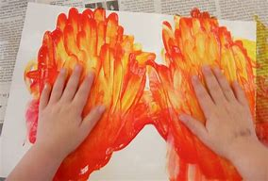
- If you are feeling very creative, make a fire engine from a large box so your child can enjoy pretend play!
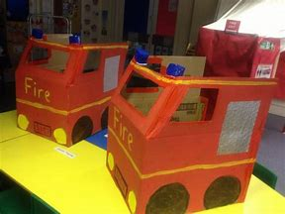
- Play with the hose and water guns in the garden on a warm day!
- Make a fire themed no mess sensory bag.
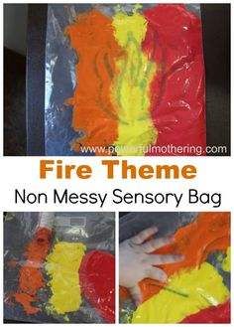
- Enjoy water play outside or in the bath; add some red food colouring, use syringes or pipettes to spray the water, use small containers to use as buckets to put out the fire!
- Make a firefighter’s hat using a paper plate.
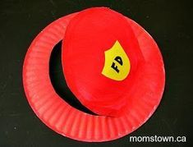
- Sing the rhyme ‘5 Little Firefighters’ with your child.
Five little firefighters (Show five fingers)
Sleeping in a row. (Rest cheeks on hands and closed eyes.)
RING goes the bell–
Down the pole, they go. (Pretend to slide down a pole.)
They jump on the engine (Jump.)
And put out the fire. (Pretend to squirt with a hose.)
Now they’re back home–
My, but they’re tired! (Stretch and yawn.)
One went to bed……and then there were 4…..and so on.
- Listen to the story Fireman Sam theme tune.
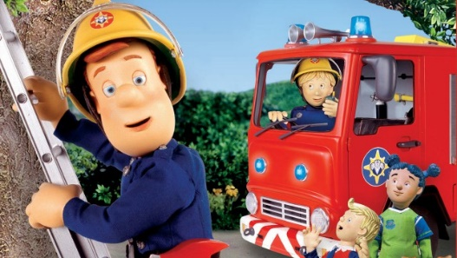
- Read ‘Charlie the Firefighter’ ebook together.

Have fun!

