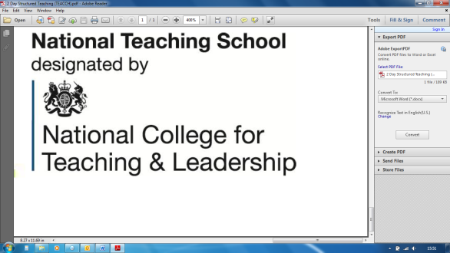

Tel: 01527 871511

courses@chadsgrove.worcs.sch.uk

For Mainstream & Special Schools

**Assessment for Pupils with SEND**

This course will provide you with an overview of the changes to the new assessment procedures, recording and reporting within the new National Curriculum framework especially for children and young people with SEND currently working within P levels. It will look at how to measure progress without levels and implications for the Ofsted inspection process.

Session 1: An overview of curriculum and assessment reform and the impact on schools

Session 2: Why do we need to assess?

Session 3: Assessment – moving forward

Session 4: Recording progress and gathering evidence

*Please complete and return the booking form overleaf or contact the school*

Course led by **Lorraine Petersen OBE**

Thursday 13th June 2019

10.00a.m. – 3.00p.m.

By the end of today delegates should have a greater understanding of:

* the requirements of current educational reform and the impact on pupils with special educational needs and/or disabilities
* the revised requirements for the end of KS1 and KS2 tests and GCSEs
* the P Scales, their use in schools and alternative progress measures that have been effectively used in schools
* relevant information in regard to Ofsted inspection and their requirements in terms of assessment, reporting and recording

For nine years Lorraine was the CEO of NASEN and prior to that she held a number of teaching posts within

mainstream schools in Sandwell, West Midlands. Lorraine completed her 25 year teaching career as headteacher of two very diverse primary schools. She has many years’ experience of working with pupils with an array of special and additional needs within mainstream settings. She also has hands-on experience of the issues relating to caring for and educating children with special and additional educational needs. Lorraine is a Trustee of Ambitious about Autism and the Chair of Governors at Treehouse School. In June 2009 Lorraine was awarded the OBE for services to education, in 2010 Lorraine was awarded the Outstanding Achievement Award at the Education Research Awards, and in 2013 the Outstanding Achievement Award at BETT.

**Course fee £110** (including lunch)

**Venue:** Chadsgrove Teaching School

Meadow Road

Catshill

Bromsgrove

B61 0JL

Chadsgrove Teaching School Alliance

**Implementing SEND Reforms ~ Where are we now?**



|  |  |  |  |  |  |
| --- | --- | --- | --- | --- | --- |
| Course Title: **Assessment for Pupils with SEND** (Course Led by: Lorraine Petersen)  13th June 2019 **Number of Places Required** (@ £110 each): | | Choose an item. | | | |
| Attendee(s) Name & Email Address  Click here to enter text. | | | | | |
| The information you provide in this form will be used solely for processing your course booking. If you wish us to retain your email address to contact you about future CTSA professional development opportunities please tick this box | | |  |  |  |
|  |
|  |
| Occupation: Click here to enter text. | | | | | |
| Special Requirements: Click here to enter text.  (e.g. dietary, access, etc) | | | | | |
| Organisation name: Click here to enter text. | | | | | |
| Postal Address for Correspondence: Click here to enter text. | | | | | |
| Invoicing Address (*if different to Postal Address*):  Click here to enter text.  Email: Click here to enter text.  Telephone Number: Click here to enter text. | | | | | |
| Total Cost: Choose cost  *(Please make cheques payable to Worcestershire County Council)* | | | | | |
| Cost Centre for Internal Transfer for **Worcestershire Schools**. Please complete **both** sections below.  Project Code: Click here to enter text. Cost Centre: Click here to enter text. | | | | | |
| Authorised Signature (Headteacher): | Name:  Click here to enter text. | | | | |
| *We regret that we cannot accept typed signatures. Digital signatures or scanned electronic copies are suitable.* | | | | | |

*Please return to:*

Chadsgrove Teaching School, Meadow Road, Catshill, Bromsgrove, Worcestershire, B61 0JL

Tel: 01527 871511 Email: courses@chadsgrove.worcs.sch.uk

Confirmation of your booking(s) will be made within 14 working days

***CANCELLATION of a course booking must be received in writing at least 10 working days prior to the course date, otherwise the following costs will be incurred: 50% of the course fee will be payable for cancellations received between 10 & 6 working days prior to course date, with 100% of the fee being payable for cancellation received later or for non-attendance. We are happy to accept substitute delegates.***

**In the event of unforeseen circumstances, we reserve the right to cancel or alter parts of the programme.**