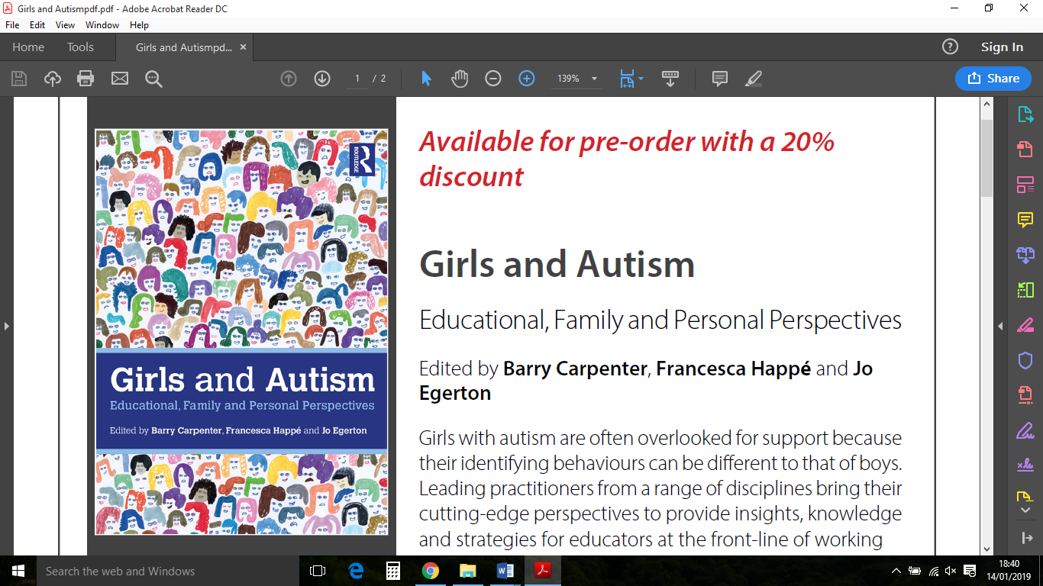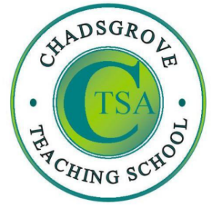

Professor Barry Carpenter CBE

Professor of Mental Health in Education at Oxford Brookes University, and  
 Chair of the National Forum on Girls and Autism.

Katie Buckingham

Successful entrepreneur with an autism spectrum disorder and founder  
 of Altruist, a social enterprise to increase knowledge around mental health.

Jo Egerton

Schools research consultant and writer in the fields of  
 autism, learning disability and special educational needs.

*Girls and Autism: Educational, Family and Personal Perspectives*

ISBN 9780815377269

**Tuesday 9th April 2019**

1.00p.m. – 4.00p.m.

**£85**

Girls with autism are often overlooked for support because their identifying behaviours can be different to those of boys. Collaborative work across a range of disciplines (including education, psychology, neuroscience), with families, and with girls and women with autism has captured new information which has strengthened the support and interventions we are now able to offer to girls with autism.

This short symposium for teachers, school leaders and allied professionals will explore how practitioners can improve their observations, enhance engagement and begin to develop an appropriate school response recognising the different support that girls with autism might require. Discussion will be informed by *Girls and Autism*, the new book edited by Carpenter, Happé and Egerton identifying the implications for evidence based practice in education. Without a diagnosis, girls on the autism spectrum can struggle with extreme stress, leading to mental health issues, problem behaviours, school refusal, or other outcomes which impact on their quality of life.

**Girls and Autism:**

**New Perspectives**

Tel: 01527 871511

courses@chadsgrove.worcs.sch.uk

**Venue:** Chadsgrove Teaching School

Meadow Road

Catshill

Bromsgrove

B61 0JL



Chadsgrove Teaching School Alliance

|  |  |  |  |  |  |
| --- | --- | --- | --- | --- | --- |
| Course Title: **Girls and Autism: New Perspectives**  9th April 2019 **Number of Places Required (at £85 each):** | | Choose an item. | | | |
| Attendee(s) Name & Email Address  Click here to enter text. | | | | | |
| The information you provide in this form will be used solely for processing your course booking. If you wish us to retain your email address to contact you about future CTSA professional development opportunities please tick this box | | |  |  |  |
|  |
|  |
| Occupation: Click here to enter text. | | | | | |
| Special Requirements: Click here to enter text.  (e.g. dietary, access, etc) | | | | | |
| Organisation name: Click here to enter text. | | | | | |
| Postal Address for Correspondence: Click here to enter text. | | | | | |
| Invoicing Address (*if different to Postal Address*):  Click here to enter text.  Email: Click here to enter text.  Telephone Number: Click here to enter text. | | | | | |
| Total Cost: Choose cost  *(Please make cheques payable to Worcestershire County Council)* | | | | | |
| Cost Centre for Internal Transfer for **Worcestershire Schools**. Please complete **both** sections below.  Project Code: Click here to enter text. Cost Centre: Click here to enter text. | | | | | |
| Authorised Signature (Headteacher): | Name:  Click here to enter text. | | | | |
| *We regret that we cannot accept typed signatures. Digital signatures or scanned electronic copies are suitable.* | | | | | |

*Please return to:*

Chadsgrove Teaching School, Meadow Road, Catshill, Bromsgrove, Worcestershire, B61 0JL

Tel: 01527 871511 Email: courses@chadsgrove.worcs.sch.uk

Confirmation of your booking(s) will be made within 14 working days

***CANCELLATION of a course booking must be received in writing at least 10 working days prior to the course date, otherwise the following costs will be incurred: 50% of the course fee will be payable for cancellations received between 10 & 6 working days prior to course date, with 100% of the fee being payable for cancellation received later or for non-attendance. We are happy to accept substitute delegates.* In the event of unforeseen circumstances, we reserve the right to cancel or alter parts of the programme.**