Milk bottle Elephant
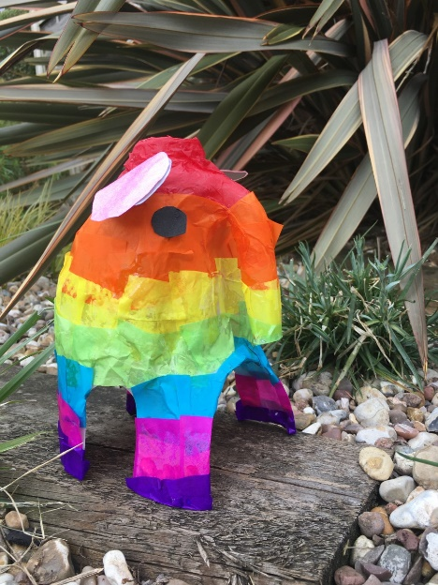
You will need
- PVA glue
- Scissors
- Tissue paper

Method
- Wash out the milk bottle
- Carefully cut as shown
- Stick tissue paper on
- Leave to dry
- Take a photo of your work
