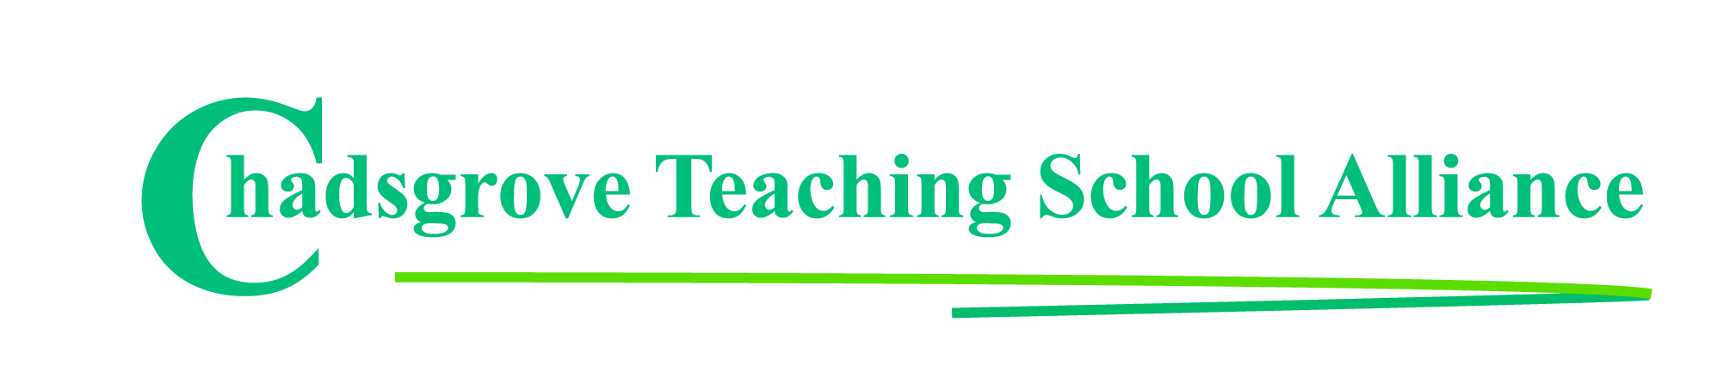
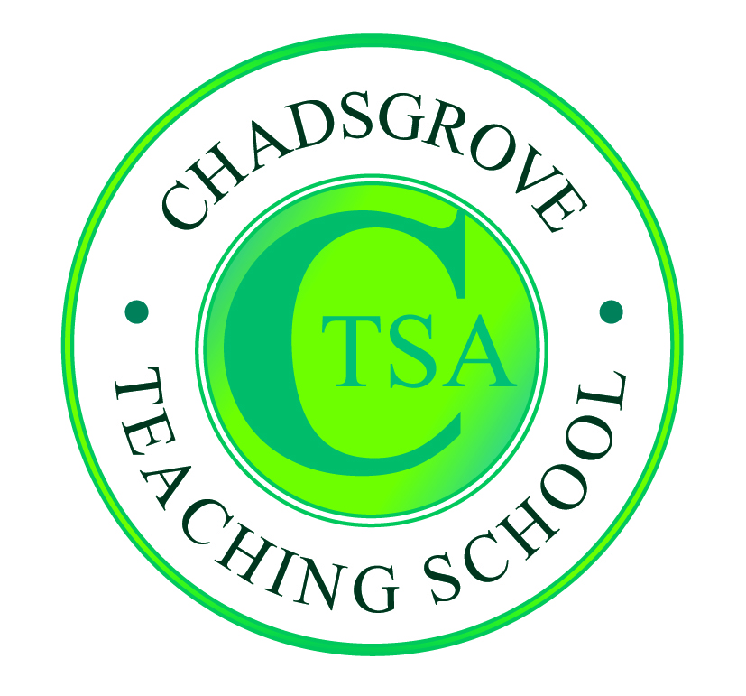

Summer Courses 2019

Date | Course Leader | Course Title
8th May  10.00 – 4.00 | Nicky Beddows &  Nia Luke  Speech & Language Therapists | Alternative and Augmentative Communication  in the Classroom: A team approach  Mainstream  SEND Schools | £80*
9th May 1.30-4.00  6th, 19th & 26th June  10.00-4.00 | John Tilley | Effective Strategic Leadership (3½ day developing leader programme)  SEND Schools  Mainstream | £425
22nd May  10.00 – 3.00 | Mark Loveday  Specialist Teacher & Trainer | Practical Ideas for Supporting Literacy in the  Classroom  Mainstream  SEND Schools | £110
23rd May  1.30 – 4.00 | Iain Chatwin  SEND Consultant & Trainer | Lego-based Therapy  Mainstream  SEND Schools | £65
4th June  10.00 – 4.00 | Suneeta King &  Emma Jordan  Speech & Language Therapists | Autistic Spectrum Disorder and Communication:  Enabling you to support the complex needs of  children and young people in your setting  Mainstream  SEND Schools | £80*
11th June  10.00 – 12.30 | Iain Chatwin  SEND Consultant & Trainer | Including Pupils with ADHD in Primary Schools  Mainstream | £65
12th June  9.30 – 3.30 | SENCO Conference *1 Free place for CTSA SENCO Network members  SEND Schools  Mainstream  at Bromsgrove School, B61 7HP * Second delegate rate £75 |  | *£155
13th June  10.00 – 3.00 | Lorraine Petersen OBE  SEND Consultant & Trainer | Assessment for Pupils with SEND  Mainstream  SEND Schools | £110
24th June &  3rd July  9.45 – 4.45 | Lorraine Petersen OBE  Accredited MHFA Trainer | Mental Health First Aid  to Support Young People (2-day course)  Mainstream  SEND Schools | £249

Course details available at: http://www.chadsgroveschool.org.uk/web/cpd_courses

*These courses are facilitated by Worcestershire Children’s Speech and Language Therapy Service.
For further information and booking please visit www.hacw.nhs.uk/our-services/speech-language-therapy/childrens/training

For further information, please contact: courses@chadsgrove.worcs.sch.uk
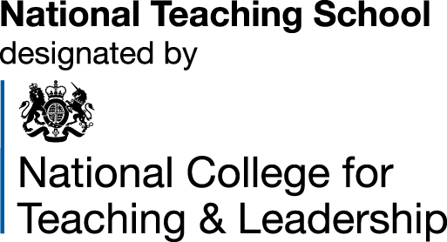
Chadsgrove Teaching School Alliance
Meadow Road, Catshill, Bromsgrove, Worcestershire. B61 0JL
Tel: 01527 871511
Email: tsa@chadsgrove.worcs.sch.uk
Booking Form
Course Title:
Number of Places Required:
Attendee(s) Name & Email Address

The information you provide in this form will be used solely for processing your course booking. If you wish us to retain your email address to contact you about future CTSA professional development opportunities please tick this box
Occupation:
Special Requirements:
(e.g. dietary, access, etc)
Organisation name:
Postal Address for Correspondence:
Invoicing Address (if different to Postal Address):

Email:
Telephone Number:
Total Cost:
(Please make cheques payable to Worcestershire County Council)
Cost Centre for Internal Transfer for Worcestershire Schools. Please complete both sections below.

Project Code: Cost Centre:
Authorised Signature (Headteacher): | Name:
We regret that we cannot accept typed signatures. Digital signatures or scanned electronic copies are suitable.
Please return to:
Chadsgrove Teaching School, Meadow Road, Catshill, Bromsgrove, Worcestershire, B61 0JL

Tel: 01527 871511 (option 1) Email: courses@chadsgrove.worcs.sch.uk
Confirmation of your booking(s) will be made within 14 working days

CANCELLATION of a course booking must be received in writing at least 10 working days prior to the course date, otherwise the following costs will be incurred: 50% of the course fee will be payable for cancellations received between 10 & 6 working days prior to course date, with 100% of the fee being payable for cancellation received later or for non-attendance. We are happy to accept substitute delegates. In the event of unforeseen circumstances, we reserve the right to cancel or alter parts of the programme.

