ENVIRONMENTAL STUDIES PROJECT 2020
In Spring term we made birds’ nests and put them in the trees around school. Unfortunately we have not been able to see if any birds used them as we are not in school.
So in the Easter holidays I found a bird’s nest in my garden. My daughter and I thought it would be a good idea to take photos and videos to show you how a bird uses a nest.

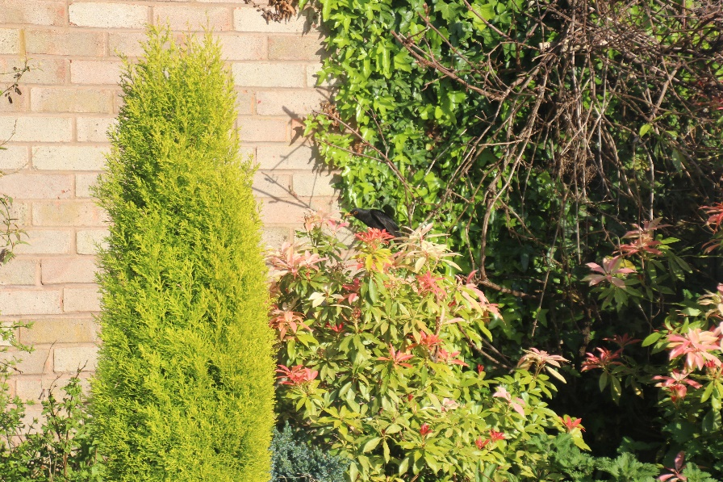

This was where the birds chose to build their nest.

We soon found out that we had a blackbird nest.
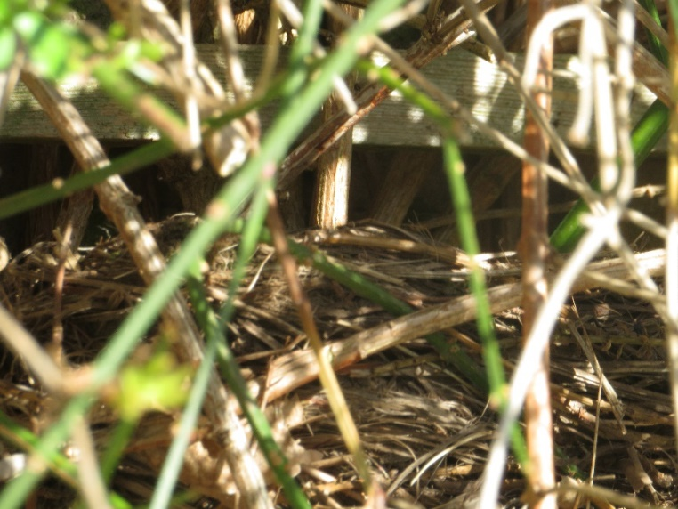
At first I was able to go up to the nest and take a sneaky look in but soon this was not possible.
The male blackbird was not very happy that I wanted to see inside the nest.
Here is a picture of the male blackbird (Dad) bringing some worms for the chicks to eat.

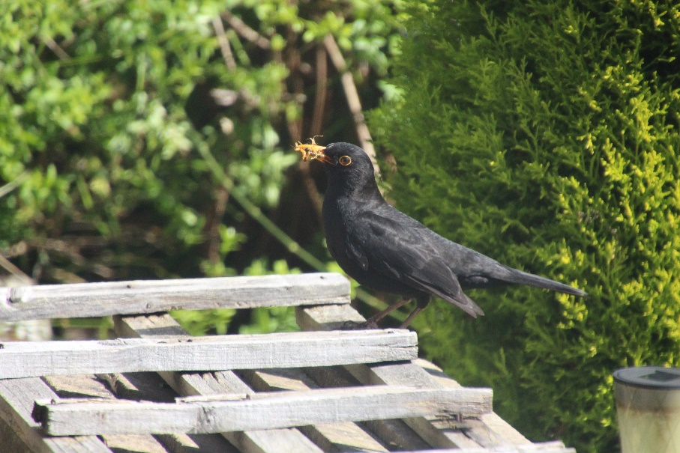
The female blackbird (Mum) was very brave and would come and walk across our lawn when we were sitting there before going to the nest.
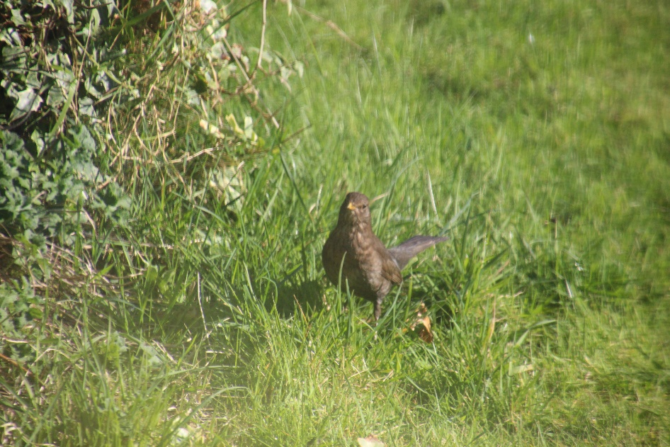
Dad used our neighbours fence to walk along when we were in the garden to avoid us when he needed to get to the nest.
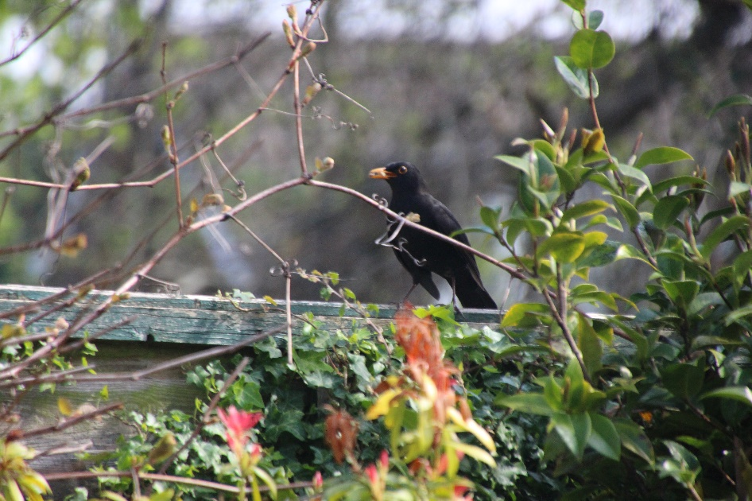

Mum even used our garden furniture as a stop gap before flying into the nest to feed her babies.
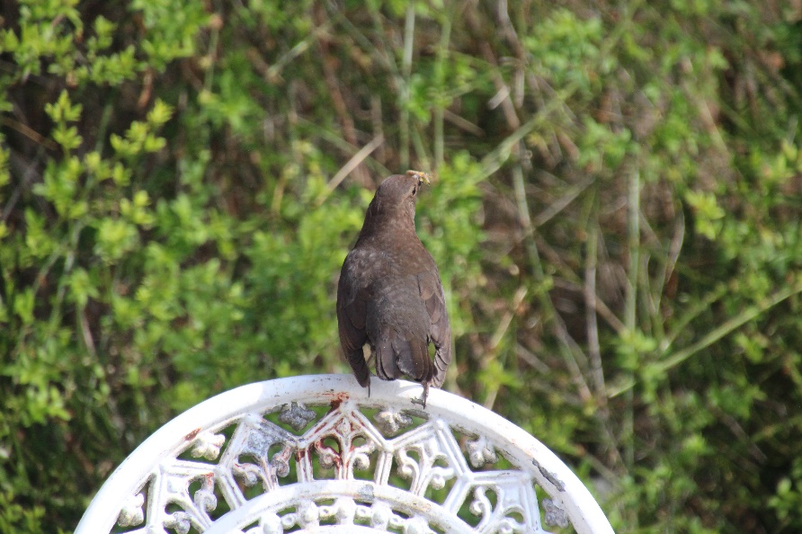
Dad got brave when we went indoors and he thought he was safe.
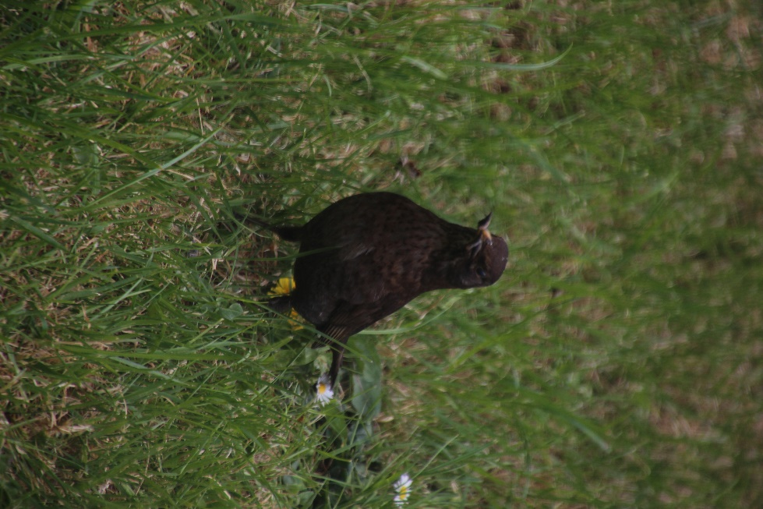
Mum used our garden shed as a viewpoint for her to see where the worms were before she flew down to get them.
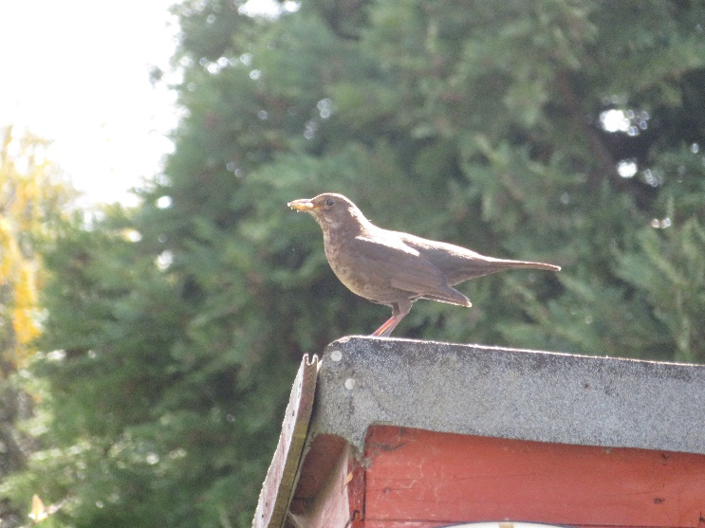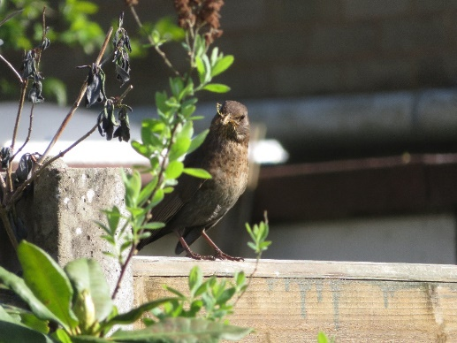
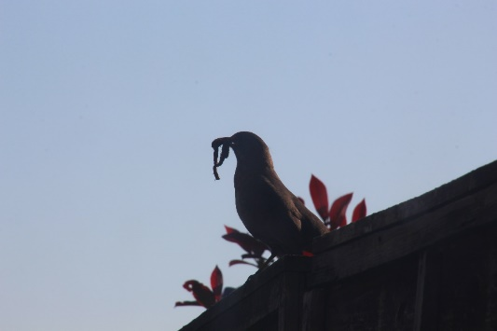
Then she took the food to them whilst Dad watched from our tree to make sure there were no other birds trying to get to their babies.
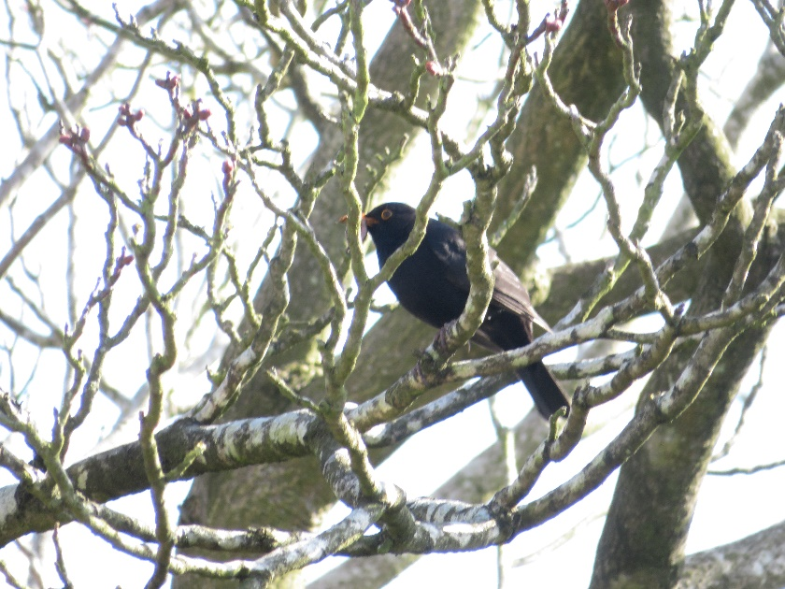

If you look carefully at this photo you should be able to see the babies with their beaks open.
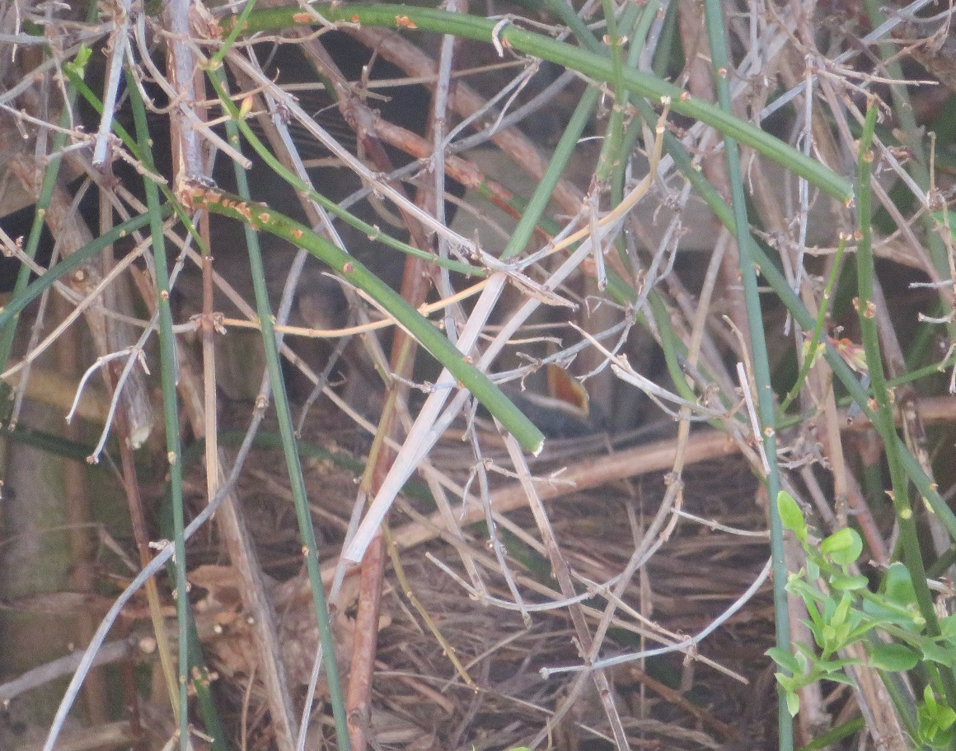
One day we were lucky and managed to get a picture of Dad flying out of the nest.
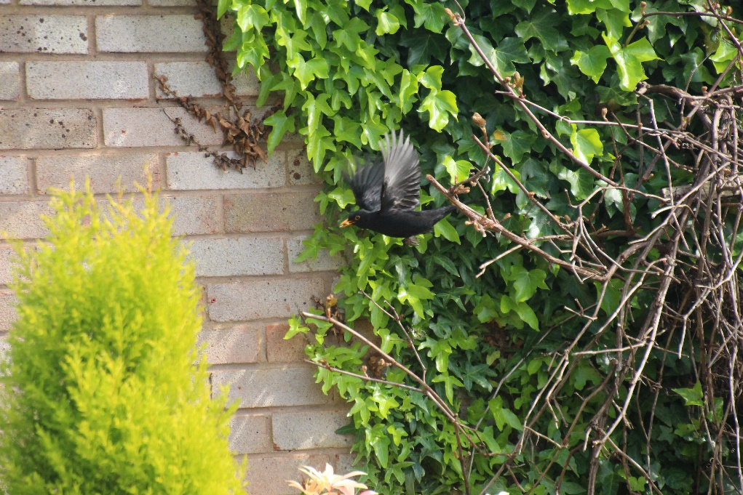
Then after about 10 days we heard them making a lot of noise one night and the next morning they were all gone.

We have seen Mum and Dad once since then so we are hoping they may use the nest again before the Summer.

Some of you have told me that you have birds’ nests in your gardens. Can you please get your parents to send me some photos via email so I can share them on the website?
Thank you

