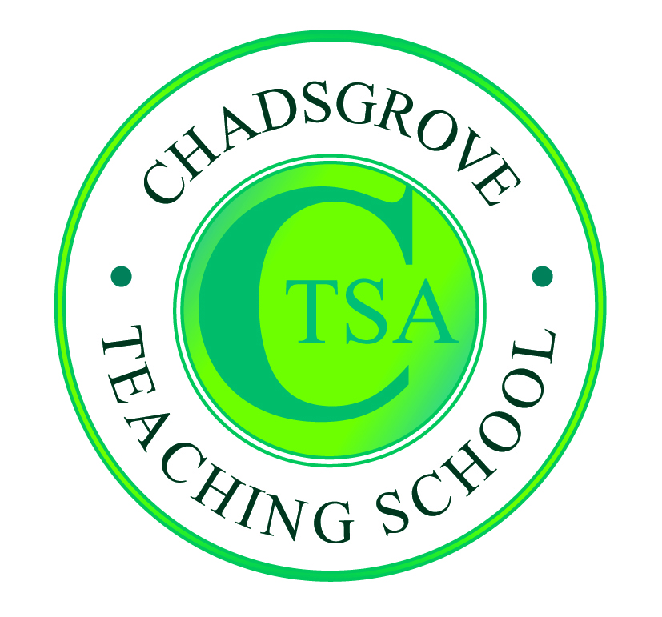

Autumn Courses 2018

Date | Course Leader | Course Title
27th September  10.00 – 4.00 | Lorraine Petersen OBE  & Bev Cockbill  Education Consultants & Trainers | Life After P Levels:  SEND Schools  Mainstream  Assessment for Pupils Working Below  National Expected Standard | £110
4th October  1.30 – 4.00 | Iain Chatwin  SEND Consultant & Trainer | Lego-based Therapy  Mainstream  SEND Schools | £65
11th October  10.00 – 4.00 | Victoria Honeybourne  Education Consultant & Trainer | The Neurodiverse Classroom:  Mainstream  Meeting individual needs in the mainstream  classroom | £110
12th October  1.00 – 4.00 | Mark Loveday  Education Consultant & Trainer | Meeting the Needs of Pupils with Dyslexia  Mainstream  SEND Schools | £65*
18th October  10.00 – 4.00 | Jo Grace  SEND Consultant & Trainer | Sensory Engagement for Mental Well Being  SEND Schools | £110  SEND Schools  Mainstream
8th November  10.00 – 4.00 | Victoria Honeybourne  Education Consultant & Trainer | Supporting Girls on the Autism Spectrum  Mainstream | £110
15th November  1.00 – 4.00 | Iain Chatwin  SEND Consultant & Trainer | Attention Deficit Hyperactivity Disorder  Mainstream  SEND Schools | £65*
22nd November  10.00 – 4.00 | Early Years Speech, Language and Communication Needs Conference  SEND Schools  Mainstream  at Worcester University Arena WR2 5JN |  | £65
23rd November  10.00 – 12.30 | Iain Chatwin  SEND Consultant & Trainer | Lego-based Therapy  SEND Schools  Mainstream | £65
29th November  1.00 – 4.00 | Becky Hadley  SEND Consultant & Trainer | Meeting the Needs of Pupils with Autism  SEND Schools  Mainstream | £65*

* These courses form part of our SpLD course menu. Book all 5 courses for £300.
See separate flyer and booking form for details.

Course details available at: http://www.chadsgroveschool.org.uk/web/cpd_courses
For further information, please contact: courses@chadsgrove.worcs.sch.uk
Chadsgrove Teaching School Alliance
Meadow Road, Catshill, Bromsgrove, Worcestershire. B61 0JL
Tel: 01527 871511 Fax: 01527 579341
Email: tsa@chadsgrove.worcs.sch.uk
Booking Form
Course Title:
Number of Places Required:
Attendee(s) Name & Email Address

The information you provide in this form will be used solely for processing your course booking. If you wish us to retain your email address to contact you about future CTSA professional development opportunities please tick this box
Occupation:
Special Requirements:
(e.g. dietary, access, etc)
Organisation name:
Postal Address for Correspondence:
Invoicing Address (if different to Postal Address):

Email:
Telephone Number:
Total Cost:
(Please make cheques payable to Worcestershire County Council)
Cost Centre for Internal Transfer for Worcestershire Schools. Please complete both sections below.

Project Code: Cost Centre:
Authorised Signature (Headteacher): | Name:
We regret that we cannot accept typed signatures. Digital signatures or scanned electronic copies are suitable.
Please return to:
Chadsgrove Teaching School, Meadow Road, Catshill, Bromsgrove, Worcestershire, B61 0JL

Tel: 01527 871511 Fax: 01527 579341 Email: courses@chadsgrove.worcs.sch.uk
Confirmation of your booking(s) will be made within 14 working days

CANCELLATION of a course booking must be received in writing at least 10 working days prior to the course date, otherwise the following costs will be incurred: 50% of the course fee will be payable for cancellations received between 10 & 6 working days prior to course date, with 100% of the fee being payable for cancellation received later or for non-attendance. We are happy to accept substitute delegates. In the event of unforeseen circumstances, we reserve the right to cancel or alter parts of the programme.

