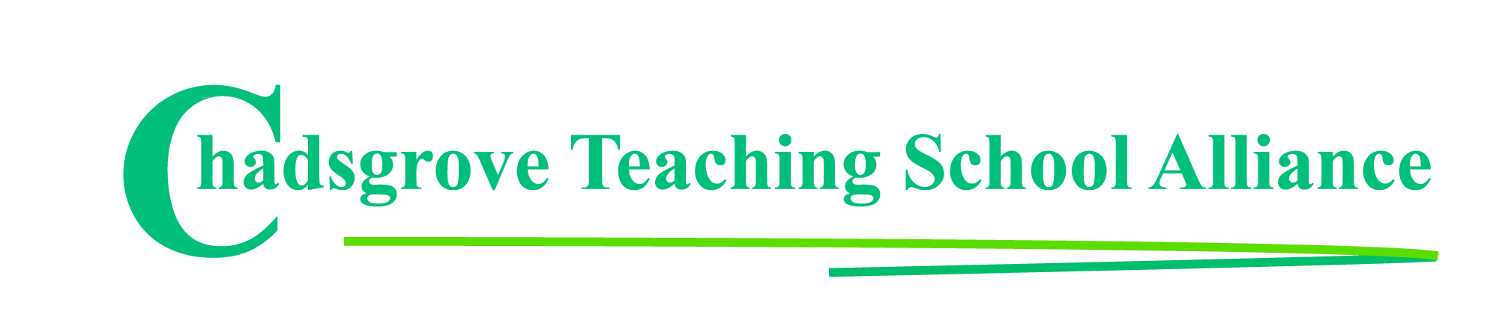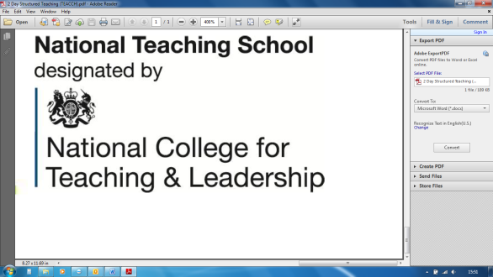

**Mental Health Champion**

**FLSE one day online course provided over 2 half-day sessions**

**Tuesday 29th June 1.30 – 4.30 pm** & **Wednesday 7th July 1.30 – 4.30 pm**

**£80** per delegate

**This one-day course qualifies you as an MHFA Champion, giving you:**

* **An understanding of common mental health issues**
* **Knowledge and confidence to advocate for mental health awareness**
* **Ability to spot signs of mental ill health**
* **Skills to support positive wellbeing**

This course is suitable for primary and secondary schools.

All delegates will receive a manual and a workbook prior to the training, plus a Mental Health Champion certificate once the training has been completed.

**£95 per delegate**

*Please complete and return the booking form overleaf or contact the school*

*This session will be hosted on Zoom. Full instructions for joining will be sent to delegates.*

Email: courses@chadsgrove.worcs.sch.uk

Tel: 01527 871511

Course led by **Lorraine Petersen OBE**

**Online Professional Development**

All Schools



Chadsgrove Teaching School Alliance

|  |  |  |  |  |  |
| --- | --- | --- | --- | --- | --- |
| **FLSE Mental Health Champion Course**  29th June & 7th July 2021 | | Select number of places | | | |
| Attendee(s) Name & Email Address  Click here to enter text. | | | | | |
| The information you provide in this form will be used solely for processing your course booking. If you wish us to retain your email address to contact you about future CTSA professional development opportunities please tick this box | | |  |  |  |
|  |
|  |
| Occupation: Click here to enter text. | | | | | |
| Special Requirements: Click here to enter text.  (e.g. dietary, access, etc) | | | | | |
| Organisation name: Click here to enter text. | | | | | |
| Postal Address for Correspondence: Click here to enter text. | | | | | |
| Invoicing Address (*if different to Postal Address*):  Click here to enter text.  Email: Click here to enter text.  Telephone Number: Click here to enter text. | | | | | |
| Total Cost: Choose cost  *(Please make cheques payable to Worcestershire County Council)* | | | | | |
| Cost Centre for Internal Transfer for **Worcestershire Schools**. Please complete **both** sections below.  Project Code: Click here to enter text. Cost Centre: Click here to enter text. | | | | | |
| Authorised Signature (Headteacher): | Name:  Click here to enter text. | | | | |
| *We regret that we cannot accept typed signatures. Digital signatures or scanned electronic copies are suitable.* | | | | | |

**In the event of unforeseen circumstances we reserve the right to cancel or alter parts of the programme.**

*Please return to:*

Chadsgrove Teaching School, Meadow Road, Catshill, Bromsgrove, Worcestershire, B61 0JL

Tel: 01527 871511 Email: courses@chadsgrove.worcs.sch.uk