

Mainstream & SEN Schools

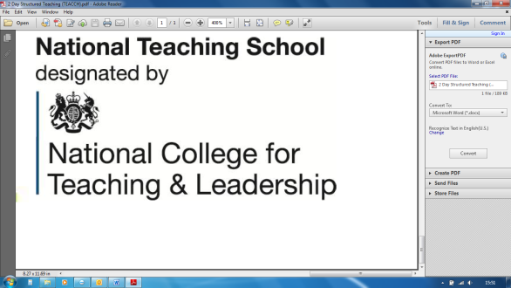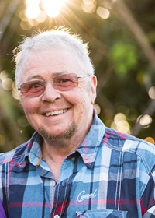

Leading international expert Wenn Lawson will explore a range of multifaceted issues to aid understanding of the neurodiverse needs of individuals, and identifying the means to effective support.

The day will explore the interaction of dual diagnoses and the nature of demand avoidance, focusing on their impact on communication, relationships, education, and behaviour, and how to enable pupils to take an active part in their educational experience.

**Monday 30th March 2020** 10.00a.m. – 4.00p.m.

**£135** including lunch

courses@chadsgrove.worcs.sch.uk

Tel: 01527 871511 (option 1)

*Please complete and return the*

*booking form overleaf or contact:*

**Venue:** Chadsgrove Teaching School, Meadow Road, Catshill, Bromsgrove B61 0JL

**Dr Wenn Lawson**

PhD CPsychol. AFBPsS. MAPs

Dr Wenn Lawson is a

psychologist, lecturer and

author, and himself has

diagnoses of autism and ADHD.

He is currently a Teaching

Fellow with the University of  
 Birmingham online Masters

autism course, and co-chair

of the Australian Autism

Research Council amongst

other roles, and has written

numerous books and papers

about the autism spectrum.

The Autism Spectrum:

Dual Diagnoses and PDA

The autism spectrum encompasses complex neurobiological differences, and nearly three-quarters of children with autism spectrum disorder (ASD) also have an additional diagnosis, whilst others are identified as displaying the characteristics of sub profiles such as Pathological Demand Avoidance (PDA).



Chadsgrove Teaching School Alliance

|  |  |  |  |  |  |
| --- | --- | --- | --- | --- | --- |
| Course Title: **Autism: Dual Diagnoses & PDA** (Course Led by: Dr Wenn Lawson)  30th March 2020 **Number of Places Required** (@ £135 each): | | Choose an item. | | | |
| Attendee(s) Name & Email Address  Click here to enter text. | | | | | |
| The information you provide in this form will be used solely for processing your course booking. If you wish us to retain your email address to contact you about future CTSA professional development opportunities please tick this box | | |  |  |  |
|  |
|  |
| Occupation: Click here to enter text. | | | | | |
| Special Requirements: Click here to enter text.  (e.g. dietary, access, etc) | | | | | |
| Organisation name: Click here to enter text. | | | | | |
| Postal Address for Correspondence: Click here to enter text. | | | | | |
| Invoicing Address (*if different to Postal Address*):  Click here to enter text.  Email: Click here to enter text.  Telephone Number: Click here to enter text. | | | | | |
| Total Cost: Choose cost  *(Please make cheques payable to Worcestershire County Council)* | | | | | |
| Cost Centre for Internal Transfer for **Worcestershire Schools**. Please complete **both** sections below.  Project Code: Click here to enter text. Cost Centre: Click here to enter text. | | | | | |
| Authorised Signature (Headteacher): | Name:  Click here to enter text. | | | | |
| *We regret that we cannot accept typed signatures. Digital signatures or scanned electronic copies are suitable.* | | | | | |

Confirmation of your booking(s) will be made within 14 working days

***CANCELLATION of a course booking must be received in writing at least 10 working days prior to the course date, otherwise the following costs will be incurred: 50% of the course fee will be payable for cancellations received between 10 & 6 working days prior to course date, with 100% of the fee being payable for cancellations received later or for non-attendance. We are happy to accept substitute delegates.***

**In the event of unforeseen circumstances, we reserve the right to cancel or alter parts of the programme.**

*Please return to:*

Chadsgrove Teaching School, Meadow Road, Catshill, Bromsgrove, Worcestershire, B61 0JL

Tel: 01527 871511 (option 1) Email: courses@chadsgrove.worcs.sch.uk

Confirmation of your booking(s) will be made within 14 working days

***CANCELLATION of a course booking must be received in writing at least 10 working days prior to the course date, otherwise the following costs will be incurred: 50% of the course fee will be payable for cancellations received between 10 & 6 working days prior to course date, with 100% of the fee being payable for cancellations received later or for non-attendance. We are happy to accept substitute delegates.***

**In the event of unforeseen circumstances, we reserve the right to cancel or alter parts of the programme.**

*Please return to:*

Chadsgrove Teaching School, Meadow Road, Catshill, Bromsgrove, Worcestershire, B61 0JL

Tel: 01527 871511 (option 1) Email: courses@chadsgrove.worcs.sch.uk