Entry Level Humanities 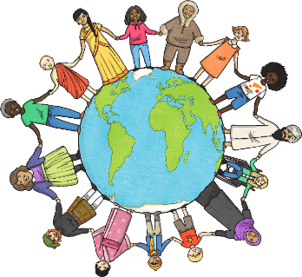

The last part of our Tourism Unit is finding out about sustainable tourism.

We need to find out what the word sustainable means and how it applies to tourism.

We will complete the course work when we get back to school but there are a few things that you could do at home.

I have created an Entry Level Humanities course work email group. Email me when you do any of this or if you need any help. Don’t stress.

1
Have a look at all the Sustainibility Powerpoint
Slide 3 tells you what sustainability means.
Slide 4 is about problems that are sometimes caused by tourists.
Slide 14 Think about how tourism could become more sustainable.

2
Have a look at this BBC clip:
https://www.bbc.co.uk/news/av/uk-19567373/greener-ways-to-enjoy-the-lake-district

3
Look at these websites.
It may help if you read and discuss it with someone if you have an adult who’s free.

https://www.bbc.co.uk/bitesize/guides/zqk7hyc/revision/5 Look at pages 4 and 5 particularly.

https://www.bbc.co.uk/bitesize/guides/zkgxsbk/revision/1 Pages 5, 6, 8 and 9

4 If you want a challenge you could try the BBC tests on the same websites but you need to read each page and it’s hard!

Mrs Evans

