6LS Staff News
Hi 6LS, this week is all about our Jacqui S! She has been so busy we thought it would be lovely to share her news for the whole newsletter!
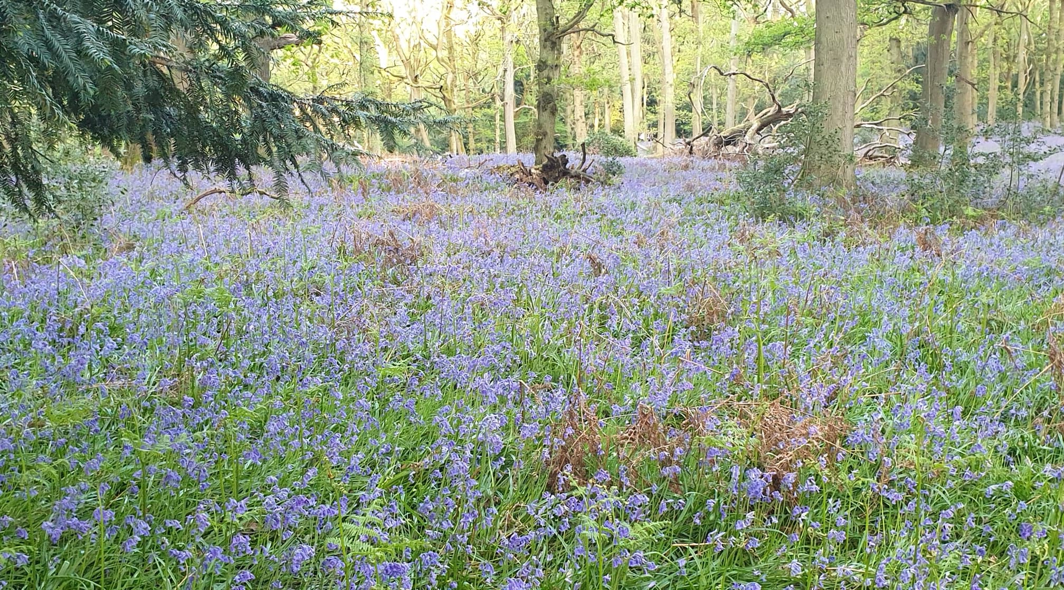
Jacqui and her twins Lily and Luke took their dog Peppa for a walk in the Bluebell Woods for their daily exercise. The colours and smells were amazing! Have you seen any flowers? What colours were they? After stopping for a rest on this fallen tree, they went home feeling tired but happy! This is the tree they sat on!
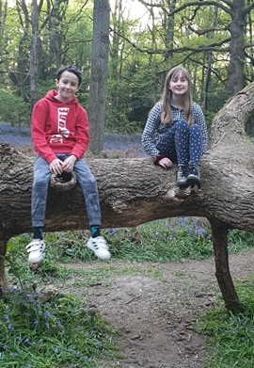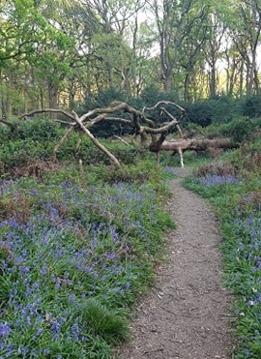
Also this week Jacqui and Lily have been baking, look at this scrummy Chocolate Brownie! They followed a Jamie Oliver recipe. Have you or anyone in your family been baking?
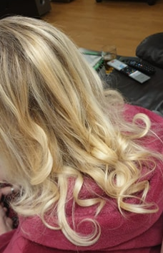
Jacqui was having a bad hair day, so Lily turned hair stylist and curled her mum's hair. What do you think 6LS, should she come to school like it???

Let us know what you have been up to if you can please? We would love to hear or see your news. Missing you, be good and be kind!

