**CHADSGROVE SCHOOL**

**Key Principles of our Vision**

 **Chadsgrove Song… Our School Values**

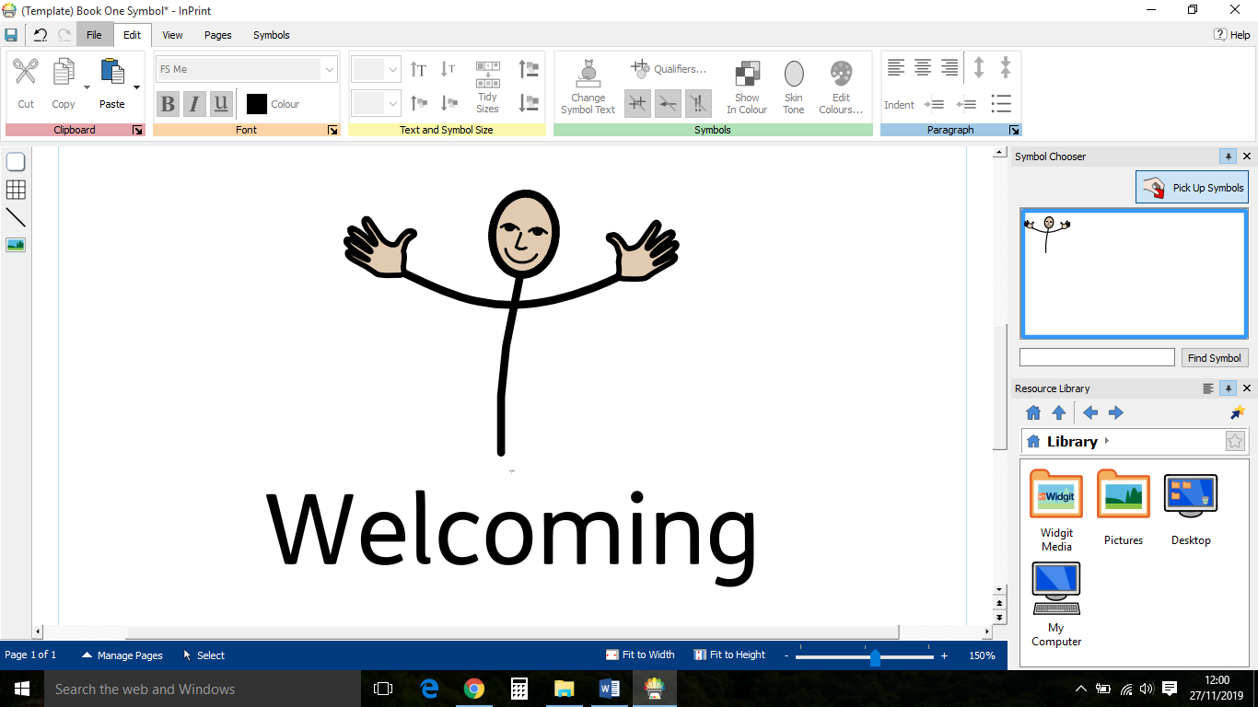

***Chadsgrove’s a community***

***We all achieve success***



***Chadsgrove’s a community***

***We all achieve success***

***Working hard and having fun***

***That’s what we do best!***

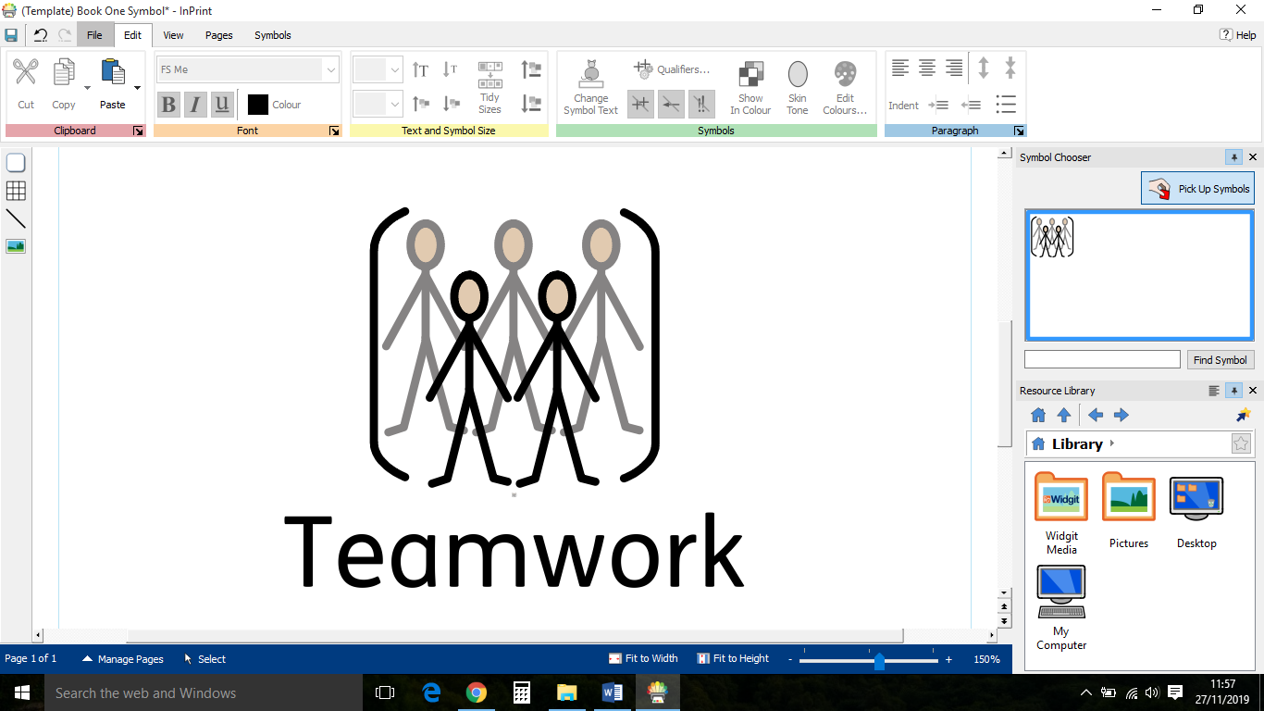

***That’s what we do best!***

***Happy faces, lots of laughter***

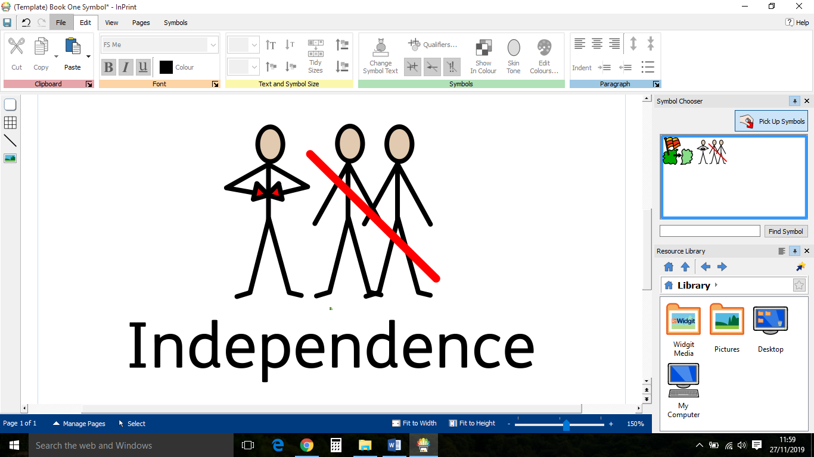

***Talking, signing; communicate***

***Walking, rolling, side by side***

***Our differences, we celebrate***

***Targeting independence***

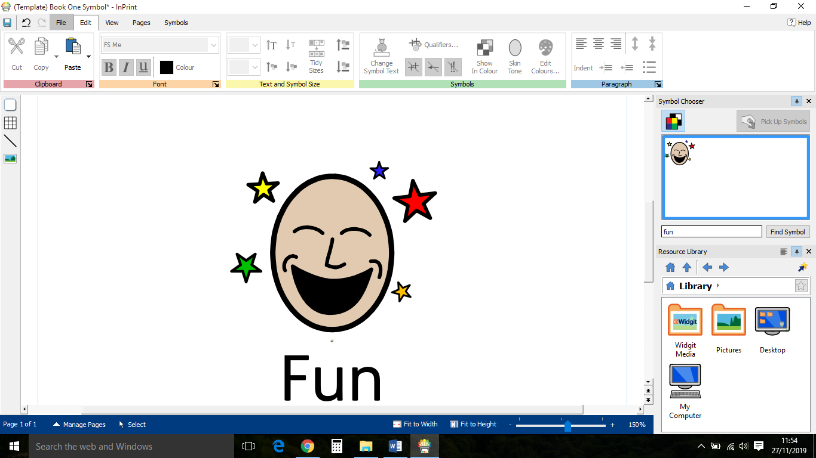

***We can fly. Feeling free***

***Skills for life. Confidence***

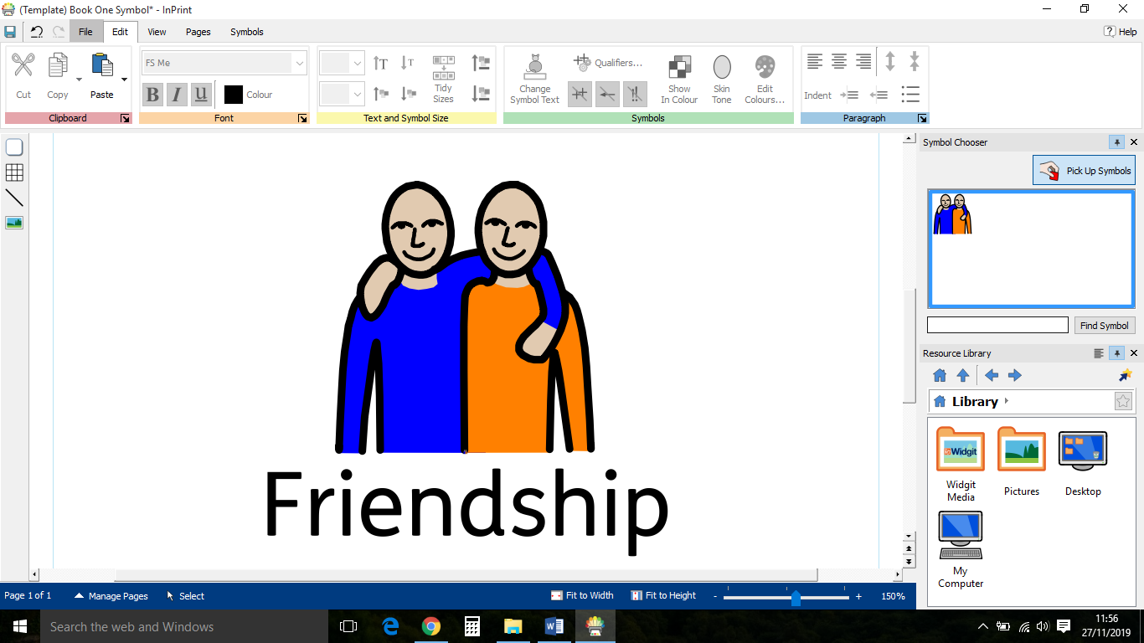

***Be the best that we can be***

Written by:Ibrahim, James, Will, Thomas,

Josh, Jessica, Sophia and Ismeal

***‘Strengthening our Community through Excellence in Education’***

**TABLE OF CONTENTS**

**Please click on the relevant links below:**

|  |  |
| --- | --- |
| School Aims | 3 |
| Review of Progress – Key Priorities for Development 2018 – 2019 | 4 |
| Key Priorities for Development – Two Year Development Plan 2019–2020 Year 1 | 27 |
| Key Priorities for Development – Two Year Development Plan 2020–2021 Year 2 | 34 |
| End of Key Stage Attainment | 39 |
| Review of Whole School Performance Targets 2018-2019 | 45 |
| Whole School Performance Targets 2019-2020 | 46 |

**SCHOOL AIMS**

**Achievement and Standards**

* To offer a broad, balanced and relevant curriculum that meets the needs of all pupils, statutory requirements and allows for flexible approaches to learning
* To maximise an individual’s potential in mobility, physical abilities, communication skills, sensory capabilities and personal independence

**Technology and Innovation**

* To maximise the use of technology within school in order to improve learning outcomes for pupils

**Professional Development and Research**

* To enable all staff to fulfil their roles as effectively as possible by accessing relevant and appropriate training
* To promote the use of research in order to develop staff expertise and maximise learning opportunities for the pupils and young people at Chadsgrove

**Teaching School**

* To provide a range of professional development and support services in education, to ensure the best possible outcomes for children and young people

**Quality of Provision**

* To provide a pleasant and stimulating learning environment which promotes effective learning and enables pupils to experience a sense of enjoyment and achievement

**Specialist Provision**

* To use specialist activities and resources as well as expertise in staffing, as a vehicle for improving pupil achievement, self-esteem and self confidence

**Outreach/School Support Services**

* To provide appropriate levels of support for pupils with physical disabilities, their parents/carers and school staff to achieve successful, inclusive education
* To offer advice, training and equipment, to help maintain access to a full curriculum
* To assist with all aspects of planning and implementing access for pupils with limited mobility, including building modifications
* To provide school to school support on request (in addition to WCC PD Outreach Service) for children with SEN in both mainstream and special school settings

**Families**

* To liaise with and support parents/carers and families as essential partners of the school

**Community**

* To foster the pupil’s social, emotional and moral development, thus enabling him/her to take their place in society as a mature and responsible adult
* To promote the school’s involvement in the community
* To maintain effective co-operation and communication with the school’s trans-disciplinary team

**We will strive to ensure our pupils will:**

* Be safe, healthy and happy - Enjoy learning and achieve success - Be able to contribute to their school and society - Be prepared for a life in the 21st Century



**REVIEW OF PROGRESS – KEY PRIORITIES FOR DEVELOPMENT 20****18 – 20****19**

**CORE FOCUS: NUMERACY AND VUNERABLE PUPILS**



| **Key Areas for Development 2018–2019** | **Outcome** | **Impact** |
| --- | --- | --- |
| **Achievement and Standards** | | |
| * Lesson observations to focus on Maths throughout the school and subject specialisms for those staff that do not teach Maths | * 13 lesson observations focussing on Maths completed - 88% outstanding * PMLD observations 4/4 judged as ‘outstanding’ * Subject Leadership observations 3/3 judged as ‘outstanding’ * 86.5% of pupils met or exceeded the Maths targets set for them in 2018-19 * 91% of pupils with PMLD met or exceeded the targets set for them in 2018-19 | * Pupils are getting an excellent Maths curriculum * All pupils with PMLD are accessing outstanding teaching * Pupils have access to outstanding teaching across the curriculum and progress in these subjects is outstanding |
| * Track and report back on data for children on School Meals and in receipt of Pupil Premium in relation to Maths | * Pupils in receipt of pupil premium performed slightly less well than other pupils in school. However, bearing in mind cohort sizes (1 in some cases), the differences were marginal * Pupils in receipt free school meals performed equally as well as other pupils in school | * Pupils in receipt of free school meals or pupil premium are not negatively impacted by this |
| * Review curriculum for children with PMLD | * MB attended PMLD Curriculum course led by Peter Imray, during which information was shared about new EQUALS Pre-Formal Curriculum which has since been purchased and is being reviewed for our pupils with PMLD | * New teaching staff within the PMLD Department are now familiar with the Barrs Court Curriculum and planning format, as well as how to use both summative and formative assessment in their classes |
| * Present the new Ofsted Framework to Governors | * Updates given in Head teacher reports * Presentations given on 11.4.19 and 4.9.19 | * Governors are informed on the new framework and can articulate the main areas and how as a school we are addressing these |
| Survey past pupils to find out how Chadsgrove prepared them for the next stage of their education/life | Destinations of past pupils have been documented on the ‘WCC Destinations Return’ form and submitted to WCC | All pupils, except one, are currently at their chosen destination |
| * PMLD leader to implement new system for monitoring planning and assessment | * New systems in place – see PMLD Subject Leaders’ File | * The introduction of standardised planning and assessment has led to increased confidence in target setting and better outcomes for pupils, as next steps are now clear and consistent |
| * PMLD leader to implement new system for moderation of work samples between Teachers in PMLD department | * New system in place – see PMLD Subject Leaders’ File | * The system of internal and external moderation means that all teachers are now providing an appropriate amount of evidence to show the progress of all pupils in their classes. They have gained confidence in using the SOLAR tool to record evidence |
| * To develop PSHE resources across school | * New resources in PSHE cupboard outside 13US * Catalogue of PMH resources on ‘Shared Drive’ and resources kept in the PMH/Common Room * Equals PSHE schemes of work purchased and saved on ‘Shared Drive’ * Free unit ‘My Physical Wellbeing’ from the new Equals curriculum on ‘Shared Drive’ * School is now a member of ‘Equals’ * Positive Mental Health resources have been purchased and are stored in Chill Out Room | * Staff have easy access to more resources to support delivery of PSHE and PMH. Teachers have structured guidance for topics and lesson ideas through the use of a planned scheme of work provided through the purchase of Equals. Membership to Equals has provided staff discount on further resources and professional guidance when needed to support staff. A central base in the common room for all PMH resources allows access to both pupils and staff when required |
| * Purchase and promote whole school use of Twinkl to help raise standards, improve engagement in the classroom and enrich homework opportunities for pupils | * Extra logins purchased and shared with teachers | * Teachers have access to a wide variety of high quality resources to support with lesson planning and save valuable time |
| * Subject leaders to review accredited courses being offered in Upper School. Ensure all Centre approvals and course requirements are in place for 2018-19 | * New courses have been reviewed * A review of P.E courses has place * ASDAN Personal Progress verified June 2019 Many courses are being updated from Sept 2020, including Entry Level, Functional Skills * Access arrangements for 2 students successfully completed * OCR Life and Living now included in curriculum plans * Approval now in place to do academic courses (GCSEs) with Edexcel * Accreditation taken place for Entry Level Functional skill for ICT, English and Maths * ASDAN and Functional skills verified in July 2019 * 13US to start OCR Life & Living Skills Entry Level 2 September 2019 * Pupils achieving Entry Level P.E Level 3 and played sport to a good level and are now ready to start the OCR Cambridge National Sports Studies short course from September 2019. The member of staff delivering the course has received training from OCR. Impact is four pupils will start this course * New Edexcel Maths Entry Level started | * We are operating within correct guidelines for offering accredited courses * We have a wide range of courses that are well matched to pupils |
| * Update LTP for ICT/Computing Involve new Teachers of ICT/Computing starting in September 2018 | * LTP updated with reference to new technologies and in line with new Ofsted framework | * Pupils are able to access an ICT/Computing curriculum that appropriately meets their needs |
| * Establish central resource for DT tools, information, materials | * Central resource now in place * Equipment/resources stored in portable trolley | * Portable trolley is being utilised by ‘Options’ DT group |
| * Commence implementation of the ‘Careers and Enterprise Strategy’ | * Careers and Enterprise Strategy completed and on the school website and presented to Governors on 11.4.19 * Holly Styles from Thursfields Solicitors has been nominated as our Enterprise Advisor * 8 children have attended work experience 2018-2019 * One pupil has a paid job through the summer holidays at Bumble Hole Foods | * All staff and parents can now see the Careers and Enterprise Strategy on the school website and have a better understanding of what this entails * Holly Styles attends on a weekly basis and has completed video CV’s with a group of 6 KS4 pupils * Pupils have gained valuable employability skills and experience whilst attending work experience placements * One pupil has changed her whole perception of herself as ‘employable’ through her summer work placement |
| * Purchase further resources required for the delivery of the RSE curriculum as identified in the audit last year | * New resources in PSHE cupboard outside 13US * Catalogue of PMH resources on ‘Shared Drive’ and resources kept in the PMH/Common Room * Equals PSHE schemes of work purchased and saved on ‘Shared Drive’ * Books Beyond Words’ (BBW) books purchased in CET and being used in school for RSE delivery * Positive Mental Health resources have been purchased and are stored in Chill Out Room | * A variety of resources enables more interesting and motivational lessons. A catalogue of resources on the staff shared drive makes searching for resources easier for staff and accessible from anywhere, though the remote access to school drives. Books Beyond Words has opened up student discussions around difficult topics within RSE. A central base for PMH resources allows access for both staff and students. |
| * Submit Artsmark Platinum Statement of Commitment | * Completed and approved by Arts Council | * The strength of our application demonstrates that we are offering a wide and varied programme of arts related activities and events |
| • Initiate Duke of Edinburgh A Award | * The expedition took place at 2 locations * 22 students are nearing completion of the Bronze Duke of Edinburgh Award | * Character building opportunity for all pupils |
| * Audit Maths resources | * Maths resource audited and new ones purchased through extra Maths focus money | * Pupils have access to an exciting range of Maths resources to support learning |
| * Investigate training to implement Maths Hub- Mastery | * The training was focussed primarily for pupils in mainstream settings | * N/A |
| * Introduce GCSE P.E. practical for more-able pupils | * A review of P.E. courses took place * 4 pupils achieved Entry Level P.E. Level 3 * Member of staff delivering the course has received training from OCR | * Pupils are playing sport to a good level and are in line to start the OCR Cambridge National Sports Studies short course from September 2019 * Staff are equipped with the necessary training to deliver the curriculum |
| * Purchase equipment for PE as curriculum priority Spring Term 2019 | * New PE mats and small games equipment purchased | * Safe and improved equipment being used in PE lessons |
| * Introduce country dancing for pupils with PMLD and SLD | * Country Dancing resources and a Maypole have been purchased * Four classes and the dance club for pupils with PMLD took part in the Maypole project | * 80 children benefited from the programme, improving concentration, coordination, agility and teamwork |
| * Host an RE curriculum day | * RE Curriculum day took place 23rd May (see evidence file) | All pupils have had the opportunity to know about and understand a range of religions and worldviews, and, where appropriate, gain and deploy the skills needed to engage seriously with religions and worldviews. This is one of the primary aims of the Worcestershire Agreed Syllabus for Religious Education. |
| * Review focus/criteria for learning walks | * New templates developed * Programme of walks in place for the year 2019-2020 | * New template developed in line with new OFSTED framework |
| * Develop an Action Plan for Curriculum developments (over the next two years) – identifying a priority list of which subjects and Key Stages need curriculum updates | * Assistant Head teacher for Curriculum attended SWALSS course on ‘Curriculum Development’ (June 2019) * ‘Action Plan’ and ‘SEF’ in process of completion by Assistant Head teacher * SLT (in consultation with staff) have decided to develop our curriculum through 3 pathways: Pre-formal, Semi-formal and Formal. The ‘curriculum’ will be the whole school focus for 2019-20 and additional ‘staff meeting’ time will be allocated to allow groups of staff to plan developmentally across the pathways * Teacher’s MTPs have been updated (Summer Term 2019) to reflect new Ofsted framework terminology (‘Intent’, ‘Implementation’ and ‘Impact’) * P.E Curriculum has been updated and rewritten to include personal outcomes: social, emotional and thinking skills | * + Staff understanding of the new Ofsted framework terminology has improved and this will inform their reviewing of their subjects policies and LTPs, and the further curriculum development work that is planned for 2019/20   + Teacher’s planning (MTPs) now reflects ‘Intent’ and ‘Implementation’   + Impact demonstrated beyond physical abilities |
| * SLT to implement new system for moderation of work samples between Teachers for different Key stages and ability levels | * EYFS internal moderation for PHSE took place 21.03.19, external moderation of EYFS PHSE 04.04.19 * PMLD moderation meetings between teachers takes place each term, Assistant Head teacher of Lower School attended 12.03.19 * External moderation for Entry Level and ASDAN courses took place June 2019 * Internal moderation of Functional Skills English work took place in July 2019, prior to external moderation * Upper School staff have trialled using SOLAR targets to moderate work done with 9/11US English group - July 2019 | * Teacher assessments accurately reflect the progress/attainment of pupils |
| * Trial Edexcel Functional skills in ICT | * Successfully delivered | * 10 pupils from 12US and 15US have been accredited at Entry Level 1 and Entry Level 2 |
| * Update LTP for DT based on last year’s audit and introduction of central resources | * A central resources base is in operation * LTP will be updated referencing audit in 2019-2020 | * Resources are accessible. New DT Lead in post will review usage in Spring 2020 |
| * Examine further how SOLAR is being used to set targets | * + SOLAR has been used to set targets for pupils in reading | * + 86% of pupils met the targets that were set for them in the core subject areas |
| * Complete an audit of provision for LAC pupils | * This is addressed termly through PEPs | * LAC pupils are accessing the resources/support required |
| * Governors to meet with subject leaders that are linked to their area of responsibility to share planning and update on subject | * Maths leader presented to Governors on 1.7.19 * English Lead (GB) and Governor (JB) met on 8.10.19 | * Governors now have a clearer understanding of how Maths is taught to pupils in different pathways and the resources and Schemes of Work used * Julia Boonnak (Governor lead for Literacy) now has a clearer understanding of how both Phonics and English are taught across the different pathways in school and recent and future developments were also discussed |
| * Develop moderation systems based on SOLAR assessments | * SOLAR targets used to moderate work with 9/11US English group - July 2019 | * Systems are working well and moderation is effective and meaningful |
| * Review progress of children in Maths specifically | * Progress reviewed on SOLAR throughout year | * 89% of pupils in early years met or exceeded the targets that were set for them * 86.5% of pupils in key stages 1-3 met or exceeded the targets set for them in maths * All pupils entered for accreditation in maths achieved expectations |
| * Review existing curriculum for pupils with PMLD and update policy in line with this | * New curriculum purchased * New Long Term Plan has been written * Policy is in the process of being updated | * + Pupils have access to high quality learning, with teachers having access to the most innovative and relevant teaching ideas available to meet their needs |
| * Host an RSE Curriculum day | * RSE Curriculum day was planned for 15.7.19 - this became WCC transition day. Lead for RSE informed all staff that the national RSE day was 27.6.19 | * Increased awareness of RSE for pupils. A focus day planned by class staff allowed required RSE issues to be covered, prioritising what staff felt was needed most for their class |
| * Review Science curriculum and resources as a curriculum priority this term | * Science meetings have been held with all Teachers of Science each term with a focus on reviewing the curriculum, planning and resources | * All resources have been organised and an inventory has been made making resources accessible and available when needed * Links established with South Bromsgrove High School to support with provision of chemicals for Entry Level Science resulting in pupils having specific resources that they need for lessons * Upper School curriculum is continually being reviewed to ensure that pupils in KS3 are prepared for beginning work on Entry Level in KS4 |
| * To develop an LGBT support group | * Students who were previously identified as needing an LGBT group left last year * LGBT has been covered in RSE lessons with 15US over the summer term | * Increasing awareness for pupils |
| * To implement revised PSHE LTP to include new schemes of work for PSHE | * This is ongoing due to the new statutory guidelines published for the inclusion of RSE to the PSHE curriculum from September 2020 | * The new LTP will ensure classes are covering a broad and balanced curriculum in PSHE and all the statutory RSE topics should be addressed over the various key stage cycles in the plan |
| * To research, combine and collate PSHE polices into one policy | * All PSHE related policies taken from the ‘Shared Drive’ | * One policy is in place. Clear guidance provided through the use of a policy |
| * To ensure that any curriculum updates from this academic year are also updated on the school website curriculum information | * LTPs have been updated for several subjects/pathways * The Curriculum Overview, Pathway Synopsis’, and Class Curriculum Statements are complete | * Documents are on the website providing full curriculum information on Chadsgrove |
| • Update LTP for ICT to include new technologies used during the year | * LTP updated with reference to new technologies and in line with new Ofsted Framework | * Pupils are able to access an ICT/Computing curriculum that appropriately meets their needs |
| * Some pupils to undertake Edexcel Functional skills ICT | * Successfully delivered * 10 pupils from 12US and 15US have been accredited at Entry Level 1 and Entry Level 2 | * Pupil performance in ICT is enhanced |
| * Review and update Long Term Plans for Key Stage 2,3 and 4 | * PMLD and RE LTPs have been updated * Work has started on English for KS1 and KS2 * P.E Curriculum has been updated and rewritten to include personal outcomes: social, emotional and thinking skills | * The focus is on the whole child not just their physical abilities |
| * Incorporate OCR Life and Living Skills Entry level 2 into 13US curriculum for 2019/20 | * Costings and paperwork submitted for approval * Approved paperwork to be submitted to OCR * OCR Entry level 2 units printed and in folder ready to be used September 2019 in 13US curriculum * Predicted outcomes set and recorded on a spreadsheet * Initial discussions with 13US new teacher (HK) started and folder handed over | * We are well prepared to deliver this course |
| * Train staff in the use of End of Key Stage reporting procedures using the new assessment frameworks | * This was not needed – pre-key stage standards were self-explanatory and assessments were easily completed via Scholarpack | * End of key stage assessments were correct and submitted on time |
| * • Complete and publish the Data Dashboard on the school website | * Completed and on the website | * The Data Dashboard is available for the wider community |
| **Technology and Innovation** | | |
| * Simplify logins for RM Easimaths to match format for Lexia and Education city and provide families with information to use software at home | * Completed and details sent home | * Pupils are finding it easier to log in and access materials off-site |
| * Investigate the increased use of wireless switches and environmental control in school, including SmartNav | * Research completed | * 3 SmartNavs now in school. This has significantly increased pupil engagement in lessons |
| * Train staff in the use of their iPads in order to control the Multi-Sensory Room | * Some class teachers have implemented using the iPads within the MSR | * Staff are becoming increasingly skilled in technology |
| * Review management of Reception TV Screen – to be updated on a regular basis so to celebrate pupil achievements | * TV screen is now in full use | * This provides an update to visitors on the work of the school |
| * School council to discuss the purchase of GoPro (used in media option), 3D printer (used in DT/Art) identified this year to enrich the delivery of ICT | * GoPro and 3D printer purchased | * Pupils have an increased access to developing technologies, allowing them to be more creative in their work |
| * Purchase 2 dedicated voice dictation laptops with head microphones and installed software to enable specific pupils to write by talking | * Laptops successfully configured to use voice dictation using head microphones | * This has increased pupil independence in lessons |
| * Purchase new Virtual Reality hardware/software | * Hardware has been purchased | * Pupils are motivated to use the technology. Engagement levels are high and expressive language used to describe/narrate experiences is excellent |
| * Review how ICT is being used across school to enable pupils to communicate and purchase resources as necessary - move to spring? | * The review is not yet fully completed – this will continue in 2019-2020 | * N/A |
| * Review all online software resources to ensure that they effectively meet the needs of all pupils and are providing good value for money | * PurpleMash, Busy Things, Lexia and EducationCity have been review by staff, for effectiveness and usage, during the year before committing to purchasing again | * All software currently purchased effectively meets the needs of pupils and is being used by staff |
| * Review the ICT infrastructure and plan for any upgrades if necessary | * Meetings held with CIS – the major requirement identified was off-site cloud backup and this has been purchased | * The safety/security of data in the event of a serious incident in school e.g. fire/theft has been significantly improved |
| * Review technical support services in school to ensure they are still providing good value for money | * This has been reviewed and remains excellent value for money | * The ICT infrastructure is well maintained and organised. Defects/failures are addressed quickly and efficiently |
| * Trial using ‘Virtual Reality’ in lessons | * Trialled by 8LS and 12US in June/July 2019. The potential for this technology appears great | * Pupils are motivated to use the technology. Engagement levels are high and expressive language used to describe/narrate experiences is excellent |
| * Review the ICT infrastructure to ensure that it continues to meet needs | * Meetings held with CIS – the major requirement identified was off-site cloud backup and this has been purchased | * The safety/security of data in the event of a serious incident in school e.g. fire/theft has been significantly improved. |
| * Support pupils to setup/use GoPro and 3D printer in lessons, clubs and options groups | * Instructions for GoPro written | * GoPro being made use of occasionally - Used on the Isle of Man trip |
| * Support selected pupils to communicate independently using voice dictation | * Support provided where required | * One pupil in 12US can now use voice dictation to help do accredited courses and can now independently use a computer using just his chin with SmartNav |
| * Review the vision of the school in the light of the changing curriculum and developments in technology | * The vision has been revised in line with staff feedback | * School vision was shared with all staff in September 2019 |
| * To investigate software for an ‘Asset Management’ system | * This has been investigated and CPOMS asset management has been identified as the most appropriate system to use as it comes alongside the CPOMS staff software already purchased. Using it has been trialled but is not yet functional | * The asset management system should help to make the management of this area more efficient |
| * Establish shared electronic diaries | * A Chadsgrove Calendar has been developed but shared personal diaries have not yet been successfully implemented | * All staff have access to information/events happening throughout the year to aid planning |
| * Complete a technology audit to inform future planning | * The iPad, desktop and laptop audits are complete | * It is now possible to quickly determine which pieces of equipment are due to be upgraded next |
| * Update Communicate In Print and Clicker resources (pending available funding) | * This has been upgraded and can be accessed via the remote logon as well as individual machines. The software is very intuitive/easy to use | * High quality resources can be prepared quickly and easily saving teachers’ time and enabling them to deliver appropriately personalised lessons. |
| * Purchase any significant IT infrastructure upgrades (pending available funding) | * The major requirement identified was off-site cloud backup and this has been purchased | * The safety/security of data in the event of a serious incident in school e.g. fire/theft has been significantly improved. |
| * Further review how best to use ‘Virtual Reality’ in the classroom | * After trailing with two classes and looking at the resources available with the package, it will now be possible to deliver training to staff on its use | * Pupils are motivated to use this technology and further use will increase the quality and delivery of lessons. |
| * Investigate moving from paper to digital based system for ‘Off-Site Visit’ documentation | * System investigated, but B & S Education (EVC Advisors) advised that ‘Off-site Visit’ documentation should remain on paper * VE, GB, and EAM all attended EVC Training and VE has updated the ‘Off-Site Visit’ documentation as advised | * Documentation is up to date and correct |
| * Complete re-accreditation for the ICT Mark | * This will be deferred to 2019-2020 | * N/A |
| * Use the learning platform to provide parents and carers with the opportunity to communicate outside of school | * The learning platform isn’t yet being used but the website / ScholarPack email is being used effectively | * Parents are more informed and included in their child’s education |
| * Complete the e-safety accreditation framework | * Deferred to 2019-2020 | * N/A |
| * Develop a database to store teaching resources for all to access | * The staff share is more organised and resources are easier to find | * Resources can be quickly accessed, saving teachers time |
| **Professional Development and Research** | | |
| * Teachers to have the opportunity of being observed by a specialist in their subject/area of expertise and specifically in Maths | * 11 teachers observed teaching Maths by Maths leader and Head teacher | * Maths teaching is strong across the school |
| * Offer training in the use of vulnerability indicators | * Explained to SLT and to staff via a staff meeting | * Staff have a greater understanding of what makes particular children in school vulnerable. |
| * INSET day followed by one Twilight to focus on ‘Attachment’ | * INSET completed – 5.9.18 * Twilights completed - 29.11.18 | * Staff have a greater understanding of the reasons behind the behaviour of children experiencing attachment difficulties. |
| * Maths lead to observe Maths being taught in other outstanding Special Schools | * Development area not yet completed - This will be deferred to 2019-2020 | * N/A |
| * Governors to consider additional INSET days for our school due to the increased level of training needed to meet medical needs | * This was investigated but is not permissible | * N/A |
| * Head teacher to complete NPQEL programme | * Qualification completed and awarded July 2019 | * This qualification will support the development of the school in general and the Support Services, Teaching School and 19-25 provision |
| * Refresh training for staff who feed children with complex feeding needs | * An audit is underway and some training has been delivered on a 1:1 basis | * Staff are increasingly competent feeding children who require a specific and detailed approach |
| * 2 Twilights to focus on ‘Attachment’ | * Training completed – 24.1.19 and 28.3.19 | * Staff have a greater understanding of the reasons behind the behaviour of children experiencing attachment difficulties |
| * teacher to train as ‘Mental Health First Aider’ | * JL completed a 2 day training course on 15th and 16th November 2018 and is now an accredited MHFA | * Staff training supports the positive mental health of staff and pupils in school |
| * Facilitate CPD opportunities for Maths for all staff | Resources have been shared and demonstrated | * Staff know what resources are available |
| * New PMLD lead to attend intensive interaction training (pending funding) | * Lead is attending three day course – April, July and September 2019 | * + PMLD Lead will be able to offer training and support for staff in the principles of Intensive Interaction to ensure best possible outcomes for pupils with complex communication needs. |
| * Provide support/training to use new resources purchased in Autumn – GoPro, 3D printer, Virtual Reality resources | * Some staff/pupils have been supported to use the new resources – more support still required | * Pupils are able to access the technologies as part of their lessons, improving the quality of the provision that they are offered. |
| * To become an ‘Attachment Aware’ school | * Completed July 2019 | * Staff have a greater understanding of the reasons behind the behaviour of children experiencing attachment difficulties. |
| * Identified staff to attend TaSSeLs training | * TaSSeLs initial training session has been delivered booked for 25.6.19 | * PMLD Leader will be able to offer training and support for staff using TaSSeLs, to ensure the best possible outcomes for pupils with complex communication needs and VI |
| * Plan with relevant Teachers to incorporate new resources into the curriculum – GoPro, 3D printer, Virtual Reality | * Resources now purchased – impact will be demonstrable next year | * N/A |
| * Facilitate CPD opportunities for teaching pupils with Severe Learning Difficulties | * Teachers have attended ‘New Entrants to SEN’ course * Teachers have attended courses that were linked to their Performance Management | * Teachers are skilled and equipped to teach as effectively as possible |
| * Unqualified Teacher to complete ‘equivalency tests’ in preparation for Teacher training September 2020 | * Not met - Angela Sturgess will be enrolling on a Maths, English and Science course in September 2019 | * N/A |
| **Teaching School** | | |
| * Review Teaching School staffing in view of increased activity | * Additional administration support in place. Additional specialist teachers in place for School Support Service. Increase in School Direct mentor team from 2 to 4 to cover increased trainee numbers for 2019-20 | * We are more effective in undertaking administrative tasks * Growth of school support services does not place additional burden on school resources * Work load for Lead Mentors is alleviated to manage larger trainee cohorts |
| * Provide at least 12 School Direct places on SEND route for 2018-19 | * 12 places identified across partner schools. 11 applicants successful at interview and accepted and undertook training 2018-19 | * New teachers beginning NQT year with enhanced SEND knowledge and skills |
| * Implement impact review of training for sample of delegates one term after completing course | * Trial completed for wider implementation 2019-20 | * We have better understanding of the impact of training on future practice |
| * Commence monthly input of Key Performance Indicators on Teaching Schools Data Hub | * DfE cancelled plan to open Data Hub across year for data entry, so this has not been possible. Data collection for 2018-19 has been delayed until autumn 2019 by DfE | * Data reporting on Teaching School activity will be delayed until DfE timescales are announced |
| * Chadsgrove to lead NPQH, NPQML and NPQSL programmes for the year | * Programmes successfully delivered in association with WGLA | * Developing leaders have been supported to gain relevant qualifications through applying knowledge and skills in practice. Chadsgrove reputation for CPLD enhanced |
| * Extend number of schools supported in Worcestershire to 30% | * The number of schools using our school-to-school support service is now over 40% of Worcestershire schools. | * Stability for future service planning is enhanced, and Chadsgrove reputation for quality support services disseminated more widely amongst Worcestershire schools |
| * Explore feasibility of providing teaching apprenticeships across alliance schools | * Option discussed but not pursued due to lack of interest from schools | * School Direct salaried route remains the preferred option for schools employing trainees, but apprenticeship option remains |
| * Expansion of Steering Group membership to include representation from a broader range of stakeholders | * Postponed for future review | * No change to current Steering Group composition |
| * CPLD programme to incorporate venues away from Chadsgrove to increase reach | * Pilot course successfully delivered in Keynsham, though delegate numbers (12) below forecast (18) | * Potential identified for expansion of CPLD offer across wider geographical area |
| * Review School Direct programme | * Evaluation conducted with current trainees and discussions held with university, leading to amendments in programme for 2019-20 | * 2019-20 School Direct programme has stronger links between theory/training input and contemporaneous trainee practice |
| * Review SENCO Network offer | * Review resulting in a minor change to membership fee for schools in a MAT. New venue for meetings explored due to school venues not being able to accommodate numbers | * MATs signing-up all trust schools * Growing membership better accommodated for meetings |
| **Quality of Provision** | | |
| * Update money resources in line with changes to currency | * Money resources continually updated, including a larger stock of real money to use in Maths/life skills lessons | * Resources are up to date and relevant |
| * Install new coat pegs and base storage units for all areas where needed | * Funding for this is in the budget for 2019-2020 | * N/A |
| * Update guided reading resources and Literacy resources in line with any changes in the curriculum | * Existing sets of ORT books have been put together to form guided reading sets * New ORT ‘Songbirds Phonics’ sets of books have been purchased to support ‘Guided Reading’. These range from ORT Levels 1+ to Level 6. Each Level contains 6 different texts (6 copies of each text) - 36 texts to work through | * Teachers in Lower School have been using the new ORT ‘Songbirds Phonics’ texts to lead ‘guided reading’ sessions with their groups * We will see the impact in pupil progress data for ‘reading’ in the future as pupils learn, practice and consolidate their phonic knowledge |
| * Refurbish main school office | * Completed August 2018 | * Data is now kept confidentially in locked cupboards * The office is working more efficiently |
| * Complete feasibility study for the re-design of the wheelchair bay, front entrance and reception area | * Due to the delay in the outcome of the nursery funding bid this work was deferred | * This will be demonstrable in 2020-2021 |
| * Consider plans for the re-location of the nursery depending on 19-25 plans | * 19-25 provision to remain in the Chestnut Centre for at least another academic year | * Nursery bid successful to remain in current setting |
| * Review shade areas in school after the work completed last year | * New wooden shaded areas have been developed | * Pupils have safe places to sit outside in the hot weather |
| * Plan new School Library | * School Library was refurbished with the support of charitable donations - February 2019. New shelving, furniture and books have been purchased | * + A wide range of books are available and are accessible. The space is warm and welcoming for all readers   + This has already contributed to a positive ‘buzz’ around ‘reading’, and both pupils and staff are using the Library space more frequently to ‘read for pleasure’. We will be further promoting the use of the new Library in 2019/20 |
| * Investigate costings for air conditioning in the main hall and classrooms that get exceptionally hot in the summer | * This is dependent upon funding for 2019-2020 | * N/A |
| * Move 19-25 provision off site if funding becomes available | * 19-25 provision to remain in the Chestnut Centre for at least another academic year | * Less disruption to the staff and pupils |
| * To update equipment and provision in Forest School | * Resources purchased to support lessons in Forest school | * Forest School provides exciting opportunities for our pupils |
| * Refurbishment of School Library | * Completed 2.2.19 | * + A wide range of books are available and are accessible. The space is warm and welcoming for all readers   + This has already contributed to a positive ‘buzz’ around ‘reading’, and both pupils and staff are using the Library space more frequently to ‘read for pleasure’. We will be further promoting the use of the new Library in 2019/20 |
| * Investigate ‘Parent Pay’ for all payments including school dinners, trips, clubs) | * System has been set up and will open from November 2019 | * N/A |
| * Consider purchasing new school bell/PA system for use throughout school | * Deferred to 2019-2020 | * N/A |
| * To extend MOVE programme across the county | * The need for this has not been demonstrated | * N/A |
| * Rebound room to be refurbished with new lighting, sound system etc. | * This has not been achieved due to funding | * N/A |
| * Swimming pool lighting to be updated | * New lightening has been purchased and installed | * The swimming pool is a vibrant place for sensory swimming to take place |
| **Safeguarding** | | |
| * For Deputy Head teacher to become a DSL Champion | * Completed | * Our school’s safeguarding systems remain highly effective and efficient |
| * Consider purchase of an alternative system to replace the ‘Policy Central’ monitoring software | * No, better, alternatives have been identified as yet. The Policy Central software itself has improved a little and monitoring is more efficient | * The online safety of pupils/behaviour of staff continues be of high importance |
| * Provide new resources/ideas for Teachers/TA4s to deliver e-safety across school | * ‘Think You Know’ resources shared/reviewed by all staff | * Staff have the resources that they require to teach this area of the curriculum |
| * Create a safeguarding suggestions box | * This is in place in the Deputy Head teacher’s office | * Issues can be addressed quickly and efficiently and this provides a foundation for discussion |
| * Ensure safer recruitment training is up to date for all relevant staff | * All relevant staff are currently up to date with training and the Key Safeguarding package has been purchased which enables any future training needs to be addressed immediately | * Recruitment procedures meet statutory requirements |
| * Ensure all acceptable use policies are up to date | * All updated and on CPOMS | * Staff and pupils are aware of their on-line responsibilities/behaviour |
| * Appoint a designated Governor for anti-bullying | * Lorraine Petersen appointed | * Governors have the appropriate support/guidance/monitoring in place |
| • Add CME/HE information to school website | * This forms part of the school’s safeguarding policy | * All staff are informed and alert to this issue |
| * For DSL Champion to review other Special Schools | * No other special schools have requested the review. Chadsgrove 19-25 provision has accessed a review | * The Chadsgrove 19-25 provision has a good understanding of its’ safeguarding strengths and areas for development |
| * To consider fencing options for the front of school | * Not noted as being needed in health and safety audit | * N/A |
| * Audit how safeguarding is addressed through the PHSE curriculum | * PSHE Long Term Plans are currently under review and are being cross-referenced | * N/A |
| * Ensure policies have front sheet with ratified date on | * All new/reviewed policies now have this in place | * It is clear to see when policies were written and when they need to be reviewed |
| * Check PAT testing records | * PAT testing machine recalibrated and Ken Malcolm attended refresher PAT testing training. All electrical equipment tested, labelled and a record kept | * All electrical equipment has been passed as safe to use |
| * Disseminate further safeguarding scenarios at class team meetings | * Individual scenarios were given to classes | * Safeguarding knowledge enhanced |
| * Safeguarding Governor to complete Prevent training | * To be completed in October 2019 | * N/A |
| * Complete child friendly anti-bullying policy | * Completed in January 2019, contributed to by all classes in school | * Pupils have a greater understanding of bullying and what being a ‘good’ friend looks like |
| * One day Safeguarding audit to take place by DSL champion and external consultant | * Completed 17.10.19 * Some minor modifications to make to our system | * We are confident that are children and staff are adequately safeguarded |
| * Create social care referral form to be used when contacting CWD duty team or family front door | * This has been designed but needs to be shared with staff during the September 19 safeguarding update | * Staff will have all of the information that they require, to hand, before making a referral. |
| * Review Safeguarding Policy | * Reviewed and ratified by Governors in July 2019 | * The policy is up to date and reflects the changes brought in by KCSIE 2019 |
| * Complete safeguarding audit and annual report to Governing Body | * Completed and ratified by Governors in July 19. Forwarded to the LA following the ratification | * All policies/procedures have been reviewed and any actions for development identified |
| * Complete 360 audit | * Deferred to 2019-2020 | * N/A |
| **Specialist Provision** | | |
| * Re-design the Forest School area | * Fire pit has been moved to an area behind Forest School | * Safer area for the children |
| * Middle area in Early Years to be developed for Stay and Play sessions | * Funding awarded for nursery development 2.7.19 (later than expected) so these sessions are planned for late next year | * N/A |
| * To complete an audit of school dinners across the whole school with School Council | * Several discussions at school council and issues raised and addressed by the kitchen staff as necessary | * The majority of pupils are now happy with school dinners |
| * 5 pupils to attend sessions at the Dolphin Centre in Bromsgrove | * All of Post 16 pupils have accessed the Abbey Stadium swimming pool and facilities on numerous occasions (after a review he Stadium was more accessible for our pupils as they have an oxford dipper and hoist for more profound disabilities) | * Pupils know how to access local facilities to keep fit |
| * Consider purchasing fixed large equipment for the Upper School playground and track | * Equipment is being investigated. One quote obtained for fixed exercise equipment; further quotes will be obtained next term | * N/A |
| * Align maintenance of school outside areas to staff and pupils | * Ashley Newman and his Duke of Edinburgh groups have taken responsibility for several outside spaces | * Several outside spaces, flower beds and planters have been tidied, cleared and re-planted with new plants and flowers |
| * Offer residential opportunity for pupils in post 16 | * 2 Post 16 pupils went to the Isle of Man – June 2019 * All Post 16 pupils camped during their Duke of Edinburgh Bronze Award – June 2019 | * The 2 Post 16 pupils who went to the Isle of Man were staying away from home without their parents for the first time. They developed their cultural capital through learning local folk songs and learning local history * The impact of the Duke of Edinburgh Award camp was very personal to each of the 22 pupils who participated; for many it was the first time they had spent a night away from home, for some it was the independence skills they developed from having to pack and be responsible for their own kit, for others it was the teamwork that was encouraged working together with their peers to prepare the camp meal or wash up the dishes after the meal |
| * Develop work experience opportunities for pupils in Post 16 | * 6 Post 16 and 1 Year 9 pupil/s successfully completed a work experience placement * Links with several local companies, Police and Councils have been made and offers of further placements have been received | * Pupils have gained confidence, an increased ability to talk to unknown people and have increased their listening skills |
| * To improve view/external environment outside the Art Room (garage wall), possibly involving an external artist | * Wooden canvases completed by 12US and 15US and hung along the garage wall | * The wall now looks a more appealing work space |
| * To raise funds to have one Eye Gaze in each of our classes for pupils with PMLD | * There is currently 1 PMLD class that has an Eye Gaze system * Further fundraising is taking place | * The Eye Gaze technology has helped pupils develop early reading skills and fundamental skills such as: tracking from left to right, locating visual images, words and or symbols on the screen and fixating on icons * These learned skills are supporting pupils to access the curriculum and engage with visual information |
| **Outreach** | | |
| * Staff to train as trainers on manual handling course | * Reviewed after staffing changes to PD Outreach and decision was made to keep one dedicated manual handler in the PD Outreach Team | * Current provision continues to meet the needs and demands successfully |
| * Staff update training on exam access arrangements | * Both specialist teachers accessed training updates for examination access arrangements (1 day course) | * Update complete. Exam Access reports provided to schools that meet new JCQ regulations. Schools have additional evidence to apply for Access Arrangements in order to support the pupil |
| * To continue to develop service in-line with WCC commissioned targets for the year | * Service continuing to support Pre School settings with equipment in line with WCC contract (for those children not diagnosed with a PD) * Staff continue to work alongside other commissioned teams to deliver cross service support | * No current changes over the academic year – provision and service level maintained * Review during 2020-21 academic year once WCC services have moved across to Worcestershire Children First |
| * Induct new member of staff – specialist Teacher for Early Years | * New member of staff inducted and deployed through the year | * Successful deployment. WCC feedback extremely good on the service provided as part of the commissioned contract * All commissioned assessments completed and additional assessments (beyond those commissioned) also completed on behalf of WCC * WCC have extended SLA for an additional year |
| * To develop resources for memory and processing interventions | * Resources developed and being utilised within learning assessments by the Learning Support Team | * Schools have current and appropriate resources/advice in order to meet pupil need. |
| * To trial service questionnaires going out to schools in spring term | * Service questionnaires sent out via post with self-addressed envelope | * 91 forms sent out, 39 were returned * 97% of schools rated the service as Good or Outstanding * Training needs to be analysed by team and support developed |
| * Full equipment audit (stored and loaned) to be completed | * Completed - Will take place on and ongoing cycle | * Service fully aware of where equipment is deployed or stored |
| * Review provision for pupils at Post 16 transition (non-school based e.g. FE college) outside of Chadsgrove | * Deferred until October 2019 | * N/A |
| * To develop early identification of need at pre-school level to inform transitions into school | * PD Outreach – dedicated Early Years practitioner working with other LA commissioned teams and NHS health e.g. inclusion team * Need then being fed into transition meetings with school | * Close working partnerships have allowed for a more joined approach to support offered. Receiving schools aware of pupils’ needs and support required * Identified next steps: To explore use of developmental assessment tool |
| **Families** | | |
| * Support families with children identified as ‘uniquely talented’ | * Families have had access to support across the school | * Families are signposted and able to access support |
| * To evaluate the impact of the role of the Family Support Worker | * The role is well established and much valued by families | * 8 families were supported between September 2018 to July 2019 * 4 families are currently receiving support * Families are signposted to specialist services as and when required so families feel supported and in control * Joint working with Early Intervention family Support Service (EIFSS) has provided a joined up model of working which is having a positive impact on families and children |
| * Implement new short breaks programme following successful tender | * Regular holiday programme now offered to children - 9 days have been delivered through out school holidays | * Parents are so grateful for the provision. Many parents report they would not be able to cope had it not been for the play scheme |
| * Provide workshops for families on   - Behaviour Strategies  - Disability Benefit System | * These were organised but we had limited uptake from parents/carers | * Parents that did attend were grateful and knew the person they had to liaise with |
| * Host a ‘Mums Pamper Night’ | * 10 parents attended. Parents were offered craft activities and pampering sessions. Parents reported it was a fabulous evening | * All mums thoroughly enjoyed the evening and thought it was a great way of meeting new mums |
| * Collate views of families at Parents’ Evening (July 2019) | * + Questionnaire completed - 70 families returned the questionnaire   + 88% families reported that their son/daughter is very happy at Chadsgrove School   + 85% families strongly agree that the pupil is taught well in school | * + Parents are very supportive of the school and feel the quality of education is of an outstanding standard for their son/daughter |
| * Opportunities for parents/families at Parents Evening in July to learn more about being safe online | * This has been deferred until Autumn 2019 | * N/A |
| **Community** | | |
| * Create links with Dementia Awareness Group in Catshill | * The group has now been established and a meeting has been held 4/7/2019 | * New community group is now being formed |
| * Link with Thorns Community College for a dance project | * 2 separate joint projects completed with Thorns Community College for 13US and 14US | Students from Thorns really enjoyed the experience and gained confidence in working with disabled children |
| * Embed ‘Catshill in Bloom’ project with the local council | * AN completed the task with his D of E group they tended the flower beds on a regular basis. | * The village and surrounding areas looked fantastic. Pupils took pride in the area |
| * Link with Lichfield school to develop a new engineering project | * This has not occurred due to changes in funding | * N/A |
| * Investigate franchise opportunities for the ‘All Active Academy’ | * This is been currently investigated with Directors | * N/A |
| * Link with Heart of Worcestershire College (HOW) to promote independent living skills for our pupils | * 13US attended 1 week at HOW College. Unfortunately, due to damage from flooding the joint project was put on hold and then cancelled due to staff absence at HOW | * N/A |



**PRIORITIES FOR DEVELOPMENT – TWO-YEAR DEVELOPMENT PLAN 2019 – 2021**

**YEAR 1 2019 – 2020**

**CORE FOCUS: CURRICULUM and READING**

***(Text in italics refers to core focus)***



|  |  |  |  |
| --- | --- | --- | --- |
| **Year 1**  **2019-2020** | **AUTUMN** | **SPRING** | **SUMMER** |
| **Achievement and Standards**   * *Review the curriculum governors statements and related materials to such as Pathways synopsis to reflect new pathways across school* * *Purchase the Equals scheme of work for Maths for pupils with SLD* * *Review the Maths policy* * *Implement new Long Term Plan (LTP) for PMLD, RE, PSHE, D and T and RSE* * *Update and revise Literacy/English policy* * *Lead staff meeting on ‘Curriculum’ (Terminology and LTPs)* * *Start teaching OCR Cambridge National Sports Studies* * *Revise and update KS1 and 2 English LTP (Semi-Formal and Formal Pathways)* * *Create a multi-cultural display area for work relating to ‘Festival of the Month’* * *Update and revise ‘Reading and Phonics’ policy* * *INSET 4.9.19 for staff and Governors – Curriculum and new Ofsted Framework* * *Frank Price to conduct ‘Ofsted Ready’ visit to focus on Maths* * *Implement ‘Festival of the Month’ initiative across school* * *Begin work with OCR Arts and Crafts with 13US* * *Purchase new ‘Phonics led’ guided reading sets and use as guided reading books* * *Create a system for recording the impact of all interventions across school* * *Celebrate ‘Bookbuzz’ for KS3 pupils and National Poetry Day (October 2019)* * *Internal Maths moderation to take place (October 2019)* * *To share findings of SOLAR moderation in English with SLT in September 2019, with a view to developing a new system of moderation using SOLAR* * *English Governor to meet with new core Literacy team in Autumn term 2019* * *Refine our tracking systems in pupils’ books to better demonstrate progress using ‘learning ladders’* * *Reading INSET 5.9.19 and 14.11.19 for all staff* * *Learning walks conducted to check reading records and reading environments* * *Re-introduce/Re-launch the ‘Reading Buddies’ paired reading programme* * *‘Progress Boards’ to be developed across school to demonstrate impact* * Helen Pretty (Babcock International) to conduct SIA visit – 27.11.19 * Review marking policy * Focus all whole school assemblies on the school values and fundamental British values | **Achievement and Standards**   * *Adopt the Equals scheme of work for Maths for pupils with SLD* * *Implement new Long Term Plan (LTP) for ICT and D and T* * *Hold an RE Curriculum day* * *To purchase a skills and reward scheme to support Forest School activities for all pupils – begin implementation into lessons (Digital Badge it)* * *Revise and update KS3 English LTP (Semi-Formal and Formal Pathways)* * *Review Action Plan for Curriculum development, in the light of any updates in the previous year - revise priorities if necessary* * *Hold a Scholastic Book Fair and celebrate ‘Book Week’* * *Review/trial new resources for Semi-formal curriculum (e.g. Equals schemes)* * *D of E - Whole school participate on a mini expedition around the Catshill area* * *Extend the Chadsgrove P Scales on SOLAR to include ICT/Computing* * *All teachers to have completed at least one peer observation* * *Investigate internship opportunities* * *Use SOLAR moderation sheets to moderate work with another special school* * *Ensure that there is a consistent approach to reading records* * *Ensure all staff are well utilized in lessons from the start of the lesson* * *Purchase new literacy texts linked to the curriculum* * Review use of questioning (in appropriate classes) in lessons observations * Host the Life Beyond School event * Create information board for work experience, work related learning and learner destinations | **Achievement and Standards**   * *Hold a whole school RSE/ Wellbeing Curriculum day* * *Monitor planning and recording of RE lessons* * *Update KS4/5 LTP for English (Semi-Formal and Formal Pathways). (GB)* * *Host 3 careers days - 29.6.20, 30.6.20 and 1.7.20* * *Link with Heart of Worcestershire College (HOW) to promote independent living skills for our pupils* * Embed engagement scales into reporting procedures * Produce help sheets/support sessions for practical advice for Teachers/TA4s on using new technologies identified and developed during the year * Achieve Bronze Eco –School Green Flag Award |
| **Technology and Innovation**   * *Review and purchase as needed additional new technologies in the curriculum e.g. virtual reality, voice recognition* * *Purchase additional iPads for individual pupils to support communication and recording* * Purchase 3 ‘Google Minis’ to be used across school * Ensure website is fully updated | **Technology and Innovation**   * Review the use of ‘Google Minis’ and purchase more if appropriate * Purchase audible system to use with ‘Google Minis’ * Replace laptops where needed * Purchase a second iPad for the Art Room * Complete the e-safety accreditation framework * Train staff on environmental control in the Multi-Sensory Room * Start to incorporate VR technology into lessons | **Technology and Innovation**   * Purchase smart plugs for ‘Google Minis’ for environmental control * Embed the use of Go Pros and link these to the VR headsets * Replace class set iPads * Complete re-accreditation for the ICT Mark |
| **Professional Development and Research**   * *Core Literacy Team to deliver staff training on Reading and Phonics teaching at Chadsgrove 2.9.19* * *INSET Twilight on ‘Reading’ for staff lead by Mark Loveday 14.11.19* * *Begin to implement curriculum moderation using SOLAR for relevant groups of pupils* * PMLD Leader to work with Intensive Interaction Institute to develop framework for assessment of outcomes for pupils and to undertake some in-depth case studies * 2 members of staff to attend a ASA Teachers swimming course * 1 member of staff to attend a Yoga and mindfulness course | **Professional Development and Research**   * *Host INSET day on a range of subjects/topics in line with staff requests to enhance curriculum delivery across the school – 24.2.20* * *New PMLD lead to complete intensive interaction Good Practice training (pending funding)* * *Maths lead to observe Maths being taught in other outstanding Special Schools* * Complete audit of provision for LAC pupils * All Teachers to complete at least one peer observation based on performance management targets * Offer CSE training to staff | **Professional Development and Research**   * *PMLD Lead to organize TaSSeLs training for appropriate staff* * *Review curriculum moderation using SOLAR for relevant groups of pupils* * *Plan an INSET day on ‘communication using ICT’* * Further develop training opportunities for Drawing and Talking Lead |
| **Teaching School**   * *Consider and investigate curriculum in special schools training in line with the new Ofsted Framework* * Expand School Direct Primary with SEND to 15 places (across fee paying, salaried and apprenticeship routes) * Review pricing and brokerage structure for school to school support (SLE) and CPLD * Review New to SEND programme * Implement impact review of training for selected course delegates one term after completing course * Network with all Worcestershire Teaching Schools in relation to the new Teaching School Hubs to ascertain the best way forward for our schools | **Teaching School**   * Increase off-site delivery of training * Explore expansion of partners for School Direct 2020-21 * Develop training courses delivered by SLEs from alliance member schools * Review numbers on NPQH cohorts (due to changes in bursary funding) led by the Head teacher and revise schedule of cohorts accordingly | **Teaching School**   * Develop case studies of school support, CPLD impact and ITT into RQT for marketing purposes * Review operational and staffing structures for Teaching School * Review outcome and impact of Teaching School Hubs ‘Test & Learn’ if published |
| **Quality of Provision**   * Produce a school calendar with all key points on including subject moderation, work scrutiny, learning walks * Work with LA and PR Associates to implement the plan to re-develop and extend the nursery * Feasibility study to be completed for the refurbishment for the front of school, staffroom, outside space, wheelchair bay and side entrance * Appoint Assistant Site Manager * Frank Price to lead a Health and Safety and Safeguarding audit * Twilights for all staff on staff wellbeing (INSET) 10.10.19, 24.10.19 * Investors in People Review 24.10.19 * New flooring and windows to be installed in the mobile * New flooring and redecoration of the Chestnut Centre * Sports wheelchair wheels to be refurbished to enable continued use for pupils with mobility difficulties (Primary Sports Premium) | **Quality of Provision**   * *Purchase outdoor fitness gym equipment to support pupils to achieve 60 minutes of exercise a day* * Put plans for front of school refurbishment out to tender * Address uneven surfaces of Forest School and the field * Consider relocation of the garages in line with building work at the front of school * Complete feasibility study for the possible extension of the Chestnut Centre * Review the use of office spaces across school * Get quotes for an open covered walkway from the hall to the end of the railings outside * Existing fire pit in Forest School will be turned into an exploring area * Bridge to be repaired and new shelter built in Forest School once funding has been sourced * 15US to carry out some planting and general upkeep of area outside 15US | **Quality of Provision**   * Nursery to move into the staffroom as a temporary classroom whilst building work takes place in the nursery * Replaced paved areas leading onto the field and around the mobile * Achieve Bronze Eco-Schools Green Flag Award * Consider purchasing new school bell/PA system for use throughout school * Refresh marking at the front of school for minibuses to maximize safety |
| **Safeguarding**   * Review the Safeguarding Champion remit and the impact for our school and the Worcestershire Special Schools that have utilised the role * Develop a child friendly safeguarding policy * Organise safer working practice training * Review e-safety policy * Complete Target 2 refresher * Establish regular DSL supervision sessions * Train all teaching assistants to add incidents to CPOMS * Discuss online safety and what needs to be included in policy with pupils * Train a further 2 members of staff as Assistant DSLs * Safeguarding Governor to complete Prevent training * Add CME/EHE information to school website * Complete Safer Recruitment Policy | **Safeguarding**   * *Consider how best to address Prevent/radicalisation in curriculum* * Increase safeguarding information on school website * Deliver CSE training * Establish a safeguarding suggestions box * DSL to attend FGM training * Update CSE Self-Assessment * Check PAT Testing records * Further safeguarding scenarios at class team meeting * Decide on a way to capture pupil voice before child in need/lac/core group meetings * Complete a child friendly on-line safety policy | **Safeguarding**   * Complete safeguarding audit and annual report to Governing Body * Complete 360 audit * Complete the anti-bullying charter audit * Complete transfer of SCR to CPOMS staff * Engage external agencies to support pupils with understanding personal safety |
|  | **Specialist Provision**   * Update equipment in the swimming pool area – purchase single floats and floatation equipment * To begin implementing additional support for pupils with a Hearing Impairment, on the advice of the teacher for the deaf | **Specialist Provision**   * Consider the purchase of new outdoor learning equipment for playground activities * To raise funds to have one Eye Gaze in each of our classes for pupils with PMLD | **Specialist Provision**   * Investigate a new outdoor learning classroom for the Forest School area |
| **Outreach**   * Review team deployment, ensuring appropriate staffing across NE and NW Worcestershire * To review provision of equipment in line with WCC needs * To develop PE specialist support provision within the team * To review specialist teachers becoming manual handling trainers | **Outreach**   * To review provision based upon new Ordinary Available document (WCC) * Review delivery of assessments across NE and NW Worcestershire * Review provision for pupils at Post 16 transition (non-school based e.g. FE college) outside of Chadsgrove | **Outreach**   * Review equipment delivery model * Review PE specialism |
| **Families**   * Promote the use of on-line subscriptions at home * Provide programme of events for the year based on feedback/attendance of events last year * Organise EIFS coffee morning | **Families**   * To complete training with the staff of The early intervention team with regard to disability issues * To investigate family activity funding streams | **Families**   * To evaluate the role of the Family Coordinator * To investigate new ways of communicating to families * Opportunities for parents/families at Parents Evening in July 2020 to learn more about being safe online * Families to complete questionnaire |
| **Community**   * To develop links with local community businesses with a view to extending our work experience placements and encounters for our pupils * Staff to visit Highfurlong School to learn about developing a new enterprise scheme | **Community**   * Develop new work experience placements   with local companies | **Community**   * Refurbish Physiotherapy Room |



**PRIORITIES FOR DEVELOPMENT – TWO-YEAR DEVELOPMENT PLAN 2019 – 2021**

**YEAR 2 2020 – 2021**

**CORE FOCUS: ASSISTIVE TECHNOLOGY**

***(Text in italics refers to core focus)***

|  |  |  |  |
| --- | --- | --- | --- |
| **Year 2**  **2020-2021** | **AUTUMN** | **SPRING** | **SUMMER** |
| **Achievement and Standards**   * + *Ensure AAC is embedded within the new Curriculum Policy and individual subject policies, as an integral part of the learning environment*   + Implement new LTP for English KS4/5 (Semi-formal & Formal)   + Consider the wording of EHCP outcomes for pupils approaching transition or adulthood   + Allocate an additional member of staff to deliver targeted support for pupils with sensory impairments subject to sustainable funding being available   + Embed the use of Assessment for Learning Software if this is felt to be appropriate and can be funded   + Embed the Engagement Scales into MAPP if is appropriate   + Review the Action Plan for Curriculum development, in the light of any updates in the previous year - revise priorities if necessary   + Implement the new RSE and Health Education curriculum   + Implement all updated LTPs   + Completed updates for all LTPs across school to reflect new disciplines and to ensure close links with other curriculum LTPs   + Complete Chadsgrove’s Statement of Impact (by February 2021) and receive Artsmark status   + Hold a P.E Curriculum day linked to the para-Olympics | **Achievement and Standards**   * + Review the impact of the additional learning space in the nursery   + Moderate SOLAR assessments with another special school   + Review all policies to ensure that the needs of LAC pupils are appropriately addressed   + Continue with rewriting courses for ASDAN   + Provide opportunities for students to go to Wild Goose Educational Centre to complete vocational qualifications   + Include a drama element to the Arts Curriculum Day   + Pupils in Upper School on the Formal Pathway have the opportunity to participate in performing some short scenes from a Shakespeare play   + A group of pupils from Upper School have the opportunity to experience watching a play (or other drama performance) at a local theatre   + Ensure all centre approvals and course requirements are in place for 2020-2021 | **Achievement and Standards**   * + Review all LTPs following one full year using the new format   + RE Leader to organise an RE Curriculum day for May 2021   + Complete the Green Schools Audit   + Monitor the implementation and impact of new LTP for Humanities   + Review Functional Skills ICT to ensure that it continues to be fit for purpose   + Review the BTEC programme content to ensure that it remains relevant to the pupils at Chadsgrove   + Review the use of the Mental Health Standards across school |
| **Technology and Innovation**   * + *Train staff on environmental control in the Multi-Sensory Room*   + *Set up/trial new resources to enable pupils to communicate more effectively using ICT*   + *Install an interactive white board for the new build in early years*   + *Complete a full audit of assistive technology equipment across the school*   + *Review every child using assistive technology to ensure all pupils have technology needed and that it is in good order to maximize their access to the curriculum and day to day living*   + Allocate a designated person to set up themed programmes in the Multi-Sensory Room | **Technology and Innovation**   * + *Ensure that we make regular contact with children in hospital through the use of technology*   + Investigate the ‘Phonics Hero’ online resources with regard to use within school and at home   + Ensure all staff working off-site use the remote system in order to further improve the security of data | **Technology and Innovation**   * + *Investigate a new electronic medical recording application* |
| **Professional Development and Research**   * + PMLD Leader to commence Intensive Interaction Mentor training   + Support staff with the new statutory Engagement Model   + Update EVC training for most staff during INSET day, September 2020   + 1 Unqualified Teacher to begin her School Direct Teacher Training qualification at Chadsgrove | **Professional Development and Research**   * + RE Leader to attend RE in Special Schools INSET organised by Worcestershire SACRE and RE Today   + Increase the awareness and competency of Upper School staff by devising a rota system which allows more than the allocated 1 TA to become familiar with the content and expectations of the group | **Professional Development and Research**   * + PMLD Leader to complete Intensive Interaction Mentor training and begin Mentor programme with staff in school   + Attend Health and Safety courses to keep up with any new legislation |
| **Teaching School**   * + Evaluate future provision of ITT, CPLD and S2SS in relation to outcome of DfE Teaching School Hub ‘test and learn’ and funding arrangements for 2020-21   + Consider collaborative bid for Teaching School Hub status, following evaluation of readiness to meet bid criteria   + Consider local alternative location for all external training and staff CPLD | **Teaching School**   * + Implement response to potential DfE changes relating to school-led system   + Evaluate core CPLD offer in relation to local need | **Teaching School**   * + Review operational and staffing structures for Teaching School activities |
| **Quality of Provision**   * + *Consider the usefulness of remote robots*   + Review outside space at the back of the kitchens with a view to a re-design   + Following the completion of the nursery building, work will begin on the refurbishment for the front of school, staffroom, outside space, wheelchair bay and side entrance | **Quality of Provision**   * + *Investigate a new ‘listening station’ for the Library so that pupils can listen to story CDs*   + Refurbish bathrooms in the middle areas   + Increase the number of ‘guided reading’ sets (beyond Stage 6) to ensure that more able pupils also have suitable and appropriate ‘guided reading’ books to read with their teachers   + Investigate suitable outside storage for books (such as ‘Reading Sheds’) to bring some of the Library books outside for break and lunchtime usage | **Quality of Provision**   * + Secure funding for Forest School projects, including revamping Forest School equipment |
| **Safeguarding**   * + Train up an additional DSL in school | **Safeguarding**   * + Evaluate the Team TEACHH approach and whether it is now necessary   + Provide support for staff on de-escalation strategies within the classroom   + Evaluate the effectiveness of the Therapeutic youth worker | **Safeguarding** |
|  | **Specialist Provision**   * + Refurbish the Rebound Therapy Room   + Develop a new Business Enterprise pop-up shop within Bromsgrove   + Ensure all pupils have a movement passport and the relevant training implemented to deliver the movement programme   + Secure plans/funding for continuation of Chadsgrove’s Open Orchestra | **Specialist Provision**   * + Investigate funding streams for a new sensory garden   + Introduce Yoga as an extra-curricular club | **Specialist Provision**   * + Develop a new sensory garden (pending funding) |
| **Outreach/S2SS**   * + Embed new SpLD reporting formats within the Learning Support Team   + Develop a Service Development Plan   + Develop team structure - principal specialist teacher roles for each core team   + PD Team development in line with targets set by WCC/Worcestershire Children First | **Outreach/S2SS**   * + PD Team assessment pathway developed by new principal specialist teacher   + Review of CCN Team assessment centre provision (Redditch) – one year since opening | **Outreach/S2SS**   * + Review principal specialist teacher roles   + Review implementation of SpLD reporting format – is it meeting the needs of schools?   + Explore the viability of a second CCN assessment centre, based on the spring term review, in Wyre Forest |
| **Families**   * + Consider offering family support/advice as a traded service for other schools to purchase   + Offer families online qualifications   + Organise a new family support area on the school website   + Offer families the opportunity to talk to other parents at a school quiz night | **Families**   * + Audit expertise within our families and set up a directory of shared services/advice for free/exchange within families   + Deliver training for parents on ‘How to best help their child with developing their reading and phonics skills’ | **Families**   * + Host a ‘meet other new families’ social event |
| **Community**   * + Evaluate the community element of the Duke of Edinburgh award scheme   + Investigate a new community café   + Introduce ‘Stay and Play’ sessions in nursery once building work has been completed | **Community**   * + Investigate funding streams for the Café | **Community**   * + Develop a new school community allotment   + Develop a community `books Beyond Words club` |







**END OF KEY STAGE ATTAINMENT**

**End of Key Stage 1**

Seven Year 2 pupils completed the whole of Key Stage 1 at Chadsgrove. Of these, 5 have severe learning difficulties and 2 have profound and multiple learning difficulties. No pupils have moderate learning difficulties.

For pupils with SLD, progress is measured in terms of percentage steps with each step representing an increase of 10% - for example, P4.4 to P4.6 is 2 steps. For pupils with PMLD, progress is measured in terms of single percentage steps.

The results for pupils with SLD and PMLD are shown in the tables below.

|  |  |  |  |  |
| --- | --- | --- | --- | --- |
| **Subject** | **Average progress**  **during Key Stage 1**  **2016-2017** | **Average progress during Key Stage 1**  **2017-2018** | **Average progress during Key Stage 1**  **2018-2019** | **Average progress over the past three years** |
| **SLD Pupils** |  |  |  |  |
| Reading | 11 | 10 | 9 | 10 |
| Writing | 12 | 10 | 10 | 11 |
| Expressive language | 13 | 14 | 11 | 13 |
| Receptive Language | 17 | 13 | 12 | 14 |
| Number | 18 | 9 | 13 | 13 |
| Measures | 16 | 10 | 11 | 12 |
| Science | 13 | 12 | 9 | 11 |
| **PMLD Pupils** |  |  |  |  |
| Reading | No data | No data | 60 | 60 |
| Writing | No data | No data | 110 | 110 |
| Expressive language | No data | No data | 130 | 130 |
| Receptive Language | No data | No data | 130 | 130 |
| Number | No data | No data | 50 | 50 |
| Measures | No data | No data | 40 | 40 |
| Science | No data | No data | 200 | 200 |
| Routes for Learning | No data | No data | 62 | 62 |

**Analysis**

The current Year 2 pupils with SLD have performed best in Number and least well in Reading and Science over the course of the Key Stage. Over the past three years, SLD pupils have performed best in Receptive Language.

The current Year 2 pupil with PMLD accessing lower P level subjects has made best progress in Science. No comparative data is available for the single pupil accessing Routes for learning.

**End of Key Stage 2**

One Year 6 pupil completed the whole of Key Stage 2 at Chadsgrove. This pupil has profound and multiple learning difficulties. One pupil started at Chadsgrove mid-way through the key stage and so has not been included in the data analysis. Both pupils have a physical disability/complex health need.

For pupils with SLD/MLD, progress is measured in terms of percentage steps with each step representing an increase of 10% - for example, P4.4 to P4.6 is 2 steps. For pupils with PMLD progress is measured in terms of single percentage steps.

The results for pupils with SLD and PMLD are shown in the table below.

|  |  |  |  |  |
| --- | --- | --- | --- | --- |
| **Subject** | **Average progress**  **during Key Stage 2 2016-2017** | **Average progress during Key Stage 2**  **2017-2018** | **Average progress during Key Stage 2**  **2018-2019** | **Average progress over the past three years** |
| **SLD Pupils** |  |  |  |  |
| Reading | 14 | 20 | No data | 17 |
| Writing | 10 | 19 | No data | 15 |
| Expressive language | 26 | 14 | No data | 20 |
| Receptive Language | 18 | 37 | No data | 28 |
| Speaking and Listening | 28 | No pupils | No data | 28 |
| Number | 16 | 19 | No data | 18 |
| Measures | 16 | 22 | No data | 19 |
| Science | 17 | 21 | No data | 19 |
| **PMLD Pupils** | |  |  |  |  | |
| Reading | | No data | No data | No data | No data | |
| Writing | | No data | No data | No data | No data | |
| Expressive language | | No data | No data | No data | No data | |
| Receptive Language | | No data | No data | No data | No data | |
| Number | | No data | No data | No data | No data | |
| Measures | | No data | No data | No data | No data | |
| Science | | No data | No data | No data | No data | |
| Routes for learning | | No data | No data | 25 (2 years of data available) | 25 | |

**Analysis**

As there is only one pupil in Year 6, it is not possible/appropriate to make comparative judgements about progress for the cohort this year.

Over the past three years, pupils at the end of Key Stage 2 with SLD have performed best in Receptive Language and Speaking and Listening. They have performed least well in Reading and Writing.

**End of Key Stage 3**

Five Year 9 pupils completed the whole of Key Stage 3 at Chadsgrove. Of these, 2 have severe learning difficulties, 2 have moderate learning difficulties and 1 has profound and multiple learning difficulties. All pupils have a physical disability/complex health need.

Progress is measured in terms of percentage steps with each step representing an increase of 10% - for example, P4.4 to P4.6 is 2 steps. For pupils with PMLD progress is measured in terms of single percentage steps.

The results for all pupils are shown in the table below.

|  |  |  |  |  |
| --- | --- | --- | --- | --- |
| **Subject** | **Average progress**  **during Key Stage3**  **2016-2017** | **Average progress during Key Stage 3**  **2017-2018** | **Average progress during Key Stage 3**  **2018-2019** | **Average Progress**  **Over the past three years** |
| MLD Pupils |  |  |  |  |
| Reading | No pupils | 13 | 12 | 13 |
| Writing | No pupils | 8 | 9 | 9 |
| Expressive language | No pupils | No pupils | No pupils | N/A |
| Receptive Language | No pupils | No pupils | No pupils | N/A |
| Speaking and Listening | No pupils | 9 | 6 | 8 |
| Number | No pupils | 13 | 8 | 11 |
| Measures | No pupils | 18 | 10 | 14 |
| Science | No pupils | No pupils | 7 | 7 |
| SLD pupils |  |  |  |  |
| Reading | 8 | 18 | 6 | 11 |
| Writing | 10 | 19 | 8 | 13 |
| Expressive language | 24 | 19 | No pupils | 22 |
| Receptive Language | 13 | 23 | No pupils | 18 |
| Speaking and Listening | 16 | 27 | 7 | 17 |
| Number | 14 | 16 | 5 | 12 |
| Measures | 13 | 15 | 6 | 11 |
| Science | 22 | 8 | 4 | 11 |
| PMLD Pupils |  |  |  |  |
| Routes for Learning |  |  | 63 (2 years of data available) | 63 |



**Analysis**

This year’s cohort of pupils with MLD have performed particularly well in Measures and Reading over the course of the key stage. They have performed least well in Speaking/Listening and Science. Over the past three years, they have also performed best in Measures and Reading. They have performed least well in Science.

This year’s cohort of pupils with SLD have performed best in Writing and not quite so well in Science. Over the past three years this cohort have performed best in expressive and receptive language

Data for the current single Year 9 pupil with PMLD indicates that this pupil met their expectations.

**Action Points**

**Key stage 1**

* Continue work on improving standards in Reading and Science through the provision of appropriate AAC strategies and resourcing for individual pupils.

**Key Stage 2** (continued from last year due to lack of data for current cohort)

* Continue work on improving standards in reading and writing through the development of phonics groups, SpLD interventions, AAC input and resourcing.
* Continue work on improving standards in Expressive Language through the provision of appropriate AAC strategies and resourcing for individual pupils.

**Key Stage 3**

* Work has already taken place to improve the ability to record progress in Science beyond P8 – this will enable teachers to more accurately record the progress being made Ensure all key stage 3 classes have at least one discreet Science lesson in addition to other Science based sessions such as environmental education
* Purchase any necessary resources/ curriculum support materials to improve the delivery of Science
* Continue work on improving standards in language development through the provision of phonics groups, SpLD interventions, resourcing and the provision of appropriate AAC strategies for individual pupils.



**ACCREDITATIONS**

**Accreditations Achieved**

|  |  |  |  |  |  |  |
| --- | --- | --- | --- | --- | --- | --- |
|  | **No of pupils entered** | **Accreditation** | **No at expected level** | **No exceeding expectation** | **No below expectation** | **Average Perf Points** |
| **English** | 7 | Functional Skills | 6 | 0 | 1 | 6 |
| **Maths** | 16 | Entry Level /FS/GCSE | 15 | 0 | 1 | 11 |
| **Science** | 5 | Entry Level | 5 | 0 | 0 | 12 |
| **ICT** | 11 | BTEC/Func Skills | 10 | 1 | 0 | 9 |
| **PE** | 9 | Entry Level | 8 | 1 | 0 | 12 |
| **ASDAN Personal Progress** | 6 | Entry Level 1 | 5 | 0 | 1 | 11 |
| **Creative Media** | 5 | Entry Level | 5 | 0 | 0 | 12 |
| **Humanities** | 3 | Entry Level | 3 | 0 | 0 | 14 |
| **Sports** | 6 | Entry Level 3 | 6 | 0 | 0 | 7 |

**School Performance Points**

School Performance Points have been calculated using the ‘old’ National Indicators. Currently, this is used as a notional measure which allows us to compare achievements over time for the pupils at Chadsgrove. In addition, pupils have been awarded a single point for each unit achieved as part of their ASDAN course work. This is to enable the achievements of pupils with severe or profound and multiple learning difficulties to be recognised.

|  |  |  |  |
| --- | --- | --- | --- |
| **Key Stage 4- Year 11**  **Points achieved by the end of Year 11** | **MLD Pupils** | **SLD Pupils** | **PMLD Pupils** |
| **2016-2017** | 58 | 4.4 | No yr. 11 PMLD |
| **2017-2018** | 63.6 | 6.3 | 2.2 |
| **2018-2019** | 47 | 17 | 0 |
|  | | | |
| **Key Stage 4 and 5 – Leavers**  **All accreditations in Key Stages 4 and 5** | **MLD Pupils** | **SLD Pupils** | **PMLD Pupils** |
| **2016-2017** | 98.5 | 20.6 | 6 |
| **2017-2018** | 180.3 | 38.7 | 16.3 |
| **2018-2019** | 127.5 | 52.5 | 7.5 |



**Analysis**

Pupils have performed particularly well Humanities, where 3 pupils all achieved the highest possible grade. Pupils appeared to perform less well in ICT, Sports and English. This was due to the predominance of Functional Skills qualifications which don’t attract as many performance points as they are Awards rather than Certificates

Pupils appear to have performed less well in English though those completing entry level who haven’t been accredited this year are on track to complete it at a higher level next year.

There has been a very slight decrease in the average performance points gained by all pupils at key Stage 4 but this difference is minimal as cohort size is very low (5 pupils in total). In addition, some pupils are only half way through their course and are not due to be accredited until next year.

There has also been a decrease in average points gained by leavers with moderate learning difficulties. This is as a result of an inflated score last year due to one of pupil being particularly gifted and able to access GCSE and Level 2 qualifications. Compared to the previous year, improved performance is evident. However, results need to be interpreted with caution as cohort size is small (8 pupils in total)

**Action Points**

* Ensure that the functional skills qualifications appropriately challenge learners



**REVIEW OF WHOLE SCHOOL PERFORMANCE TARGETS 2018-2019**

|  |  |
| --- | --- |
| **Target** | **Evaluation** |
| **Target 1**  All pupils in Year 10 and above have an appropriate accreditation pathway and (with the exception of those absent for extended periods of time) are at least meeting expectations within this | All pupils in Year 10 are following an appropriate accreditation pathway so this target has been achieved. There are:   * 1 pupil with PMLD completing ASDAN Transition Challenge, meeting expectations * 4 pupils with SLD completing ASDAN Personal Progress, PE, all meeting expectations; 1 pupil also completing Art accreditation and meeting expectations * 1 pupil with MLD completing D of E, English, Maths, Science, ICT, Humanities, Music, Art, meeting expectations in 6 subjects, exceeding in 1 and still to be accredited in 1 further subject, though meeting expectations |
| **Target 2**  The average progress indicators for Reading will increase by at least 1 point for all SLD and MLD pupils in Key Stages 1 to 4 | This target has been achieved. Particular progress has been made at Key Stage 3.     |  |  |  |  |  |  |  |  |  | | --- | --- | --- | --- | --- | --- | --- | --- | --- | |  |  | 2018 | 2019 |  |  |  | 2018 | 2019 | | SLD | KS1 | 8 | 9 |  | MLD | KS1 | No data | No data | |  | KS2 | 6 | 7 |  |  | KS2 | 7 | 8 | |  | KS3 | 3 | 5 |  |  | KS3 | 9 | 10 | |
| **Target 3**  80% of the most vulnerable pupils in school will make at least expected progress in reading and writing | |  |  |  | | --- | --- | --- | |  | At least Expected Progress | Below expected progress | | Early Years Literacy | 3 | 0 | | Reading | 1 | 0 | | Writing | 1 | 0 | | Routes for Learning | 5 | 2 |   83% of the most vulnerable pupils have made at least expected progress so this target has been achieved |
| **Target 4**  83% of all EHCP targets set at annual review during 2018-2019 will be met | 558 of 664 targets were met. This is equal to 84% so this target has been achieved |



**WHOLE SCHOOL PERFORMANCE TARGETS 2019-2020**

|  |
| --- |
| **Target** |
| Intervention strategies will improve the rate of progress for 75% of pupils engaged in them |
| Average Performance points for English accreditations will increase by at least 2 points |
| 83% of the most vulnerable pupils in school will make at least expected progress in Science |
| 85% of all EHCP targets set at annual review during 2019-2020 will be met |

