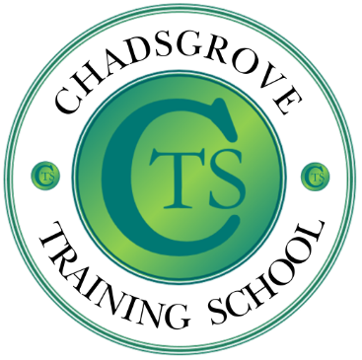
SENCO Network
The SENCO Network is led by Lorraine Petersen OBE and Helen Pretty as a collaborative project between Chadsgrove Training School and Worcestershire Children First. Firmly established as a highly valued resource, providing regular updates, expert advice and interactive discussion the network supports SENCOs in Worcestershire to develop effective practice.
Because the SENCO role is unique within schools, it may feel isolated. Our SENCO Network offers the chance to share concerns, gain advice on specific issues, and identify good practice with colleagues.
Membership of the SENCO Network includes attendance at termly meetings, a termly newsletter with important updates on SEN policy, and one free delegate place at the annual SENCO conference. Additional conference places are available to SENCO Network schools at a reduced delegate rate.
SENCOs in MATs – One school pays the membership fee and this enables the other SENCOs to attend the termly meetings free of charge but they will have to pay for a conference place at the reduced rate.
Membership can be commenced at any time, and SENCOs wishing to join the network more than one term into the year may be entitled to a discounted rate.
Please complete the membership form below and return it to courses@chadsgrove.worcs.sch.uk
For further inquiries please contact:
courses@chadsgrove.worcs.sch.uk
Chadsgrove Training School, Meadow Road, Bromsgrove, B61 0JL
Telephone: 01527 871511
https://www.chadsgroveschool.org.uk

SENCO Network Membership 2021 – 2022 £230
Members Name and Email Address

If you are joining on behalf of a MAT please list the other SENCOs names and email addresses

If you are an existing member school renewing for 2021 – 2022 please tick here

The information you provide in this form will be used solely for processing and administering your network membership. If you wish us to use your email address to contact you about future CTA professional development opportunities please tick here

Special Requirements:
(e.g. dietary, access etc)
School:
Postal Address for Correspondence:
Invoicing Address (if different from postal address)

Email:

Telephone Number:

Cost Centre for Internal Transfer for Worcestershire Schools – please complete both sections below

Project Code: Cost Centre:
Authorise Signature (Headteacher) | Name in Capitals
Please return to courses@chadsgrove.worcs.sch.uk
