30/04/20
Out at sea
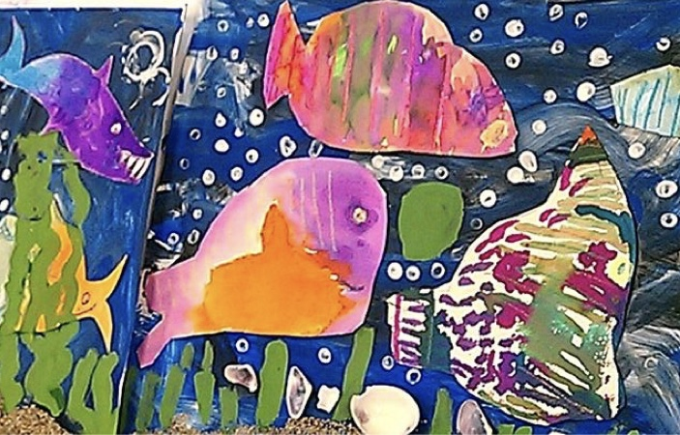
I am going to be setting weekly art projects to link in with our topic for this term. ‘Out at sea’ is a great project to get creative with. I saw this painting and thought it was the perfect inspiration for an under the sea painting. I love the colours used for the fish and the deep blue sea. I would you like to do your own painting; it would be great if you could paint a sea background and layer with fish, seaweed or anything else you find in the sea.

If you take a photo of what you create and email it to me by 7th May, I will send you a certificate as a well done! My email address is cfarrand@chadsgrove.worcs.sch.uk
I can wait to see what you come up with!
Claire Farrand Teaching assistant 5ls

