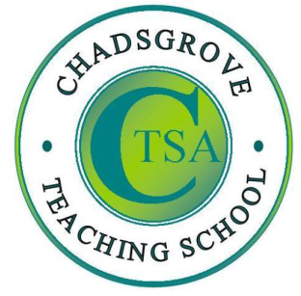
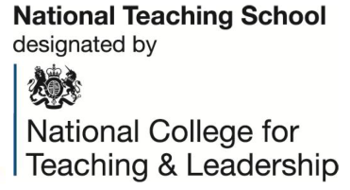

Iain draws upon over 30 years experience of working with children and young adults with ADHD and autism spectrum disorders, ranging from those with complex learning difficulties and disabilities to those studying for GCSE examinations. He has worked in schools, residential settings, and has been leading training for professionals and parents for more than ten years, alongside consultancy work, university lecturing and contributing to texts and online materials.

Lego-based Therapy
to build social skills for children
on the autism spectrum
at Keynsham Hall 99 Bath Road, Keynsham BS31 1SR

Wednesday 10th July 2019 11.00a.m. – 1.30p.m.
£65 per person

Course led by Iain Chatwin

Lego® is a highly structured and systematic construction toy, meaning that children on the autism spectrum are likely to be motivated by tasks involving its use. This workshop will explore strategies that are indicated to support effective use of Lego®-based activities and identify how to set up and implement Lego®-based therapy for children on the autism spectrum and those with related social communication difficulties, attachment and anxiety conditions.
The therapy uses Lego® construction to encourage verbal and non-verbal communication and social development such as joint attention, sharing, turn-taking and following social rules. The approach develops collaborative problem-solving and cooperative building with a group of peers. Groups meet on a regular basis, and different responsibilities are assigned to group members who work as a team to assemble the project. Participants will explore the methods used, and be provided with guidance on monitoring and recording the impact of this approach.
Participants will gain:
- understanding of how to implement Lego®-based therapy
- awareness of the evidence to support its effectiveness in developing social skills
- guidance on effective monitoring and recording of sessions and individual attainment
Please complete and return the booking form overleaf or contact the school
Tel: 01527 871511 (option 1)
courses@chadsgrove.worcs.sch.uk
For Primary, Secondary
& Special Schools

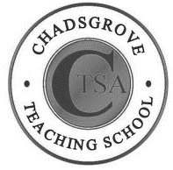
Chadsgrove Teaching School Alliance
Course Title: Lego-based Therapy (Course Led by: Iain Chatwin)
10th July 2019 Number of Places Required (@£65 each):
Attendee(s) Name & Email Address
The information you provide in this form will be used solely for processing your course booking. If you wish us to retain your email address to contact you about future CTSA professional development opportunities please tick this box
Occupation:

Special Requirements:
(e.g. access, etc)
Organisation name:

Postal Address for Correspondence:
Invoicing Address (if different to Postal Address):

Email:
Telephone Number:
Total Cost:
(Please make cheques payable to Worcestershire County Council)
Authorised Signature (Headteacher): | Name in Capitals:
We regret that we cannot accept typed signatures. Digital signatures or scanned electronic copies are suitable.
Please return to:
Chadsgrove Teaching School, Meadow Road, Catshill, Bromsgrove, Worcestershire, B61 0JL

Tel: 01527 871511 (option 1) Email: courses@chadsgrove.worcs.sch.uk
Confirmation of your booking(s) will be made within 14 working days

CANCELLATION of a course booking must be received in writing at least 10 working days prior to the course date, otherwise the following costs will be incurred: 50% of the course fee will be payable for cancellations received between 10 & 6 working days prior to course date, with 100% of the fee being payable for cancellation received later or for non-attendance. We are happy to accept substitute delegates.

In the event of unforeseen circumstances, we reserve the right to cancel or alter parts of the programme.

