Jelly rainbow
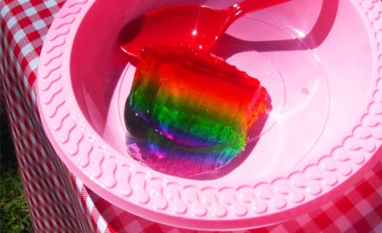

Ingredients
- 7 packets Jelly:(Grape (purple)
- Creaming Soda (pink)
- Blueberry (blue)
- Lime (green)
- Lemon (yellow)
- Orange (orange)
- Raspberry (red)
- if you cannot locate the colours, add food colouring to other mixes
Method :
- .Prepare a ring jelly mould by spaying lightly with canola spray. It's tasteless and will assist in the removal of jelly at completion.
- Follow directions to prepare the first jelly colour (purple) in a jug and fill approximately 1/7th of the mould. This doesn’t need to be science, an estimation is fine!
- Place a lid on your mould or cover with cling film and place in the refrigerator for 2 hours, or until firmly set.
- When the first layer is set, prepare the second jelly colour (pink).
- Pour another 1/7th of the mould over the purple jelly, cover and return to the refrigerator to set.
- Repeat this process for each colour, to achieve a ‘true rainbow’ pour the jelly in the colour order listed in the ingredients list.
- When the last layer (red) has set completely, remove the lid/cover and place the plate or platter you wish to serve the rainbow on top of the mould, face down.
(It is a good idea to ensure the plate or platter is approximately 20 per cent wider than the mould.)
- Turn the mould over the holding plate or platter in place, so the mould sits on top of the plate.
- Remove the centre part of the mould. The jelly will flop onto your plate or platter.
- Cut a slice in the bottom centre portion of the jelly, then carefully extend from the cuts outward to form a rainbow shape.

Slice and serve with your favourite fruit or ice cream

Well Done you have made an NHS rainbow jelly

