No. | Item | Yes | No | Don’t Know
1 | Resists changes to familiar routines
2 | Does not recognise familiar people in unfamiliar clothes
3 | Dislikes bright lights
4 | Dislikes fluorescent lights
5 | Is frightened by flashes of light
6 | Puts hands over eyes or closes eyes in bright light
7 | Is attracted to lights
8 | Is fascinated by shiny objects and bright colours
9 | Touches the walls of rooms
10 | Enjoys certain patterns (e.g. brickwork, stripes)
11 | Gets lost easily
12 | Has a fear of heights, lifts, escalators
13 | Has difficulty catching balls
14 | Is startled when approached by others
15 | Smells, licks, taps objects and people
16 | Appears not to see certain colours
17 | Uses peripheral vision when doing a task
18 | Find it easier to listen when not looking at person
19 | Remembers routes and places extremely well
20 | Can memorise large amounts of information on certain topics
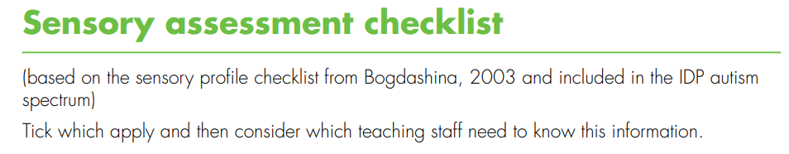
Pupil:
School:
Date completed::

AET Sensory Checklist
Page 1 of 3
No. | Item | Yes | No | Don’t Know
21 | Finds crowded areas very difficult
22 | Prefers to sit at back of group or front of group
23 | Covers ears when hears certain sounds
24 | Can hear sounds which others do not hear
25 | Is very distressed by certain sounds
26 | Bangs objects and doors
27 | Is attracted by sounds and noises
28 | Does not like shaking hands or being hugged
29 | Likes a hug if chosen to do this
30 | Only seems to hear the first words of a sentence
31 | Repeats exactly what others have said
32 | Very good auditory memory for songs and rhymes
33 | Dislikes the feel of certain fabrics and substances
34 | Seems unaware of pain and temperature
35 | Dislikes certain foods and drinks
36 | Seeks pressure by crawling under heavy objects
37 | Hugs very tightly
38 | Enjoys feeling certain materials
39 | Dislikes certain everyday smells
40 | Eats materials which are not edible
41 | Likes to have food presented in a certain way on the plate
42 | Dislikes crunchy or chewy food
43 | Quite clumsy and bumps into objects and people  Page 2 of 3
No. | Item | Yes | No | Don’t Know
44 | Finds fine motor movements hard
45 | Has difficulty running and climbing
46 | Finds it hard to ride a bike
47 | Does not seem to know where body is in space
48 | Has poor balance
49 | Afraid of everyday movement activities such as swings, slides trampoline
50 | Has extremely good balance
Page 3 of 3

