People who help us – Police
Take a look through these suggested learning activities and choose what you feel your child would enjoy.
- Dress up as a police officer by making this mask and badge. A blue shirt would make a great jacket.
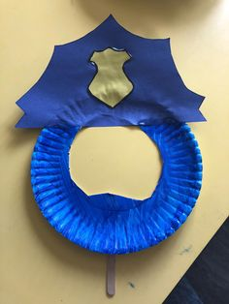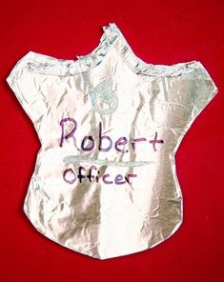
- Pretend to be a detective and go on a hunt around the room for previously hidden objects.
- Experience sensory play by hiding small world play people and animals in the snow (shaving foam or squirty cream!). Pretend they are lost and you need to find them.
- Make lots of finger prints while playing with talc, either on black paper or anything!
- Listen to the song about the police officer.

- Practise counting by listening to ‘5 policemen jumping on the bed’. Use any props you may be able to find or just sing along with your child.
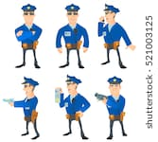

- Listen to the sound of police sirens by clicking on this sound effect video.

- Role play with toy cars, pushing them along so they travel fast!

Have fun!

