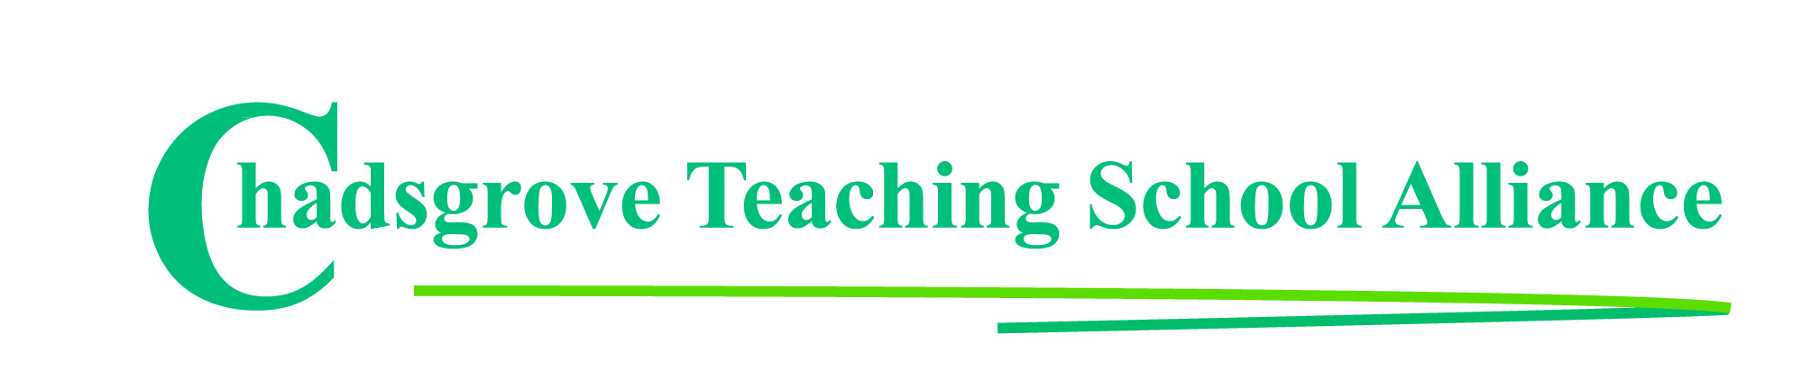

Autumn Courses 2019

Date | Course Leader | Course Title
6th September  9.00-5.00 | HSE Approved Instructor | Emergency First Aid at Work certificated course  (Limited places available) | £85
26th September  1.30 – 4.00 | Iain Chatwin  SEND Consultant & Trainer | Lego®-based Therapy to Build Social Skills for  Children on the Autism Spectrum  Mainstream  SEND Schools | £65
3rd October  1.30-4.00  24th October, 7th & 28th November  10.00-4.00 | John Tilley | Effective Strategic Leadership (3½ day developing leader programme)  Mainstream  SEND Schools | £425
11th October  10.00 – 4.00 | Joanna Grace  SEND Consultant & Trainer | Behaviours that Challenge - Exploring the Impact  the Senses have on Behaviour  Mainstream  SEND Schools | £130
17th October  10.00-12.30 | Iain Chatwin  SEND Consultant & Trainer | Including Pupils with ADHD in Primary Schools  SEND Schools  Mainstream | £65
14th November  10.00 – 4.00 | Lorraine Petersen OBE | Supporting Pupils with Attachment & Trauma  Difficulties  SEND Schools  Mainstream | £110
21st & 22nd November  9.45 – 4.45 | Lorraine Petersen OBE | Mental Health First Aid  to Support Young People (2-day course)  Mainstream  SEND Schools | £249
5th December  10.00 – 4.00 | Iain Chatwin  SEND Consultant & Trainer | How to Write Social Stories to Develop Social  Competence for Pupils on the Autism Spectrum  SEND Schools  Mainstream | £110
12th December  10.00 – 12.30 | Iain Chatwin  SEND Consultant & Trainer | Lego®-based Therapy to Build Social Skills for  Children on the Autism Spectrum  Mainstream  SEND Schools | £65
Course details available at: https://www.chadsgroveschool.org.uk/web/cpld_courses/204963

For further information, please contact: courses@chadsgrove.worcs.sch.uk
Chadsgrove Teaching School Alliance
Meadow Road, Catshill, Bromsgrove, Worcestershire. B61 0JL
Tel: 01527 871511
Email: tsa@chadsgrove.worcs.sch.uk
Booking Form
Course Title:
Number of Places Required:
Attendee(s) Name & Email Address

The information you provide in this form will be used solely for processing your course booking. If you wish us to retain your email address to contact you about future CTSA professional development opportunities please tick this box
Occupation:
Special Requirements:
(e.g. dietary, access, etc)
Organisation name:
Postal Address for Correspondence:
Invoicing Address (if different to Postal Address):

Email:
Telephone Number:
Total Cost:
(Please make cheques payable to Worcestershire County Council)
Cost Centre for Internal Transfer for Worcestershire Schools. Please complete both sections below.

Project Code: Cost Centre:
Authorised Signature (Headteacher): | Name:
We regret that we cannot accept typed signatures. Digital signatures or scanned electronic copies are suitable.
Please return to:
Chadsgrove Teaching School, Meadow Road, Catshill, Bromsgrove, Worcestershire, B61 0JL

Tel: 01527 871511 Email: courses@chadsgrove.worcs.sch.uk
Confirmation of your booking(s) will be made within 14 working days

CANCELLATION of a course booking must be received in writing at least 10 working days prior to the course date, otherwise the following costs will be incurred: 50% of the course fee will be payable for cancellations received between 10 & 6 working days prior to course date, with 100% of the fee being payable for cancellation received later or for non-attendance. We are happy to accept substitute delegates. In the event of unforeseen circumstances, we reserve the right to cancel or alter parts of the programme.

