Sensory Moon
Don’t forget to email me your photographs of your child creating and enjoying these activities!
Idea 1
You could create your own Moon to display at home! For this idea you will need:
- White paint
- Flour
Mix the two together. Then, press your finger in or use a bottle cap/something round to create the texture of the moon!
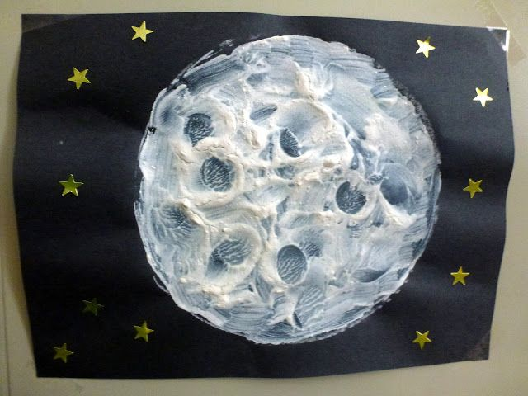

Idea from: http://choices4children.blogspot.com/2013/04/textured-moon-paintings.html
Idea 2
You could create some moon rocks! For this you will just need tin foil – enjoy exploring the scrunching up of the foil and then once you have created some, you can throw them in the air, roll them to your partner, or just enjoy moving your fingers through them in a bowl.
Alternatively, cover a paper plate with tin foil – see picture – and hang it by a window to catch the sunlight so your moon glimmers!
