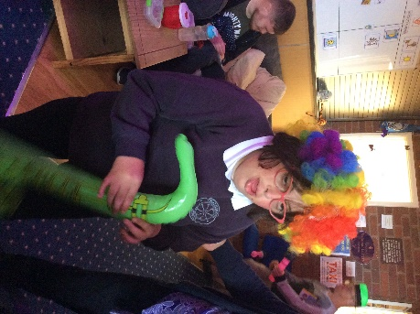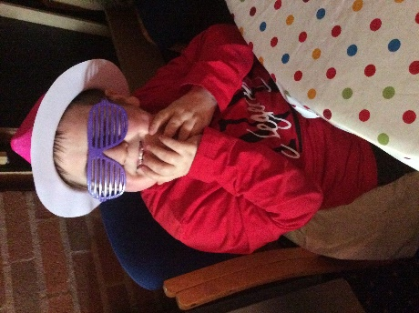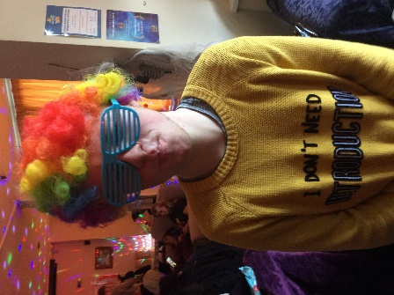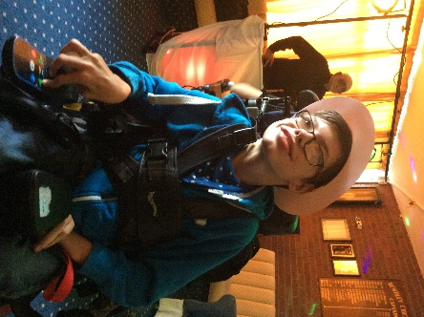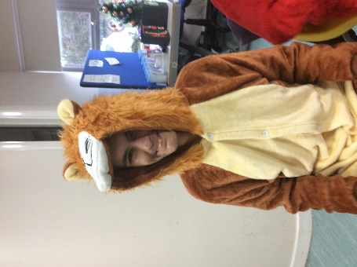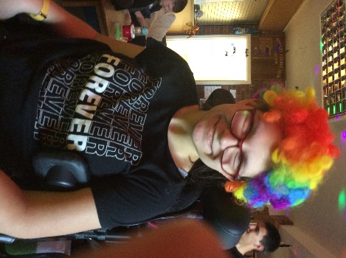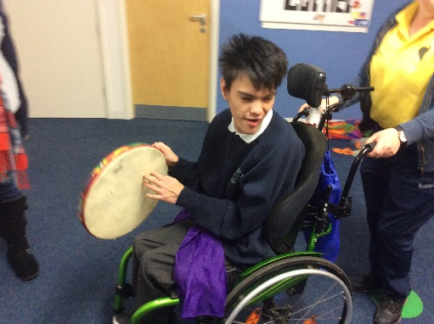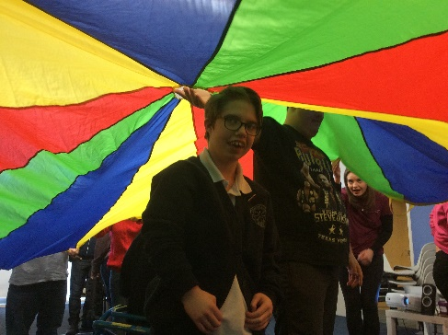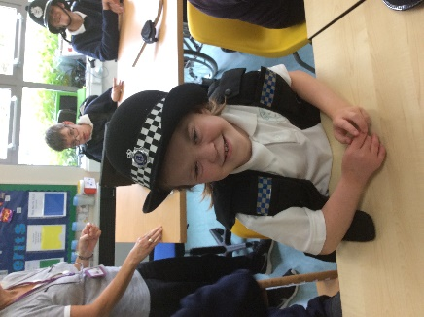

Thought you would like to have a look at all the lovely, happy faces of your friends in 13US.

We are all missing seeing you at school. We hope you have had a good first week and made the most of the lovely sunshine.

You are all in our thoughts daily.

Take care, Helen, Hannah, Jayne, Jenny, Glenda, Sharon and Chantelle (your dream team!)

A big ‘Hello’ to everyone in 13US