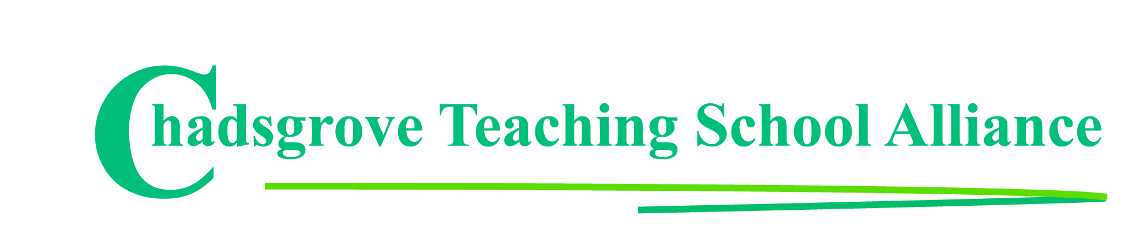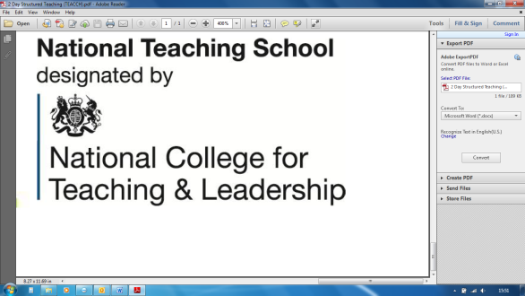

Course led by **Iain Chatwin**

**This twilight online session will look at how autism spectrum disorders (ASD) impact on the child and their daily living and learning. From this a range of practical interventions and support strategies will be identified. The knowledge gained will help you to recognise the signs of autism and choose practical strategies to develop more effective support for an individual who has been diagnosed with an ASD, including those with Pathological Demand Avoidance (PDA).**

Participants will gain:

* understanding of how the characteristics of autism arise from developmental differences
* awareness of why a personalised approach is important
* practical strategies to support the learning styles of pupils with autism

**Including Pupils on the Autism Spectrum**

**in Primary Schools**

*Please complete and return the booking form overleaf or contact the school*

*This session will be hosted on Zoom. Full instructions for joining will be sent to delegates.*

Email: courses@chadsgrove.worcs.sch.uk

Tel: 01527 871511

**Wednesday 30th June 2021** 4.00p.m.– 5.30p.m.

**£25** per delegate

(For up to 5 places, then additional places at £15)

**Online Professional Development**

Mainstream Primary



Chadsgrove Teaching School Alliance

|  |  |  |  |  |  |
| --- | --- | --- | --- | --- | --- |
| **Including Pupils on the Autism Spectrum in Primary Schools** 30th June 2021 | | Select number of places | | | |
| Attendee(s) Name & Email Address  Click here to enter text. | | | | | |
| The information you provide in this form will be used solely for processing your course booking. If you wish us to retain your email address to contact you about future CTSA professional development opportunities please tick this box | | |  |  |  |
|  |
|  |
| Occupation: Click here to enter text. | | | | | |
| Special Requirements: Click here to enter text.  (e.g. dietary, access, etc) | | | | | |
| Organisation name: Click here to enter text. | | | | | |
| Postal Address for Correspondence: Click here to enter text. | | | | | |
| Invoicing Address (*if different to Postal Address*):  Click here to enter text.  Email: Click here to enter text.  Telephone Number: Click here to enter text. | | | | | |
| Total Cost: Choose cost  *(Please make cheques payable to Worcestershire County Council)* | | | | | |
| Cost Centre for Internal Transfer for **Worcestershire Schools**. Please complete **both** sections below.  Project Code: Click here to enter text. Cost Centre: Click here to enter text. | | | | | |
| Authorised Signature (Headteacher): | Name:  Click here to enter text. | | | | |
| *We regret that we cannot accept typed signatures. Digital signatures or scanned electronic copies are suitable.* | | | | | |

**In the event of unforeseen circumstances we reserve the right to cancel or alter parts of the programme.**

*Please return to:*

Chadsgrove Teaching School, Meadow Road, Catshill, Bromsgrove, Worcestershire, B61 0JL

Tel: 01527 871511 Email: courses@chadsgrove.worcs.sch.uk