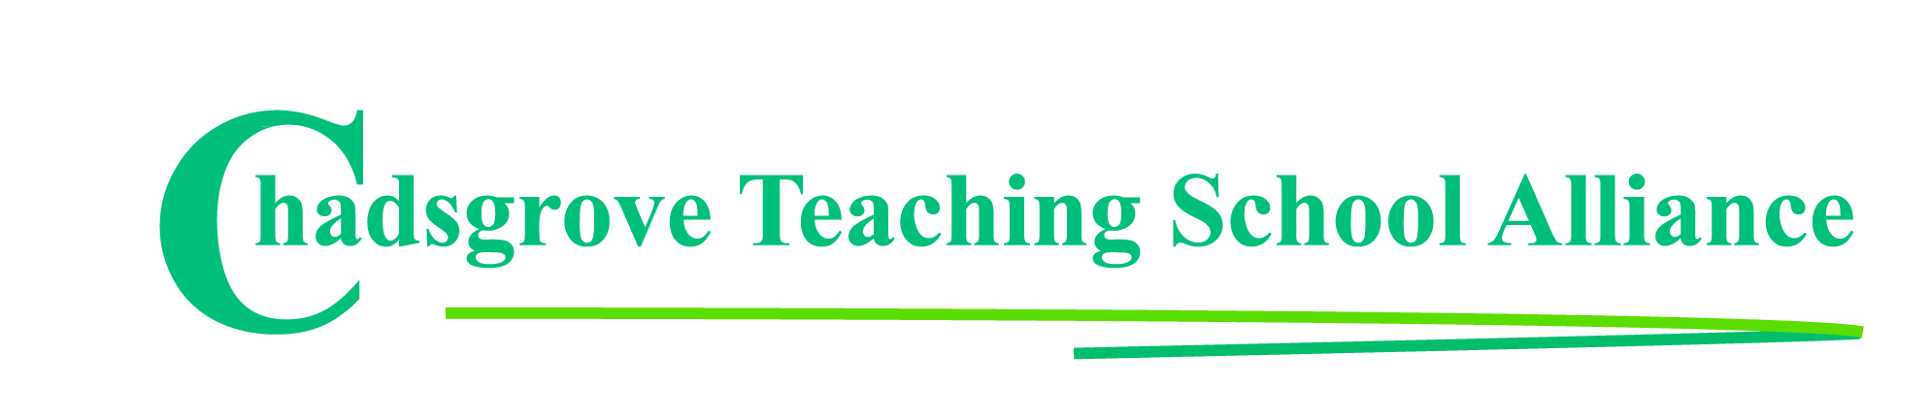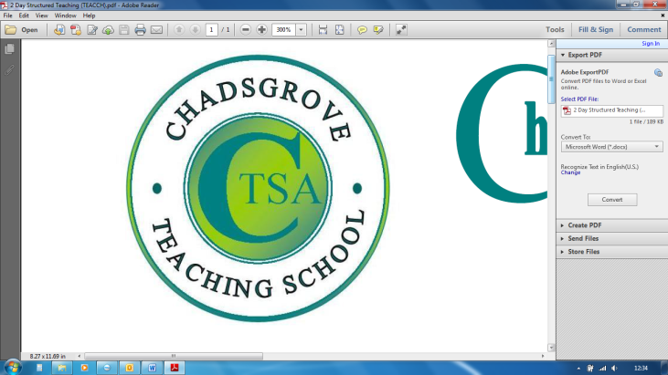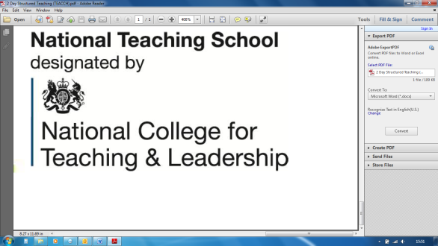

***“Clear …practical …easy to follow …it was fantastic!”***

*Evaluation comments from December 2019 course participants*

Course led by **Iain Chatwin**

**Lego® is a highly structured and systematic construction toy, meaning that children on the autism spectrum are likely to be motivated by tasks involving its use. This workshop will explore strategies that are indicated to support effective use of Lego®-based activities and identify how to set up and implement Lego®-based therapy for children on the autism spectrum and those with related social communication difficulties and anxiety conditions.**

The therapy uses Lego® construction to encourage verbal and non-verbal communication, and social development such as joint attention, sharing, turn-taking and following social rules. The approach develops collaborative problem-solving and cooperative building with a group of peers, including some who do not have social skills deficits. Groups meet on a regular basis, and different responsibilities are assigned to group members who work as a team to assemble the project. Participants will explore the methods used, and be provided with guidance on monitoring and recording the impact of this approach.

Participants will gain:

* understanding of how to implement Lego®-based therapy
* awareness of the evidence to support its effectiveness in developing social skills
* guidance on effective monitoring and recording of sessions and individual attainment

Tel: 01527 871511 (option 1)

courses@chadsgrove.worcs.sch.uk

Mainstream & Special Schools

**Lego**®**-based Therapy to Build Social Skills**

**for Children on the Autism Spectrum**

**Thursday 19th March 2020** 12.30p.m.– 4.00p.m.

**£75**

**Iain** draws upon over 30 years experience of working with children and young adults with ADHD and autism spectrum disorders, ranging from those with complex learning difficulties and disabilities to those studying for GCSE examinations. He has worked in schools, residential settings, and has been leading training for professionals and parents for more than ten years, alongside consultancy work, university lecturing and contributing to texts and online materials.

*Please complete and return the booking form overleaf or contact the school*

**Venue:** Chadsgrove Teaching School

Meadow Road

Catshill

Bromsgrove

B61 0JL

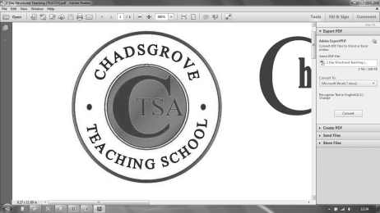

Chadsgrove Teaching School Alliance

|  |  |  |  |  |  |
| --- | --- | --- | --- | --- | --- |
| Course Title: **Lego-based Therapy** (led by Iain Chatwin)  19th March 2020 **Number of Places Required** (at £75 each)**:** | | Choose an item. | | | |
| Attendee(s) Name & Email Address  Click here to enter text. | | | | | |
| The information you provide in this form will be used solely for processing your course booking. If you wish us to retain your email address to contact you about future CTSA professional development opportunities please tick this box | | |  |  |  |
|  |
|  |
| Occupation: Click here to enter text. | | | | | |
| Special Requirements: Click here to enter text.  (e.g. dietary, access, etc) | | | | | |
| Organisation name: Click here to enter text. | | | | | |
| Postal Address for Correspondence: Click here to enter text. | | | | | |
| Invoicing Address (*if different to Postal Address*):  Click here to enter text.  Email: Click here to enter text.  Telephone Number: Click here to enter text. | | | | | |
| Total Cost: Choose cost  *(Please make cheques payable to Worcestershire County Council)* | | | | | |
| Cost Centre for Internal Transfer for **Worcestershire Schools**. Please complete **both** sections below.  Project Code: Click here to enter text. Cost Centre: Click here to enter text. | | | | | |
| Authorised Signature (Headteacher): | Name:  Click here to enter text. | | | | |
| *We regret that we cannot accept typed signatures. Digital signatures or scanned electronic copies are suitable.* | | | | | |

*Please return to:*

Chadsgrove Teaching School, Meadow Road, Catshill, Bromsgrove, Worcestershire, B61 0JL

Tel: 01527 871511 (option 1) Email: courses@chadsgrove.worcs.sch.uk

Confirmation of your booking(s) will be made within 14 working days

***CANCELLATION of a course booking must be received in writing at least 10 working days prior to the course date, otherwise the following costs will be incurred: 50% of the course fee will be payable for cancellations received between 10 & 6 working days prior to course date, with 100% of the fee being payable for cancellation received later or for non-attendance. We are happy to accept substitute delegates.***

**In the event of unforeseen circumstances, we reserve the right to cancel or alter parts of the programme.**