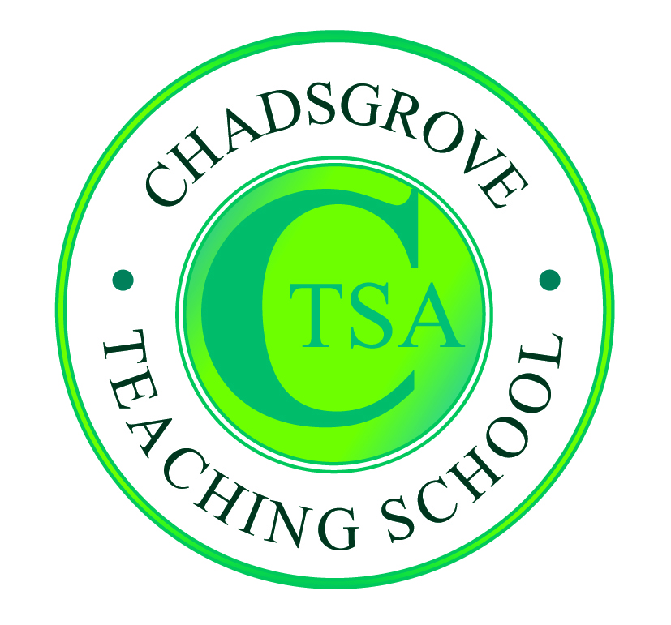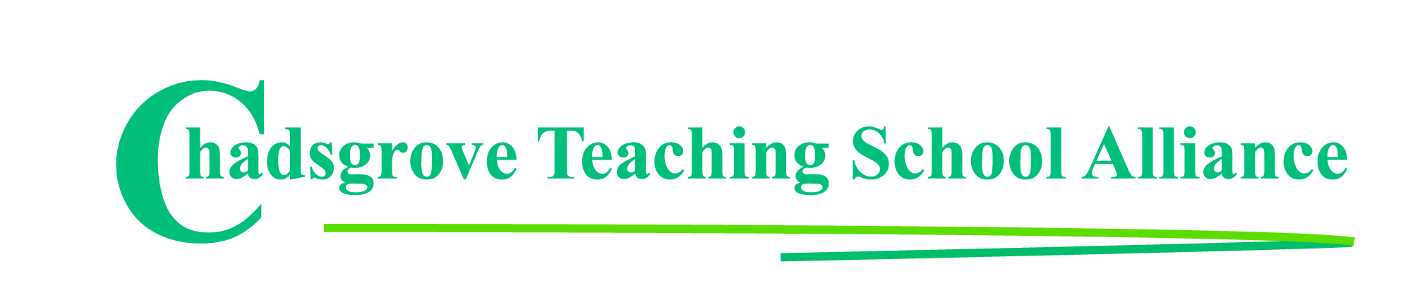

SENCO Network

The SENCO Network is led by Lorraine Petersen OBE and Helen Pretty as a collaborative project between Chadsgrove Teaching School and Worcestershire Children First. Firmly established as a highly valued resource, providing regular updates, expert advice and interactive discussion the network supports SENCOs in Worcestershire to develop effective practice.

Because the SENCO role is unique within schools, it may feel isolated. Our SENCO Network offers the chance to share concerns, gain advice on specific issues, and identify good practice with colleagues.

Membership of the SENCO Network includes attendance at termly meetings, a termly newsletter with important updates on SEN policy, and one delegate place at the annual SENCO conference 2021. Additional conference places are available to SENCO Network schools at a reduced delegate rate.

Membership for 2020-21 costs **£230** and runs from 1st September 2020 to 21st July 2021.



For further enquiries please contact:

courses@chadsgrove.worcs.sch.uk

Chadsgrove Teaching School, Meadow Road, Bromsgrove, B61 0JL

Telephone: 01527 871511

www.chadsgroveschool.org.uk

**University of Worcester.png**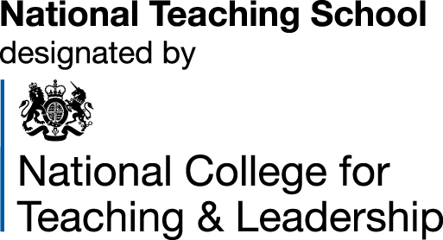

In partnership with:



Chadsgrove Teaching School Alliance

|  |  |  |  |  |
| --- | --- | --- | --- | --- |
| SENCO Network Membership 2020-21 | | £230 | | |
| Member’s Name & Email Address | | | | |
| If you are an existing member school renewing for 2020/21 please tick here | | |  |  |
|  | | |  |  |
| The information you provide in this form will be used solely for processing and administering your network membership. If you wish us to use your email address to contact you about future CTSA professional development opportunities please tick this box | | |  |  |
|  | | | | |
| Special Requirements:  (e.g. dietary, access, etc) Click or tap here to enter text. | | | | |
| School: Click or tap here to enter text. | | | | |
| Postal Address for Correspondence:  Click or tap here to enter text. | | | | |
| Invoicing Address (*if different to Postal Address*):  Click or tap here to enter text.  Email: Click or tap here to enter text.  Telephone Number: Click or tap here to enter text. | | | | |
| Cost Centre for Internal Transfer for **Worcestershire Schools** please complete **both** sections below  Project Code: Click or tap here to enter text. Cost Centre: Click or tap here to enter text. | | | | |
| Authorised Signature (Headteacher): | Name in Capitals:  Click or tap here to enter text. | | | |
| *We regret that we cannot accept typed signatures. Digital signatures or scanned electronic copies are suitable.* | | | | |

*Please return to:*

Chadsgrove Teaching School, Meadow Road, Catshill, Bromsgrove, Worcestershire, B61 0JL

Tel: 01527 871511 Email: courses@chadsgrove.worcs.sch.uk