Butterfly Arts and Crafts Ideas!
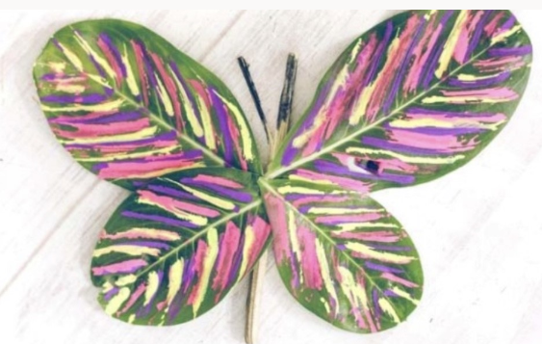

Make a butterfly from some painted leaves

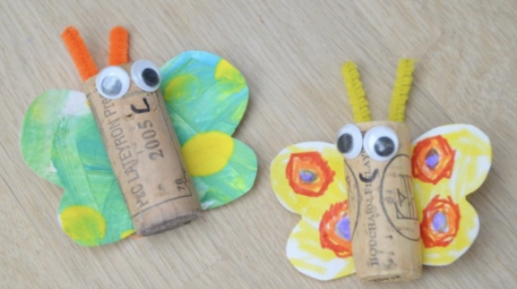
Butterfly craft with corks or toilet roll tubes

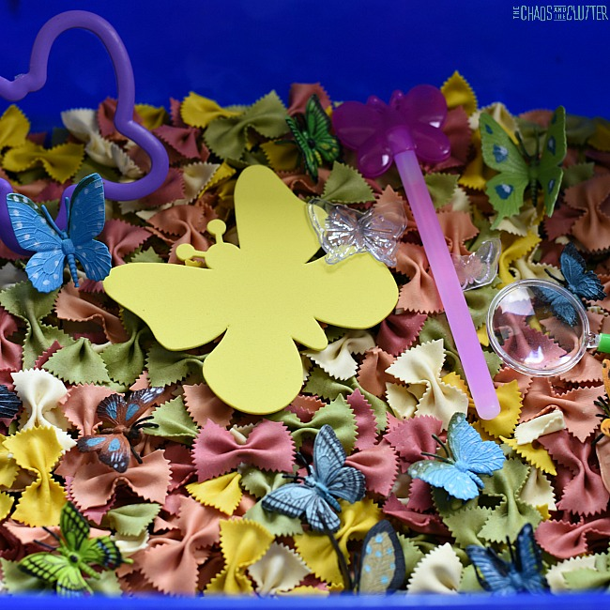

Butterfly sensory bin – cut out butterfly shapes with farfalle pasta
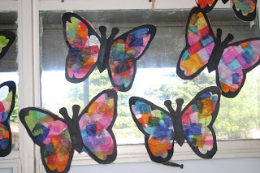

Suncatchers, made with tissue paper and cling film
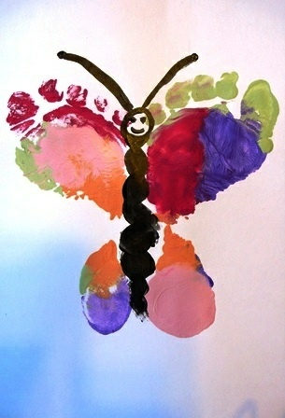

Butterfly foot print pictures
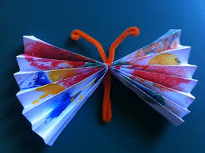

Paper fan butterfly – useful in the warm weather too!

