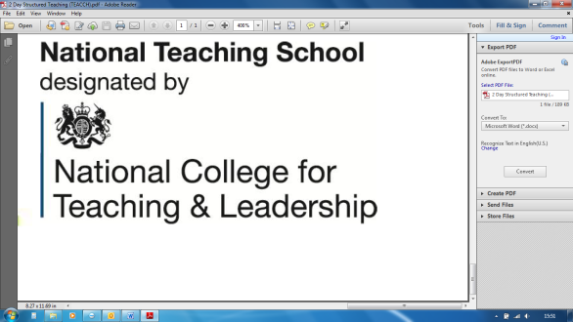

**Supporting Pupils with  
Attachment and Trauma Difficulties**

Research is increasingly showing that the way a child is treated in the early years of their life can be really important and can influence the way they relate to other people.

Trauma occurs when a child has been exposed to multiple adverse experiences or prolonged levels of neglect or abuse, as a developing baby in the womb, and/or during their early years.

Attachment develops when a baby instinctively turns to their caregiver for safety and comfort, and the parent or caregiver protects and cares for the baby. Attachment issues describe a variety of behaviours which may arise after a child has lost his or her primary carer.

A child’s distressed behaviour is often masked or misunderstood in our schools, causing escalating stress on all levels. These issues can often mean a child is excluded or moved to inappropriate settings and this can lead to family breakdowns, mental health difficulties and life-long problems.

This course will support schools in identifying and supporting those children who may have had adverse childhood experiences leading to trauma and attachment issues.

**Thursday 14th November 2019**

10.00a.m. – 4.00p.m.

**£110** including lunch Registration from 9.45 a.m.

**Course content**

Session 1: What are Adverse Childhood Experiences? What is Trauma?

Session 2: What is attachment? Why attachment is important for learning and behaviour.

Session 3: The important role of schools in supporting these children. Practical classroom strategies.

Course led by **Lorraine Petersen OBE**

Tel: 01527 871511 (option 1)

courses@chadsgrove.worcs.sch.uk

For Mainstream & SEN

*Please complete and return the booking form overleaf or contact the school*

**Venue:** Chadsgrove Teaching School

Meadow Road

Catshill

Bromsgrove

B61 0JL



Chadsgrove Teaching School Alliance

|  |  |  |  |  |  |
| --- | --- | --- | --- | --- | --- |
| Course Title: **Trauma & Attachment** (Course Led by: Lorraine Petersen)  14th November 2019 **Number of Places Required** (@ £110 each): | | Choose an item. | | | |
| Attendee(s) Name & Email Address  Click here to enter text. | | | | | |
| The information you provide in this form will be used solely for processing your course booking. If you wish us to retain your email address to contact you about future CTSA professional development opportunities please tick this box | | |  |  |  |
|  |
|  |
| Occupation: Click here to enter text. | | | | | |
| Special Requirements: Click here to enter text.  (e.g. dietary, access, etc) | | | | | |
| Organisation name: Click here to enter text. | | | | | |
| Postal Address for Correspondence: Click here to enter text. | | | | | |
| Invoicing Address (*if different to Postal Address*):  Click here to enter text.  Email: Click here to enter text.  Telephone Number: Click here to enter text. | | | | | |
| Total Cost: Choose cost  *(Please make cheques payable to Worcestershire County Council)* | | | | | |
| Cost Centre for Internal Transfer for **Worcestershire Schools**. Please complete **both** sections below.  Project Code: Click here to enter text. Cost Centre: Click here to enter text. | | | | | |
| Authorised Signature (Headteacher): | Name:  Click here to enter text. | | | | |
| *We regret that we cannot accept typed signatures. Digital signatures or scanned electronic copies are suitable.* | | | | | |

*Please return to:*

Chadsgrove Teaching School, Meadow Road, Catshill, Bromsgrove, Worcestershire, B61 0JL

Tel: 01527 871511 (option 1) Email: courses@chadsgrove.worcs.sch.uk

Confirmation of your booking(s) will be made within 14 working days

***CANCELLATION of a course booking must be received in writing at least 10 working days prior to the course date, otherwise the following costs will be incurred: 50% of the course fee will be payable for cancellations received between 10 & 6 working days prior to course date, with 100% of the fee being payable for cancellations received later or for non-attendance. We are happy to accept substitute delegates.***

**In the event of unforeseen circumstances, we reserve the right to cancel or alter parts of the programme.**