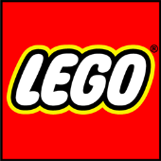
Lego Club Rules

- Build things together
- Do your job, and not anyone else’s
- If you break it, you have to fix it
- If you can’t fix it, ask for help
- If someone else is using it, don’t take it, ask first
- Use indoor voices, no shouting
- Use polite words
- Keep your hands and feet to yourself
- Do not put Lego in your mouth
- Clean up and put things back where they came from

