14US Family Newsletter
We thought it would be nice to do a weekly newsletter for our class to keep families connected. I am sure all of the pupils will be happy to know what their friends are up to at home
As time goes on, we will try and make it a bit jazzier! We are all trying to improve our technical skills during this time and I’m sure we will all be amazing at ICT when all this is over (ha, ha, ha )
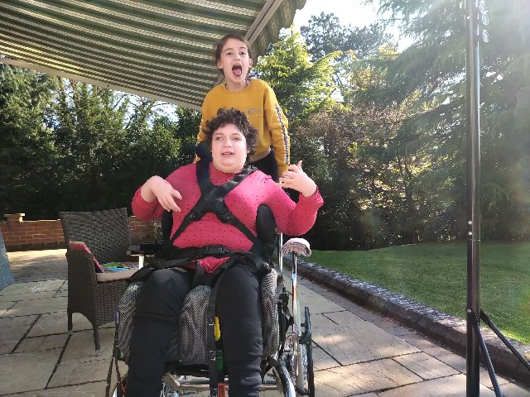
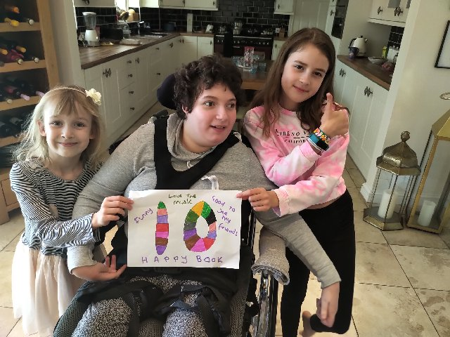

Holly has been listening to the stories on the website and really enjoyed ‘everyone feels …happy’ she even scored it a 10!!
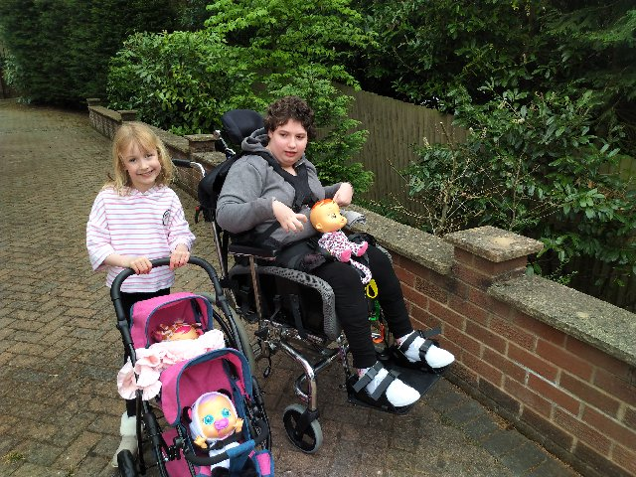
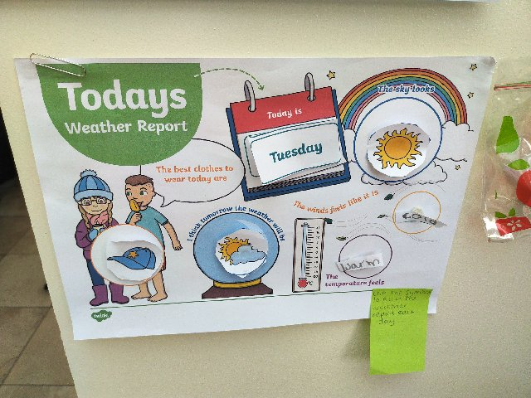
Holly has also been enjoying spending time outdoors with her sisters and has been thinking about the weather. Look at all the information that Holly has helped to gather about the weather! You could be our weather reporter Holly! You can see the weather was much better last week! STOP SINGING Lisa and Hayley!!!

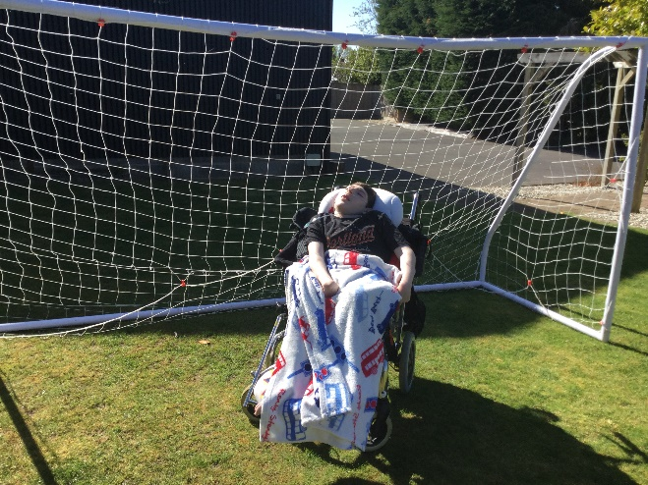
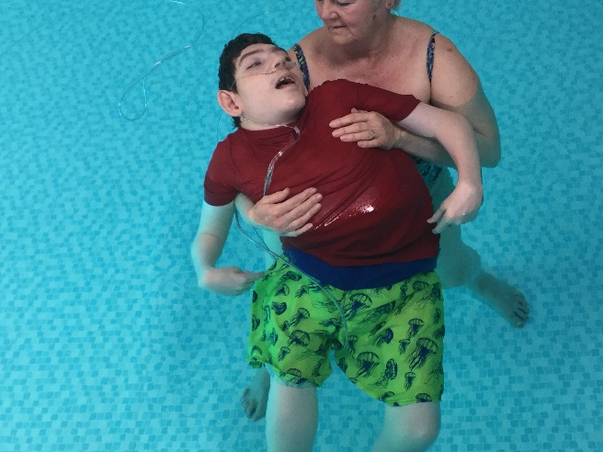
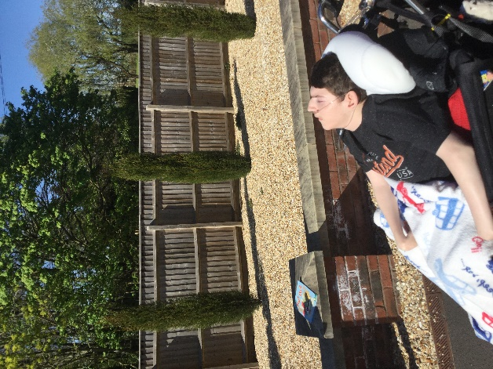
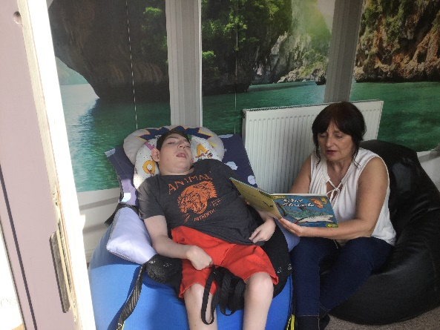
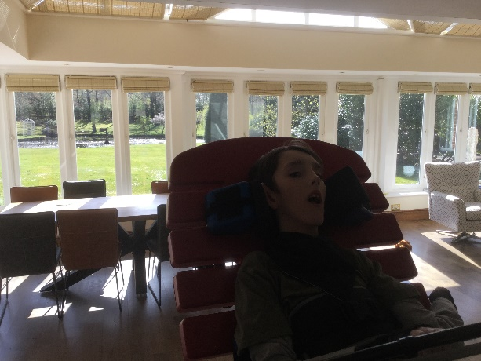
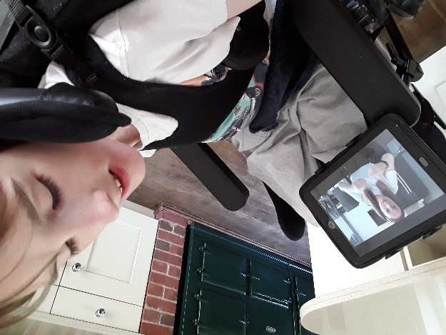
Jack has been really chilled out and happy at home listening to stories and he especially like The Enormous Crocodile story on the website.
We are delighted to see Jack has been spending time in his wheelchair exploring the great outdoors. It looks like you are catching the rays there Jack!
The change in weather this week might be disappointing for some people but we know Jack loves the rain so I am sure he has been listening out for it this week!
It’s great to see Jack keeping up with his fitness but watch out for those footballs Jack and whatever you do don’t splash June’s hair!!

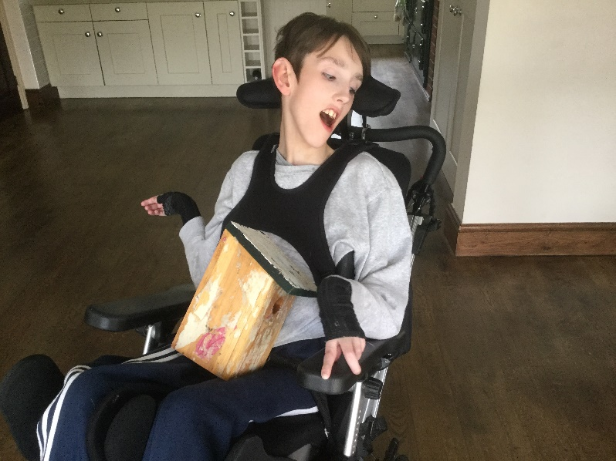
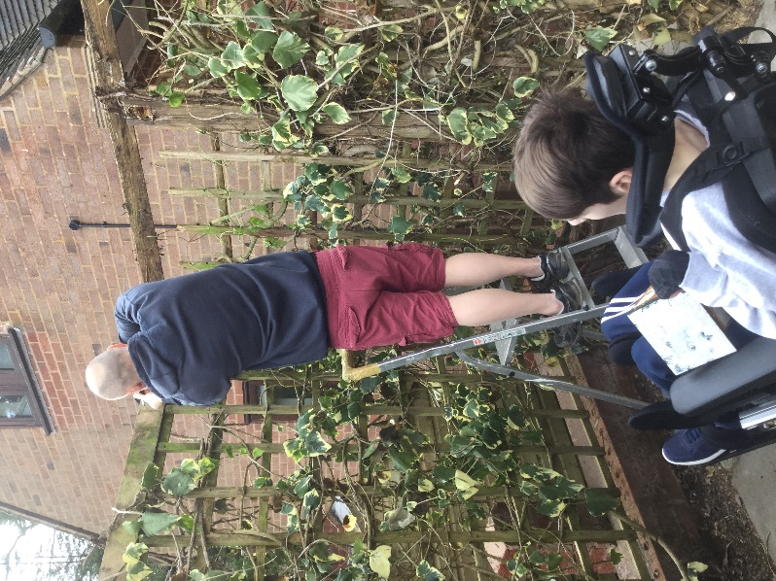
Jimmy has been listening to lots of stories from the website and as you can see he is listening very carefully! He is also enjoying the Harry Potter collection Mom and Dad got for him I wonder who else likes Harry potter? When we return to school we could make some potions and cast some spells of our own!
We are really pleased to hear Jimmy is working hard with Dad on his physio routine and you are looking great in your stander Jimmy, Well done!
Jimmy loves to spend time at home with his family and it’s a good job he is there to help Dad in the garden! Health and safety monitor!
The bird house looks fantastic though and Jimmy has been busy learning lots of important life skills. Keep up the good work!

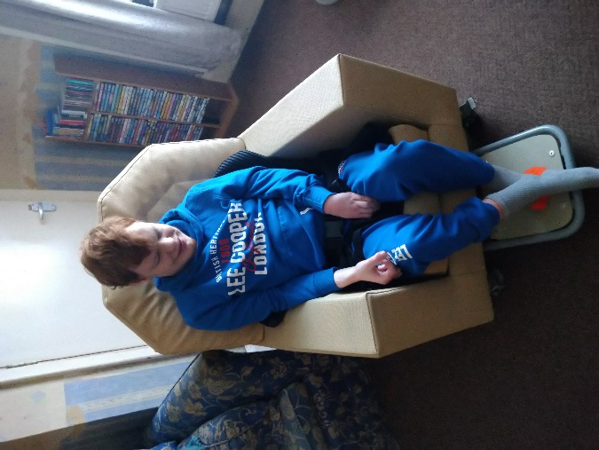
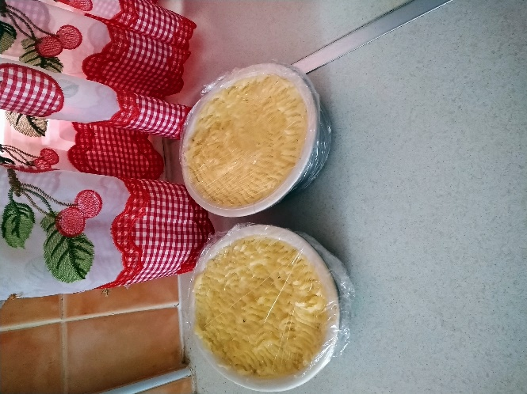
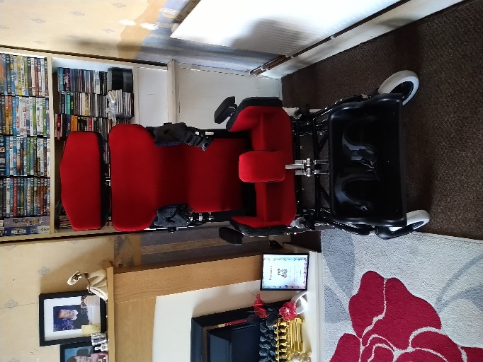
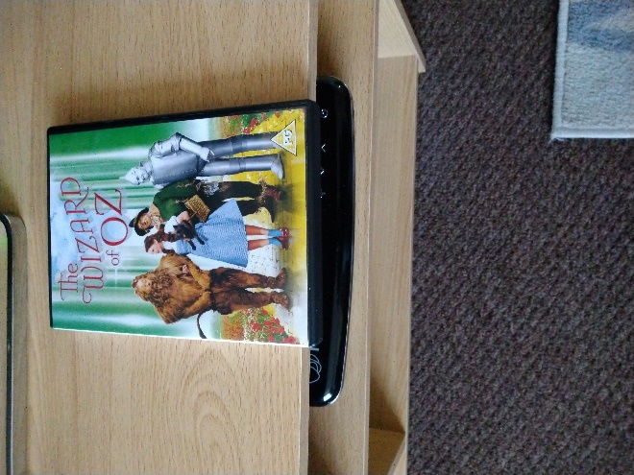
Kyle has been spending quality time at home with Mom and enjoying some films together. The wizard of Oz has been Kyles favourite and Mom must know every word of it by now!! We will have to do a sing along to some of the songs when we get back to school. Your chair looks comfy Kyle!
Talking of chairs, take a look at Kyle’s new wheelchair! I love the colour and it looks a better size now that Kyle has had a growth spurt! I wonder how tall he will be when we get back to school?
Kyle is also learning lots of life skills at home and has been helping Mom with the tea That looks delicious! Well done Kyle!

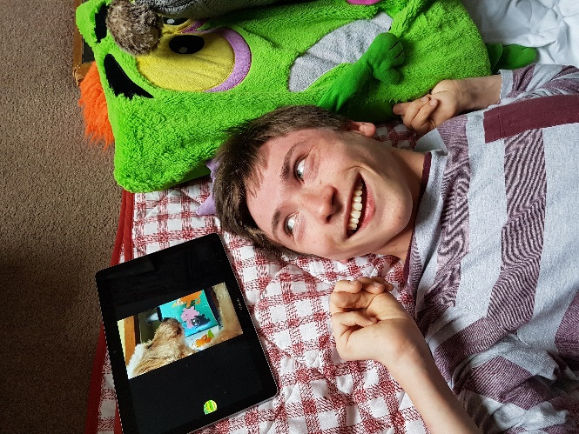
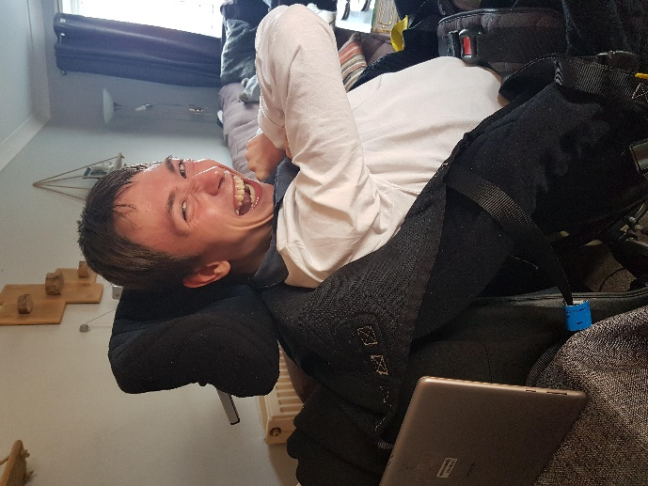
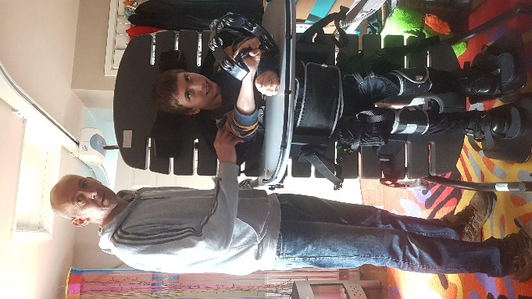
Mason has also been keeping fit and healthy at home and has loved spending time with Mom in the hot tub! Now I can see why you love the bubbles in the school pool! When we get back to school we could have a pool party, what do you think?
It’s great to see you in your stander too! I know its hard work but you can do it! We believe in you Mason
I can see you entertaining Dad with your musical skills too! I hope your neighbours are into rock music like you! They can probably hear you rocking away to ACDC!
Mason has been enjoying the stories from Ted the school dog. I bet he misses your kind strokes Mason.
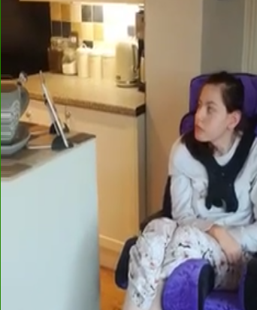
Fern has been enjoying time at home and has been very relaxed.
She is still keeping up with her good work using her standing frame though. Well dome Fern, we are really proud of you!
You can keep an eye on Mom and Dad from up there and check they are doing the gardening right

Fern has also been watching the stories on the website. Just like Jack, Fern has enjoyed ‘The Enormous Crocodile’
I think we have some Roald Dahl fans in our class.
That’s all the news for this week, thank you so much for sending items in. Don’t worry if you haven’t had chance to send anything in yet. We really do understand that you are all extremely busy at the moment and we don’t want to add to the pressure.

We can’t tell you how much we miss you all and we hope to be back together very soon.

Until then, keep checking in on the website so that we can Keep that special connection with each other.
We’re all in this together!
Lots of love from the 14US team
Ange, Ren, Ria, Hayley, Lisa and Kate xxx

