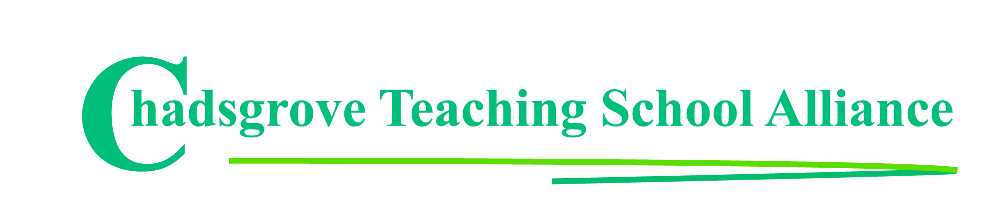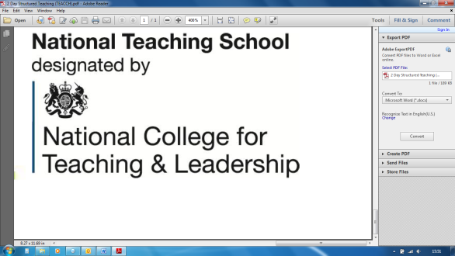

Tel: 01527 871511

courses@chadsgrove.worcs.sch.uk

For Mainstream & SEN

*Please complete and return the booking form overleaf or contact the school*

**Thursday 21st March 2019**

10.00a.m. – 4.00p.m.

**£110** including lunch Registration from 9.45 a.m.

Course content:

● Assessing the issues causing difficulty, and planning responses

● Structuring stories, defining sentence function, and using appropriate phrasing

● Individualising stories

● Effective strategies for introducing and presenting the story

This course will introduce the use of stories to address social understanding difficulties encountered by people on the autism spectrum. Stories can be a powerful tool in positive behaviour intervention if they are written for specific individuals as narratives to describe situations, skills or concepts that they find difficult in relation to social settings.

Participants will look at methods for assessing the issues that need to be addressed, and how to apply the criteria and guidelines that define effective stories. The course will include workshop activities that provide participants with the opportunity to begin writing stories for use with individuals they work or live with.

Iain has worked with children and young people on the autism spectrum for over 30 years, ranging from those with complex learning difficulties and disabilities to those studying for GCSE examinations. He has worked in schools, residential settings and as a trainer, lecturer and author.

Course led by **Iain Chatwin**

**How to Write Social Stories**   
to Develop Social Competence for

Pupils on the Autism Spectrum

**Venue:** Chadsgrove Teaching School

Meadow Road

Catshill

Bromsgrove

B61 0JL



Chadsgrove Teaching School Alliance

|  |  |  |  |  |  |
| --- | --- | --- | --- | --- | --- |
| Course Title: **How to Write Social Stories** (Course Led by: Iain Chatwin)  21st March 2019 **Number of Places Required** (@ £110 each): | | Choose an item. | | | |
| Attendee(s) Name & Email Address  Click here to enter text. | | | | | |
| The information you provide in this form will be used solely for processing your course booking. If you wish us to retain your email address to contact you about future CTSA professional development opportunities please tick this box | | |  |  |  |
|  |
|  |
| Occupation: Click here to enter text. | | | | | |
| Special Requirements: Click here to enter text.  (e.g. dietary, access, etc) | | | | | |
| Organisation name: Click here to enter text. | | | | | |
| Postal Address for Correspondence: Click here to enter text. | | | | | |
| Invoicing Address (*if different to Postal Address*):  Click here to enter text.  Email: Click here to enter text.  Telephone Number: Click here to enter text. | | | | | |
| Total Cost: Choose cost  *(Please make cheques payable to Worcestershire County Council)* | | | | | |
| Cost Centre for Internal Transfer for **Worcestershire Schools**. Please complete **both** sections below.  Project Code: Click here to enter text. Cost Centre: Click here to enter text. | | | | | |
| Authorised Signature (Headteacher): | Name:  Click here to enter text. | | | | |
| *We regret that we cannot accept typed signatures. Digital signatures or scanned electronic copies are suitable.* | | | | | |

*Please return to:*

Chadsgrove Teaching School, Meadow Road, Catshill, Bromsgrove, Worcestershire, B61 0JL

Tel: 01527 871511 Email: courses@chadsgrove.worcs.sch.uk

Confirmation of your booking(s) will be made within 14 working days

***CANCELLATION of a course booking must be received in writing at least 10 working days prior to the course date, otherwise the following costs will be incurred: 50% of the course fee will be payable for cancellations received between 10 & 6 working days prior to course date, with 100% of the fee being payable for cancellations received later or for non-attendance. We are happy to accept substitute delegates.***

**In the event of unforeseen circumstances, we reserve the right to cancel or alter parts of the programme.**