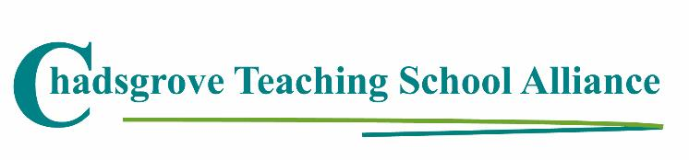

Spring Courses 2020

Date | Course Leader | Course Title
24th January  10.00 – 3.00 | Lorraine Petersen OBE  SEND Consultant & Trainer | Assessment for Pupils with SEND  Mainstream  SEND Schools | £110
27th February & 5th March  9.45 – 4.45 | Lorraine Petersen OBE  Accredited MHFA Trainer | Mental Health First Aid  to Support Young People (2-day course)  Mainstream  SEND Schools | £249
7th February  8.30 – 12.30 | Iain Chatwin  SEND Consultant & Trainer | The Effective Teaching Assistant:  Supporting Pupil Independence  SEND Schools  Mainstream | £85
19th March  1.30 – 4.00 | Iain Chatwin  SEND Consultant & Trainer | Lego®-based Therapy to Build Social Skills for  Children on the Autism Spectrum  Mainstream  SEND Schools | £75
30th March  10.00 – 4.00 | Dr Wenn Lawson  ASD Trainer, Consultant & Author | The Autism Spectrum: Dual Diagnoses and PDA  SEND Schools  Mainstream | £135
1st May  10.00 – 4.00 | Peter Imray  SEND Consultant & Author | Effective Practice for Pupils with Profound and  Multiple Learning Difficulties (PMLD)  SEND Schools | £110

Course details available at: https://www.chadsgroveschool.org.uk/web/cpld_courses/204963

For further information, please contact: courses@chadsgrove.worcs.sch.uk
Chadsgrove Teaching School Alliance
Meadow Road, Catshill, Bromsgrove, Worcestershire. B61 0JL
Tel: 01527 871511 (Option 1)
Booking Form
Course Title:
Number of Places Required:
Attendee(s) Name & Email Address

The information you provide in this form will be used solely for processing your course booking. If you wish us to retain your email address to contact you about future CTSA professional development opportunities please tick this box
Occupation:
Special Requirements:
(e.g. dietary, access, etc)
Organisation name:
Postal Address for Correspondence:
Invoicing Address (if different to Postal Address):

Email:
Telephone Number:
Total Cost:
(Please make cheques payable to Worcestershire County Council)
Cost Centre for Internal Transfer for Worcestershire Schools. Please complete both sections below.

Project Code: Cost Centre:
Authorised Signature (Headteacher): | Name:
We regret that we cannot accept typed signatures. Digital signatures or scanned electronic copies are suitable.
Please return to:
Chadsgrove Teaching School, Meadow Road, Catshill, Bromsgrove, Worcestershire, B61 0JL

Tel: 01527 871511 (Option 1) Email: courses@chadsgrove.worcs.sch.uk
Confirmation of your booking(s) will be made within 14 working days

CANCELLATION of a course booking must be received in writing at least 10 working days prior to the course date, otherwise the following costs will be incurred: 50% of the course fee will be payable for cancellations received between 10 & 6 working days prior to course date, with 100% of the fee being payable for cancellation received later or for non-attendance. We are happy to accept substitute delegates. In the event of unforeseen circumstances, we reserve the right to cancel or alter parts of the programme.

