6LS Staff News
Hi 6LS, we really miss seeing you and hearing all about what you have been up to, here is an update on Jackie D.
Well as you all know there are some children and staff in 6LS that love sausages! Can you guess who they are? I bet you can! But this newsletter is about Jackie D I hear you cry!! She isn’t the member of staff that likes sausages, so what’s occurring?
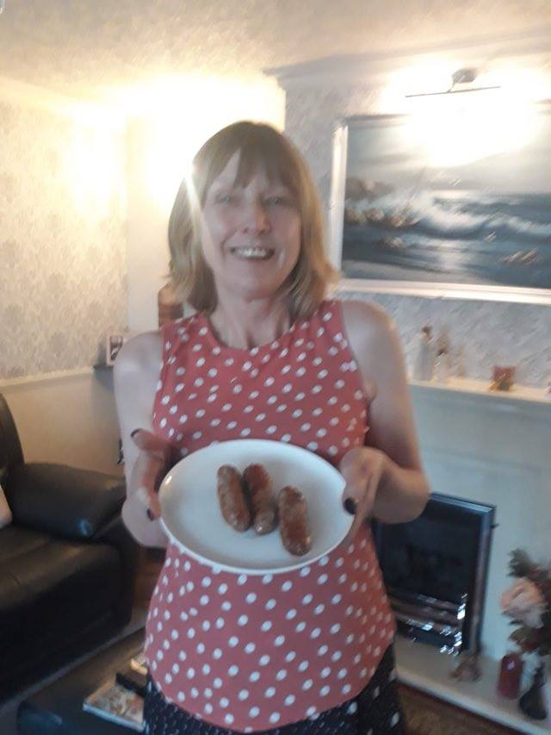
This picture was sent today and we couldn’t believe it..........that Jackie D is having sausages for tea. I think we will all have to keep an eye on our lunches when we are back in school!!!!
Jackie has been thinking about you and has been very creative, drawing and colouring a lovely poster for you all. We definitely need to find a place to put this in class. Get your thinking caps on. Where you think it should be hung? Can you see any characters on there you like?
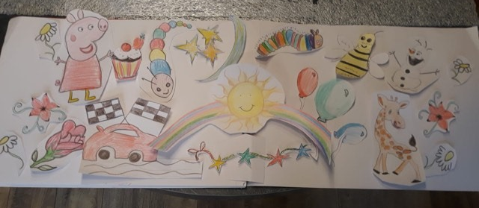

Well until next time be good and stay safe!

