No. | Item | Yes | No | Don’t Know
1 | Resists changes to familiar routines
2 | Does not recognise familiar people in unfamiliar clothes
3 | Dislikes bright lights
4 | Dislikes fluorescent lights
5 | Is frightened by flashes of light
6 | Puts hands over eyes or closes eyes in bright light
7 | Is attracted to lights
8 | Is fascinated by shiny objects and bright colours
9 | Touches the walls of rooms
10 | Enjoys certain patterns (e.g. brickwork, stripes)
11 | Gets lost easily
12 | Has a fear of heights, lifts, escalators
13 | Has difficulty catching balls
14 | Is startled when approached by others
15 | Smells, licks, taps objects and people
16 | Appears not to see certain colours
17 | Uses peripheral vision when doing a task
18 | Find it easier to listen when not looking at person
19 | Remembers routes and places extremely well
20 | Can memorise large amounts of information on certain topics
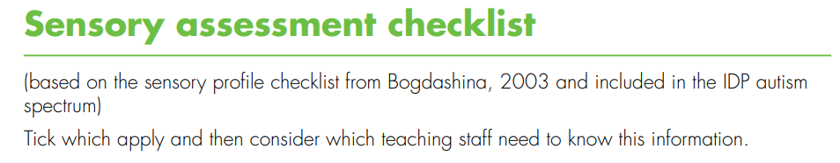
Pupil:
School:
Date completed::

AET Sensory Checklist
Page 1 of 3
No. | Item | Yes | No | Don’t Know
21 | Prefers to sit at back of group or front of group
22 | Covers ears when hears certain sounds
23 | Can hear sounds which others do not hear
24 | Is very distressed by certain sounds
25 | Bangs objects and doors
26 | Is attracted by sounds and noises
27 | Does not like shaking hands or being hugged
28 | Likes a hug if chosen to do this
29 | Only seems to hear the first words of a sentence
30 | Repeats exactly what others have said
31 | Very good auditory memory for songs and rhymes
32 | Dislikes the feel of certain fabrics and substances
33 | Seems unaware of pain and temperature
34 | Dislikes certain foods and drinks
35 | Seeks pressure by crawling under heavy objects
36 | Hugs very tightly
37 | Enjoys feeling certain materials
38 | Dislikes certain everyday smells
39 | Eats materials which are not edible
40 | Likes to have food presented in a certain way on the plate
41 | Dislikes crunchy or chewy food
42 | Quite clumsy and bumps into objects and people  Page 2 of 3
No. | Item | Yes | No | Don’t Know
43 | Finds fine motor movements hard
44 | Has difficulty running and climbing
45 | Finds it hard to ride a bike
46 | Does not seem to know where body is in space
47 | Has poor balance
48 | Afraid of everyday movement activities such as swings, slides trampoline
49 | Has extremely good balance
Page 3 of 3

