Phase 3 phonics 5ls skittles game

What you need-
- something for skittles; empty cardboard toilet rolls, water bottles, empty cans from the recycling all work great!
- Pieces of paper with phonics sounds on to stick on skittle.
- A ball or something to knock skittles over with.

How to play- Line up the skittles in a triangle shape and use a ball. Roll the ball and aim to knock over the skittles. Which ever skittle or skittles have been knocked over try and sound out the sound written on the skittle. You can also use a switch and get your grown up to record two phonic sounds, press the correct one! Then think of a word that has the same sound in as on the skittle. For example, if you knock over the phonic “sh” you could think of the word shop. Play untill you are confident with the sounds and have knocked all the skittles over!
Before you start- Watch a short YouTube video to remind yourselves of the sounds. https://www.youtube.com/watch?v=aNcBWSBxSp0 (copy the link).

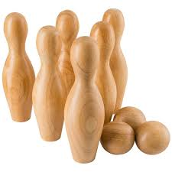

Phonic sounds to write on the skittles;
j
v
w
x
y
Choose as many as you like and write the sound on the skittle.

z
qu
ch
sh
th
ng
ai
ee
igh
oa
oo
ar
or
ur
ow
oi
ear
air
ure
er

